Kennedy High School
Advisor: Barry Wilson
Location: 4545 Wenig Rd. NE, Cedar Rapids, IA, 52402
Phone Number: 319-784-7697
bwilson@cr.k12.ia.us
Derek Severson, Grade 12, Crew Chief
Jesse Hempstead, Grade 9 Assistant Crew Chief
Kaleigh Martin, Grade 10, Driver
Dylan Davis, Grade 9, Documentation writer
984 or S984 February Monthly Report
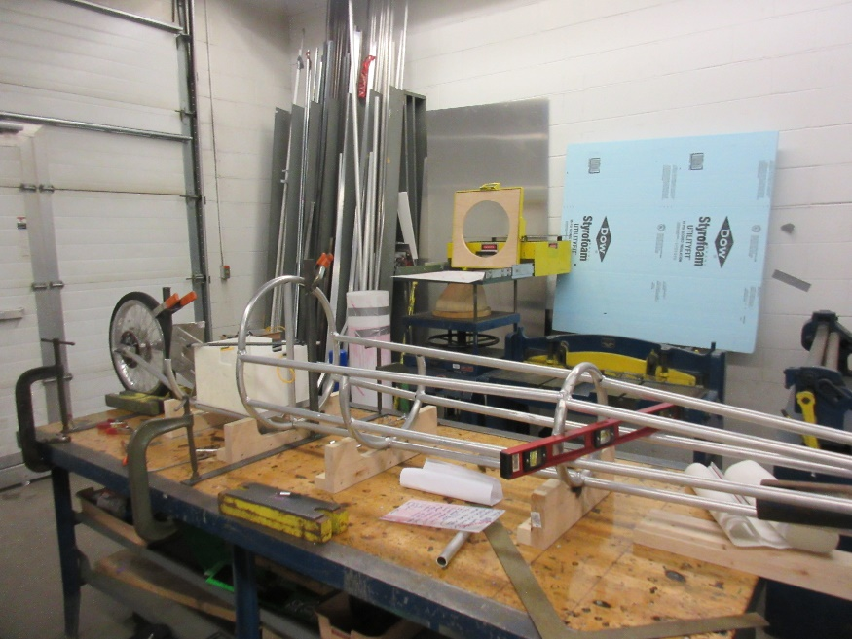
A lot of improvement has happened over the past month on the 984. It started off the month as a series of aluminum rings on jigs, and since then, Derek Severson and Jesse Hempstead, his assistant, have made major progress. They have put all the tubes together, and added the tail end of the car, with the motor mount, rear wheel, and battery compartment. They keep modifying to fit everything into the car.
The graphics team has made our shirt design for the year and is getting ready to mass-produce them over the coming weeks. Rodrigo Sagastume, our graphics person, also took time to make the 983’s number board at short notice for our Incoming Freshman Orientation. Orientation went well, and we think we have recruited several new members for the upcoming 2020 season.
The batteries team has successfully set up the dyno tester and is running battery tests on our old A and B battery sets to see how well the batteries would perform in the upcoming racing season.
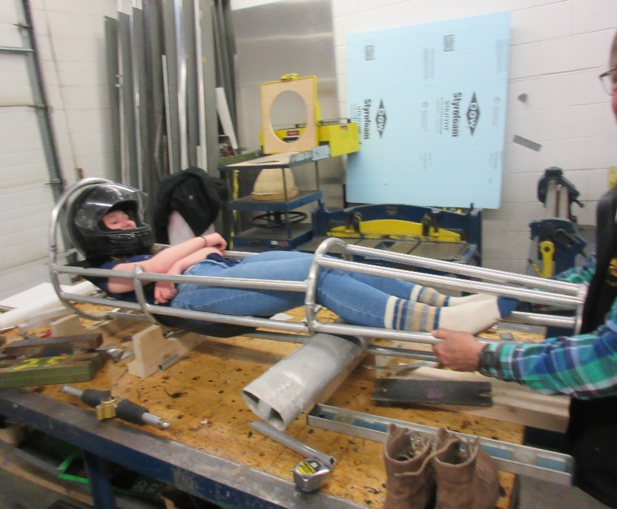
Following several changes between semesters 1 and 2, Dennis Davis from documentation moved to the battery team which was down to one person. Brian Stubblefield from telemetry has joined documentation and will be assisting telemetry when he can.
The graphics team has made our shirt design for the year and is getting ready to mass-produce them over the coming weeks. Rodrigo Sagastume, our graphics person, also took time to make the 983’s number board at short notice for our Incoming Freshman Orientation. Orientation went well, and we think we have recruited several new members for the upcoming 2020 season.
The batteries team has successfully set up the dyno tester and is running battery tests on our old A and B battery sets to see how well the batteries would perform in the upcoming racing season.

.

