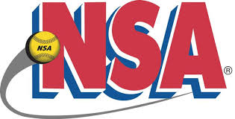
2019 NSA “C” State Tournament
Patriot Park-Michigan City
June 21-23, 2019

10u “C” Pools

POOL A POOL B
- Duneland Diamonds 1) Dynamite
- Riptide 2) NWI Alliance
- PJM Elite 3) Midwest Pride

Day Time Field Game
Friday 9:30 AM Duneland Duneland Diamonds vs Riptide 15-5
11:00 AM Duneland Duneland Diamonds vs PJM Elite 14-6
12:30 PM Duneland Riptide vs PJM Elite 9-3
2:00 PM Duneland Dynamite vs NWI Alliance 15-2
3:30 PM Duneland Dynamite vs Midwest Pride 13-2
5:00 PM Duneland NWI Alliance vs Midwest Pride 14-2

Pool Games may end in a tie
All Pool games are 75 minutes, finish the inning
All Teams MUST be at the field and ready to play 15 minutes before scheduled time
All players must have a wristband in order to play

