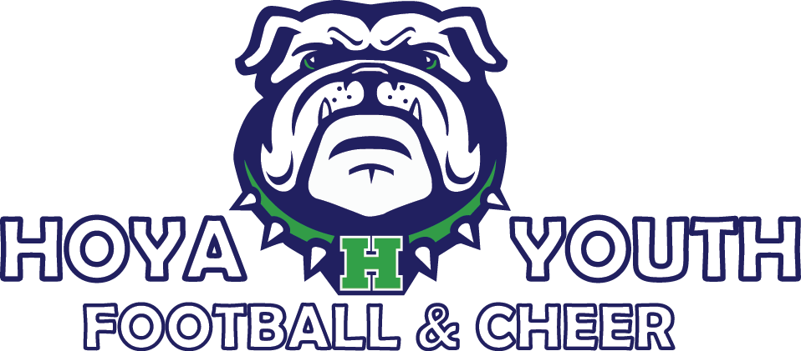
Fitting Dates:
Sunday, July 26 (12:00 – 3:00 p.m.)
Wednesday, July 29 (5:30 – 8:30 p.m.)

Saturday, August 1 (9:00 a.m. – 12:00 p.m.)

GHSA Guidelines used as basis:
- Every table will be cleaned at the beginning of each day and after each fitter.
- All staff will wash hands or use hand sanitizer before and after contact with every player.
- All reusable equipment will be cleaned after use by each athlete.
- Personal Protection Equipment (PPE) will be provided and worn / used as indicated.
- All disposable goods and PPE will be disposed of properly.
- Follow CDC COVID-19 guidelines and GHSA principles and infectious disease planning templates for youth sports: https://www.ghsa.net/latest-ghsa-statements-coronavirus-situation https://www.ghsa.net/sites/default/files/documents/sports-medicine/IDP_Template_-_1.pdf

HYFCA Fitting Guidelines:
- ONLY the athlete and 1 parent/guardian are allowed at fittings to maintain numbers/social distancing guidelines.
- Due to fitting proximity, all athletes, parents, coaches, and board members MUST wear a mask during fittings.
- Face masks will be provided for any parent/child who did not bring a mask for fitting – especially for cheer fittings held in Field House as the area is a confined fitting space.
- For all athletes: Parents must temperature screen children prior to fitting. If you or your athlete has a fever, please do not attend fittings. Please email a board member for rescheduling your athlete’s fitting.
- Cheer Athletes – ALL girls must wear leotard or bathing suit in order to be fitted.
- Football athletes: Parents MUST bring 2 copies of their athlete’s birth certificate. Please do not bring an original.
- For all athletes: Parents will need bring a $200 check postdated for 11/1/2020 for equipment rental. We will keep this check on hand in case equipment is damaged or not returned at the end of the season.
- For all athletes: Parents will need to bring a $100 check postdated for 11/1/2020 for concession/volunteer duty. We will keep this on hand in case concession/volunteer duty is not fulfilled.*
*Please note: Disregard #4 if you have already paid to optout of concession/volunteer duty during online registration.
- All HYFCA fitting volunteers will be temperature screened and must be symptom-free.
- Volunteers not fitting athletes must follow 6 ft distance guidelines and/or wear appropriate PPE.
- There will be separate “entrance” tables for Football and Cheer with clearly marked X’s for line formation.
- Fitting routes will be clearly marked with caution tape/cones to proceed through fitting (i.e. registration table -> football helmets ->shoulder pads rack ->jersey/pant pick up then exit out back).
- Football fitting – will be conducted outside (provided no weather issues) to allow for proper social distancing guidelines of 6 ft between volunteers.
- Cheer fitting inside Field House – no more than 2 cheerleaders at one time with 1 female parent each upstairs in Field House. A volunteer will be outside of the Field House to monitor the entrance/exit procedures including marked exit route similar to football.
- The Spirit Shack will be set up under the main pavilion. Several Hoya items will be on sale for $5 along with $1 practice jerseys and $1 old cheer shells/skirts. Debit/credit only accepted.
Important Season Reminders:
- Football: Speed and Agility conditioning (optional) will begin Monday, August 3. More info to come from the coaches.
- Football: As of 7/25/20, practices will be held Mondays, Tuesdays, & Thursdays from 6:30 – 8:30 p.m. beginning Monday, August 10 at Lost Mountain Park.
- REVISED: Cheer: Practice begins Monday, August 10 at Lost Mountain Park.
- Competition cheer will have a parent meeting on Friday, August 14 and closed competition assessments to follow directly after the meeting. 6:00 – 8:00 p.m. Location TBD.
- The first game: September 12, 2020
- Fall Break: 9/28 – 10/2: Games will be on Saturday, September 26, so please plan accordingly.
- Homecoming: October 10, 2020

