Intermediate School 78
The School of Architectural Design & Innovative Technology

Parent/Student Handbook
2016 - 2017

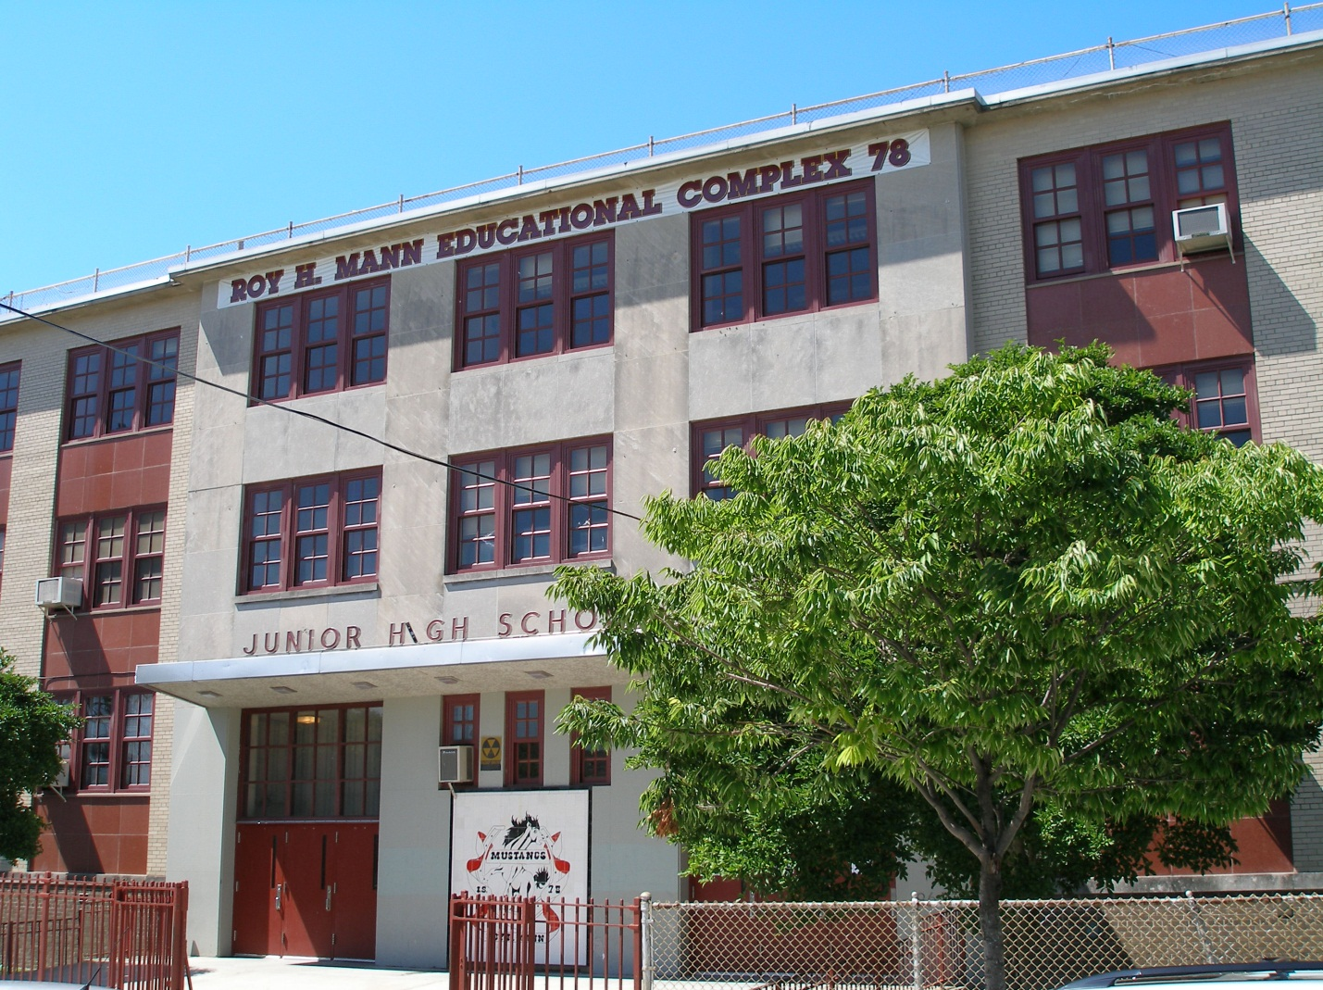

Anthony Cusumano
Principal

“Together We Make A Difference”

ATTENDANCE/LATENESS
- Regular attendance and punctuality is a key factor to success in school
- A parent/guardian must send a written explanation when a student is absent or late
- Students are responsible for the work missed due to absence

BATHROOM PROCEDURES
- Students are to use student designated bathrooms only
- Students must have a pass to use the bathroom
- Bathrooms are open during periods first floor during non-lunch periods (2, 6, 7) and in
the basement during lunch periods (3, 4, 5)
- Bathrooms are closed periods 1 & 8

BOOK BAGS
- Book bags should not be left unattended in classrooms, the playground, schoolyard or cafeteria
- Students with back problems may want to use bags with wheels
- Please label your book bag inside with name and official class

BREAKFAST/LUNCH PROGRAM
- Students use a six digit PIN number in the cafeteria
- Letters with PIN numbers will be distributed to parents
  - We encourage students to memorize these assigned numbers to help speed up the serving lines
- Please be reminded that parents may bring in lunch for their child, but should refrain from bringing fast food items in for their child to eat in the cafeteria

DAILY SUPPLIES
- All students must come to school each day prepared and ready to learn. We recommend students have the following supplies daily:

  - Pens & Pencils
  - Notebooks or a binder with dividers and paper
  - Textbooks (if needed)
  - Completed homework assignments
  - Agenda
  - Any supplies requested by individual teachers
  - Gym uniforms on appropriate days

ELECTRONICS
- No cell phones, iPods, or any other type of electronic devices are permitted to be used in the school building as per Chancellor’s Regulations
- If a student needs to contact a parent/guardian, they may request to use the phone in the parent coordinators office (room 126)

DISCIPLINE/DETENTION POLICY
- The staff at Roy H. Mann believes that a safe, orderly, and respectful environment is necessary for student success. The school has “Zero Tolerance” for violence and blatant disrespect of authority. We will maintain the highest standards for student behavior. The administration will uphold the NYC Dept. of Education Discipline Code, as well as the school’s Discipline Plan. Both policies will be distributed to parents and reviewed with students.
  - Seniors who receive conduct grades of N or U and/or consistently break school rules may be excluded from senior activities, Prom and Graduation

DRESS CODE
- Attire of all students is carefully monitored to ensure safety and proper decorum. Please work with us to ensure that students follow the NYC Dept. of Education Discipline Code. They cannot wear hats or clothing that is unsafe or disruptive to the educational process. Pants MUST be worn at the waist.
- All students will receive classroom lessons on the NYC Discipline Code and Bill of Student Rights and Responsibilities. It is a good habit to review this booklet.

EMERGENCY HOME CONTACTS
- To ensure the school is prepared for emergencies, it is essential that we have correct and updated Blue Emergency Contact Cards in order to contact a parent/guardian in the event of an emergency
  - Please make sure all names and phone numbers are correct
  - Please notify the school of any changes to the provided inforamtion
  - Without prior notice, a student WILL NOT be released to anyone not on the Blue Card
*All emergency contacts MUST be at least 18 years of age and present proper photo identification when picking up a student

EVACUATION & LOCKDOWN DRILLS
- Drills are held regularly to ensure the safe evacuation of the building in the event of an actual emergency
- These drills are serious procedures
- During drills, there is absolutely no talking
- Students are required to follow the directions of their teachers or adults in authority

GRADING POLICY
- Grades are determined by department based on:

  - Test scores
  - Class work
  - Homework
  - Reports
  - Projects
  - Class Participation

- Students in danger of failing a subject will receive notice prior to the end of the marking period
- Homework is given on a daily basis and is part of the grading criteria
- Excessive absence from class may result in a failing grade
- The Uniform Grading Policy is available on our website, www.IS78.org

HALL PASSES
- A standard hall pass, with the teachers’ name, is required by all students who are out of a classroom
- If a teacher keeps a student late for his/her next class, it is the student’s responsibility to get a pass to show to the next teacher
- Students in the hall without a proper pass are considered cutting class

HEALTH
- All children entering school in September are required by NYS Law to show proof of having the following immunizations:
(Number of doses required depends on grade level)

  - Chickenpox (Varicella)
  - Diptheria- Tetanus
  - Tdap
  - Hepatitis B
  - Polio-Sabin (Oral)
  - Measles
  - Rubella
  - Mumps
  - Tine Test (T.B.)

- There will be a review of each student’s health record, including for vision/hearing screening
- The school MUST be advised of any existing, chronic health problems your child has
- Students must have a pass to visit the nurse’s office
- The nurse will:
- Diagnose the extent of the illness
- Apply first aid when needed
- Notify the parent/guardian if necessary
- Call ambulance if needed
  - If a parent/guardian is unavailable, a staff member will accompany the child
to the hospital

INJURIES
- Any child who reports that he/she is sick or injured, will be escorted to the nurse’s office where the nurse will assess the extent of the injury/illness
- An injury report will be filed if needed
- If emergency treatment is deemed necessary, the child will have a staff member escort him/her to the hospital if the parent/guardian cannot be reached

PROMOTIONAL REQUIREMENTS
- All students must meet the promotional requirements outlined by the New York City Department of Education

REPORT CARDS
- There are four marking periods
- Report cards will be distributed in October, January, March & June
- Parents/guardians must pick up the first quarter report card in person

SCHOOL SAFETY PLAN
- The Roy H. Mann School Safety Plan contains information regarding emergency procedures
- Our evacuation sites are as follows:

Primary -
P.S. 312
7103 Avenue T
Secondary -
P.S. 236
6302 Avenue U
Out of Area -
IS 14
2424 Batchelder Street

- In the event that it is necessary to pick up your child from school during an emergency situation, the procedure will be as follows:
  - The parent or designated adult (as per the Emergency Blue Card) will enter the school building through the Main Entrance on East 68th Street
  - The parent/designated adult will sign the student out in the designated sign out area

TESTING DATES
- The complete assessment schedule for state exams, MOSL exams, Quarterly Assessments and Final Exams is available on our website, www.IS78.org

TRIPS/ACTIVITIES
- Students must have signed consent forms three days in advance
- PHONE CONSENT WILL NOT BE ACCEPTED. NO EXCEPTIONS!
- Students can be denied participation in trips for poor behavior, even after payment has been submitted. A refund will be given when possible.
- Any monies over $10 must be in the form of a money order. No personal checks will be accepted. Money orders should be made out to I.S. 78

VISITING PROCEDURES
- Although we consider parents/guardians to be vital parts of our school community, we ask everyone to follow the regulations below upon entering the building:
  - All visitors are required to show proper photo identification at the safety desk. This is required especially when picking up a student.
  - No child can leave the school building before the end of the day without a parent/guardian or Blue Card designee signing him/her out

SCHOOL CLOSINGS
- In the event of a severe storm, delayed opening or any other event that warrants school closing, listen to 1010 WINS AM, Cable News 1, or local news stations for information

WEBSITES
- www.IS78.org
- NYC Department of Education: www.nycboe.net
- NYS Education Department: www.nysed.gov
- NYC Website: www.nyc.gov

If you have any questions, you may contact the Parent Coordinator,
Mrs. D’Aleo, at (718) 763-470 ext. 1260

