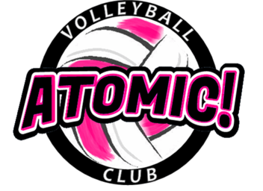

***Elementary Volleyball Clinic***

**1st – 5TH GRADE GIRLS**

**5 Sundays**

**Mar 1 – Mar 29, 2020**

**Location of Clinic: Brownstown Sports Center, 21902 Telegraph Rd, Brownstown, MI 48183**

**Program Details:** This is the 6th season of the elementary clinics. It is designed to teach the fundamentals of volleyball in a fun, player-centered atmosphere. The program is a great way to introduce volleyball to the novice player as well as continue the development of young individuals who have already started playing the world’s greatest team sport.

The athletes will be placed with other athletes of similar ability and grade level.

**Please bring:** Court shoes, knee pads (if possible) and workout clothes, water bottle, good attitude.

**Cost**: $60 includes a t-shirt (payable to Atomic! VBC)

**Coaches:**

**Coach Dennis Yack**, Atomic! Volleyball Director **Coach Jeff Klug**, Atomic! 10u Coach

* Former head Varsity VB coach at Woodhaven HS **Coach Heather Grybel**, Atomic! 10u Coach
* 24 years coaching experience at HS/MS/AAU **Coach Abby**, Atomic! 10u Coach

**Time**: 4:00PM - 5:00PM

***Mail Registration form and check to: Atomic! VBC, P.O. Box 1381, Southgate, MI 48195***

**Questions: atomicvbc@gmail.com or call/text Coach Yack at 734-934-4064**

**Like us on facebook**

----------------------------------------------------------------------------------------(keep to portion for your records)------------

**Registration Form 🡪 Atomic! Elementary Clinic (Mar 1 – Mar 29)**

Athlete’s Name: ______________________________Cell Phone ______________________

Address:_____________________________________ City, Zip: ____________________

Email (print clear) : _______________________________

Grade Level (Fall of 2019) ____School Name: ______________________________

Emergency Contact Phone______________________ Shirt Size (youth) _____

I hereby authorize the staff of the Atomic! VBC to act on my behalf according to their best judgment in any emergency requiring medical attention if I cannot be reached. I, further, waive and release the Atomic! VBC and its staff from any and all liability for the injuries or illnesses incurred while involved in this camp. I have no knowledge of any physical impairment that would keep the above named athlete from full participation in this camp.

Parent or guardian signature ___________________________________Date __________________

Parent Name (Printed) ___________________________