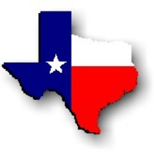Texas History with Mr. Brown Name ____________________ Period _____
Royse City Map Activity
Directions: Study the map then use it to answer the 15 questions that follow.
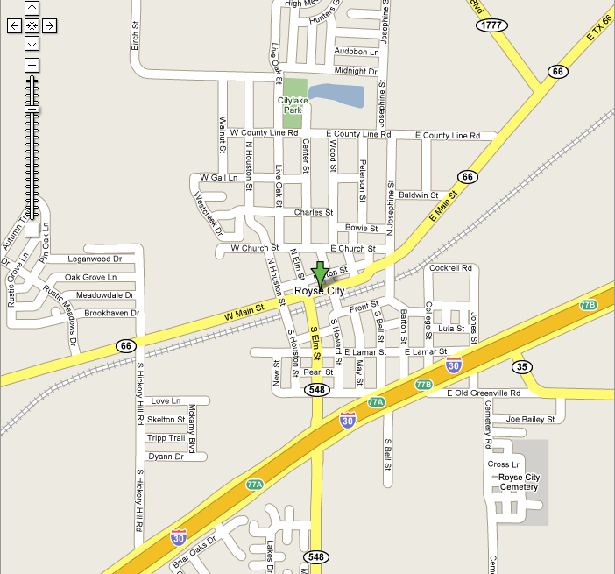
1) Turn right off of E old Greenville Rd on to ________________ to reach the Royse City Cemetery.
2) In down town Royse City HWY 66 is known as _________________________________.
3) From HWY 66 you would need to turn south on _________________ to reach Love Ln.
4) The railroad runs nearly parallel to what street?
5) What two roads would I take from the Middle school to reach Citylake Park?
6) FM 548 is also known as ___________________.
7) What three roads cross College Street?
8) Rustic Meadows drive is _______________ of HWY 66.
9) Traveling north on Rustic Meadows drive, Oak Grove lane is the ______ right.
10) Name one street that crosses New St.:
11) Tripp Trail runs from east to west between Hickory Hill Road and _____________________ Blvd.
12) ______________ is just north of and parallel to Midnight Drive.
13) ______________ is south of Cockrell Road but North of Lamar Street and perpendicular to Jones Street.
14) What is the next street north of Oak Grove Lane off of Hickory Hill Road?
15) What Interstate Highway passes through Royse City?

