Travels with Anzie – Sagrada Familia
March 2020
I first discovered Antoni Gaudi in 1994 during a business trip to Barcelona. My hosts showed me a few of his architectural wonders. I became immediately enthralled with the organic features: a dragon back for a roof line, balconies shaped like turtles, mosaic lizards instead of gargoyles, on and on. I was astounded by the fact that he designed these modernist features in the early part of the 20th Century.
Sagrada Familia is his most famous and awe-inspiring work. This church (actually a basilica) was begun in 1882 and is still unfinished. How to describe it. Much of it appears to be melting. Remember the Mason Williams song made famous in the 70’s? “Someone left the cake out in the rain …”. Did you ever make a drip sandcastle at the beach? Both of these give you a pretty good idea of S.F.’s exterior organic appearance.
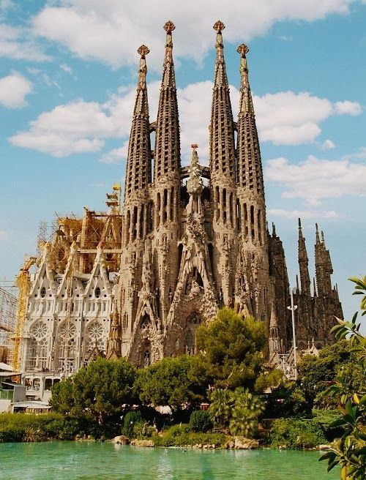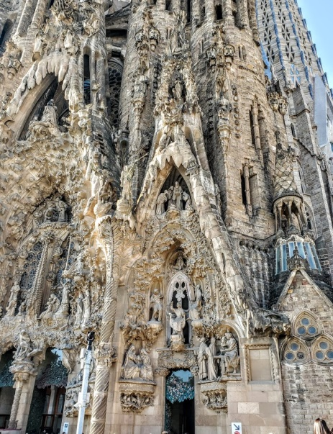
When construction began, the design was to be a Gothic-revival style. The original architect quit in the second year, and Gaudi took over. He completely redesigned it. Although still basically Gothic, Gaudi added his own Art Nouveau/Modernisme touches. All the statuary rests on the exterior. There are no exterior buttresses; the supports are all inside in the form of magnificent stone tree-like structures, including leaves, sunflowers and birds. There are eight 330-foot spires, topped with crosses. They will be joined by ten more before it is finished. One of them will be the 560-foot Jesus tower. The church is designed to hold up to 8000 worshippers. The stained-glass windows, which cover a good portion of the walls, are abstract. Starting from the base in blue, then purple, green, yellow, red, finally orange, sunlight gives a veritable symphony of light to the interior.
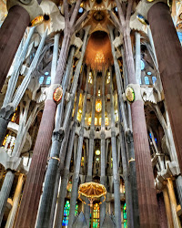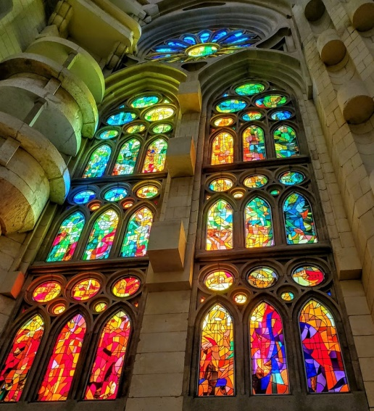
Gaudi was hit by a streetcar and died in 1925. He knew he wasn’t going to live to see the completion, and he planned accordingly. He was supposed to have said, ”My client (God) is not in a hurry”. He made several models and drew countless plans, which he left as his legacy. The current goal is completion by 2026, the centennial anniversary of Gaudi’s death.
So, what’s taking so long? Is this the normal pace of construction projects in Catalonia? Certainly funding is always a problem. Tourists pay a minimum of about $19.each to tour the church. A good portion of that goes toward the construction. So, each tourist can be proud that he or she is contributing to this awesome project.
Work was delayed for a time after Gaudi’s death. In 1936-39 work was halted by the Spanish Civil War. The crypt was burned along with many of Gaudi’s plans. Building didn’t really resume in earnest until the 1950’s. In the 1980’s computer technology began to help speed up the pace.
The roof was finally enclosed in 2010, just in time for Pope Benedict XVI arrival to dedicate the church as a basilica.
If you examine the intricate detail on the exterior, you can perhaps understand why things took so long. What you see over the entrances is a series of cement grottoes peopled with biblical figures.
Anzie and I have visited Barcelona several times over the years. Except for a drive-by, this was our first real visit to this truly amazing site. Here’s hoping we live long enough to see it finished.
(Please see photos attached) https://photos.app.goo.gl/s1g7Do7XBC9hApRM9
Hasta la proxima,
Chuck & Anzie

