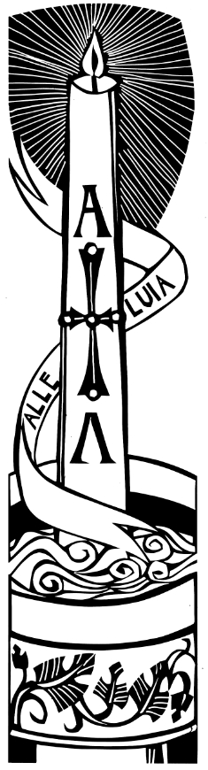
Exsultet & Prayers from St Giles, Aintree

Holy, or Black, Saturday is part of the big 3 days of the triduum, in which the church builds up to celebrating Jesus’ resurrection on Easter Day.
Traditionally, it is held in the hours of darkness between sunset on Holy Saturday and sunrise on Easter Day – most commonly in the evening of Holy Saturday or midnight and is the first celebration of Easter. In Jesus’ day, days were considered to begin at sunset.
This service is a short offering of prayers & readings, along with the Exsultet – an ancient hymn dating back to the 7th Century that recalling God’s presence with his people through the Bible and welcoming Christ’s Resurrection.
This service is a shortened version of a vigil service.
A Gathering
Our service begin with the church in darkness; before a candle is lit.

The Exsultet
The Easter Hymn of Praise is sung.

Bible Readings & Prayers
Bible Readings are read, along with prayers giving thanks.
After each prayer, we join in the ending, with ‘Amen’.

Paschal Homily
St John Chrysostom (d. 407), known as ‘Golden Tongue’ wrote a homily for Easter.
It is read at the first service of Easter in Eastern Orthodox and Byzantine Catholic Churches. It may be read here or another short reflection given.

Final Prayers & Easter Acclamation
Let us bless the Father, the Son, and the Holy Spirit. Let us praise and exalt him for ever.
All Blessing and honour and glory and power be to him who sits upon the throne and to the Lamb for ever and ever. Amen.

Great and marvellous are your works, Lord God the almighty; just and true are your ways, King of saints; all glorious your gifts, Spirit of life. Blessing and honour and glory and wisdom and thanksgiving and honour and power and might be to our God for ever and ever. Amen.
After each bidding prayer, we respond with:
‘and his mercy endures forever’ or ‘blessed be Christ’.

The final prayer:
Blessing and honour and thanksgiving and praise more than we can utter,
more than we can conceive, be to you, O most adorable Trinity,
Father, Son, and Holy Spirit, by all angels, all peoples, all creation, for ever and ever.
(Lancelot Andrewes, 1626)
Alleluia, Christ is risen! He is risen indeed, Alleluia!

