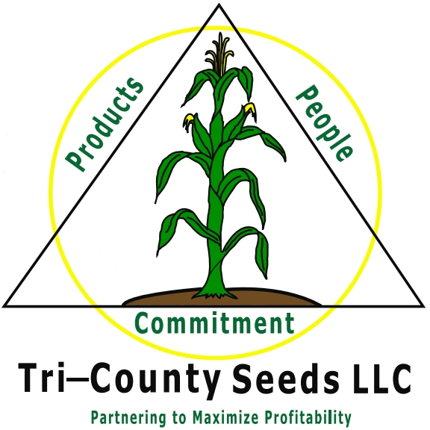
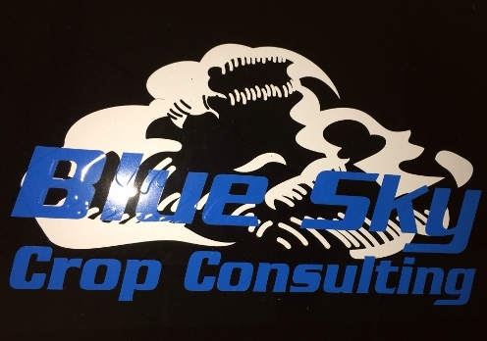
Tri-County Seeds
and Blue Sky Crop Consulting
Fall & Spring
Internships

Innovative and service oriented companies are seeking an agronomic leader for fall and/or spring internship positions in the months of August through May. This Internship position requires a self-motivated person to assist in seed sales, seed orders and deliveries, warehousing, soil sampling, precision ag and other duties as required by management. It is an excellent opportunity to apply classroom knowledge to practical experience the field. The intern will gain experience with seed varieties and hybrids, sales and relationship building and valuable crop experience.

This position will be headquartered in Kinsley, KS working with producers in South Central and Southwest Kansas.

The Successful Candidates Will Have:
- College Major in Agricultural Business, Agriculture Economics, Agronomy or other related field
- Solid farm background or experience
- Excellent written and verbal communication skills
- Desire to learn about sales
- Attention to detail
- Ability to operate with little supervision
- Knowledge of corn, soybean and wheat crops; agricultural chemicals and fertilizer is helpful
- Valid drivers license with good driving record

Salary and Benefits:
- Extremely competitive hourly rate
- Vehicle for all work related activities
- Potential for full-time employment upon graduation

For more information, contact Amy Gerdes at 620-338-7593 or email cover letter and resume to 4agerdes@gmail.com.

