**Biology 112**  
**Lab 2: Protists** belong to Domain Eukarya and are organisms that are not   
plants, animals, or fungus.

**Part I: Autotrophic protists** produce their own food via photosynthesis.

1. ***Spirogyra*** (Green algae/filamentous.) Prepared slide; Place at 10X or 40X. Label nucleus, spiral chloroplasts; p. 50.

2. ***Chlamydomonas*** (Green algae/unicel.) Use prepared slide at 100x. Label the double flagella. No reference.

3. ***Volvox*** (Green algae/colonial); Prepared slide; p. 45.

a) Draw at 10X and label vegetative cells and daughter colonies.

b) Draw at 40X a few interconnected cells.

(Note: these are 2 separate drawings)

4. ***Euglena*** – These organisms are **mixotrophic.** What does this mean?

Label the parts indicated.

5. Dinoflagellate*.* Prepared slide. Draw at 40X. Label the

transverse groove and cellulose plates. P.40, fig.4.20 and 4.21.

6. Diatoms – Use prepared slide at 10X. Draw various shapes. Label silica cell wall. No reference.

7. ***Fucus*** – a type of brown algae/kelp. Draw preserved specimen.

Label blade, stipe, receptacle (floats), p.59 top.

8. ***Sargassum*** – a type of brown algae/kelp. Draw preserved specimen.

Label floats and blade. (p.57, fig.4.96).

9. Red Algae – List three commercial products that are made with red algae.

**Part II: Heterotrophic Protists** obtain their food by ingesting other molecules or organisms. These protozoans are often described based on how they move.

**Moves via pseudopods**

10. Amoeba **–** Prepared slide. Label pseudopods, nucleus.

10X. p.41

11. Radiolaria- Prepared slide; 10X. No good atlas reference.

12. Foraminifera - Prepared slide; 10X. No good atlas reference.

Q: What are the skeletal remains of radiolaria and foraminiferans called?

**Moves via cilia**

13. ***Paramecium*** – Prepared slide. Label the oral groove. 10X. p.43.

14. ***Stentor* –** Label cilia, where the macro-and micronucleus are located, and contractile vacuoles. 10X. p.36 Fig.4.3d

15. ***Vorticella* –** Use prepared slide; 10X. Label macronucleus, stalk.

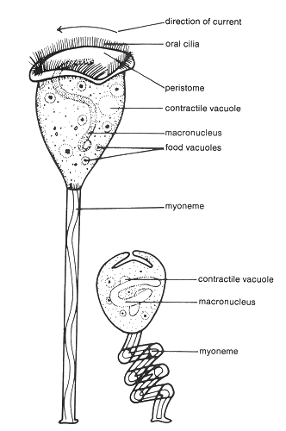

**Q:** *Paramecium, Stentor,* and *Vorticella* have a macronucleus and a micronucleus. What is the difference?

**Moves via flagella**

16. ***Trypanosoma*—**Use prepared slide. Label red blood cells and the *Trypanosoma*; 40X. p.42, Fig. 4.29

**Q:** Which diseases could you get if you are infected with *Trypanosoma*?

**Mostly non-motile (don’t really move)**

17. ***Plasmodium\****—Use prepared slide. Label red blood cells and *Plasmodium* stages; 40X. p.42 fig.4.26 [find stages like (a) (b) and (c)]

**Q:** What disease will you get if you are infected with *Plasmodium*?   
  
 **Part III: Saprotrophic Protists** digest food outside their bodies and then ingest smaller molecules. They are considered decomposers.

18. ***Physarum* –** a plasmodial* slime mold, p.64. (*Note: “*Plasmodium”* in italics is the genus name for the organism that causes malaria. “Plasmodium” without italics is the common name used for a slime mold.)  
List the names of the different cell types or shapes that are present in the life cycle of the slime mold.

When you see a fresh, gooey, yellow slime mold in the wild, which part of the life cycle are you seeing?

When you see an older, dusty, rust-colored or brown slime mold in the wild, which part of the life cycle are you seeing?

