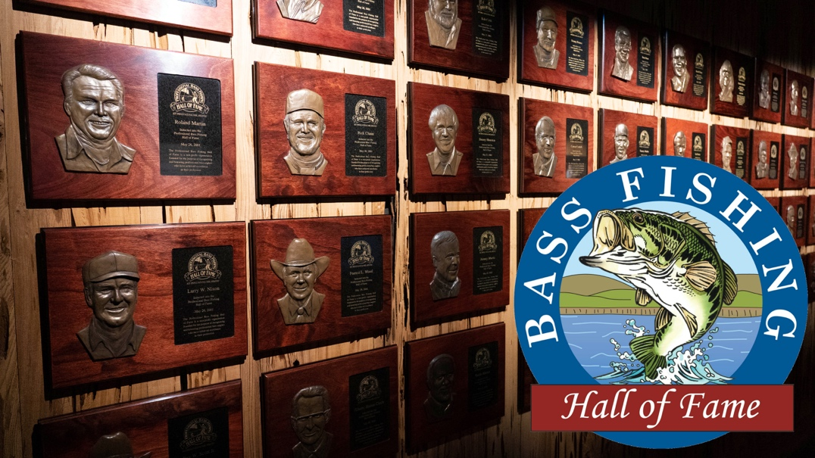
PRESS RELEASE

CONTACT INFORMATION:
Bass Fishing Hall of Fame
Barbara Bowman
501-541-6660
bbowman@bassfishinghof.com

RELEASE DATE:
8/9/2021

Bass Fishing Hall of Fame Makes Four Conservation Grants

SPRINGFIELD, Mo. – August 9, 2021 – For the second consecutive year, the Board of Directors of the Bass Fishing Hall of Fame announces that the Hall has awarded four conservation grants to contribute to its mission of celebrating, promoting and preserving the sport of bass fishing. The recipients were selected through a highly competitive process, and they represent a diverse group of deserving projects.
“We are once again thrilled to be able to contribute to these worthy projects that should provide immediate impacts,” said Bass Fishing Hall of Fame President John Mazurkiewicz. “Habitat restoration and management, and other conservation efforts, are the lifeblood of our sport and are critical to bass fishing’s future. These grants are all going to worthy recipients for the benefit of the wider community.”
The four grantees are as follows:
- Southwest Iowa Fishing Team (Iowa Bass Federation) – The SWIFT Conservation Fish Habitat Project will place artificial fish habitat structures in lakes and ponds throughout southwest Iowa, utilizing materials that will benefit biodiversity without decomposing or otherwise negatively impacting the fisheries.
- Springs Bassmasters & Southern Colorado Junior Bass Club (Colorado Bass Federation) – Youth volunteers will create structures of chain, twine, cables and weight to sink approximately 100 cottonwood trees in the Valco ponds, adding much-needed fish habitat.
- Tri-County Bass Anglers (Indiana Bass Federation) – Youth volunteers will employ a habitat enhancement plan created by the Indiana DNR in Patoka Lake, utilizing Pennsylvania porcupine cribs, pallets, black bass nesting structures and Hoosier cubes.
- Chattanooga Bass Association (TN) – The Association will build a release boat to redistribute tournament-caught fish throughout Lake Chickamauga, with help from TWRA, the Tennessee Aquarium, Chattanooga Tourism, Fish Dayton, and the Tennessee Department of Tourism.
“These represent a truly inspirational slate of bass anglers’ volunteer efforts,” said Board member Gene Gilliland, Conservation Director for B.A.S.S. “Once again, we wanted to make sure that sweat equity was incentivized and rewarded.” Gilliland and Board member Casey Shedd with AFTCO spearheaded the BFHOF conservation grant selection process.
The Bass Fishing Hall of Fame will hold its annual induction dinner on Thursday, September 30, 2021, at the Wonders of Wildlife Museum and Aquarium in Springfield, Mo. There will also be a concurrent auction, starting on September 27 through noon on October 1. The proceeds assist the Board in hosting the dinner and other recognition events each year, along with funding its conservation grants and other worthy endeavors benefiting the sport of bass fishing. Generous donors from all walks of the fishing and outdoors industries have already donated numerous products and experiences, many of them one-of-a-kind items that cannot be purchased elsewhere at any price. For information on induction dinner tables and tickets, visit https://www.bassfishinghof.com/2021-banquet - or call (501) 541-6660.

###

About the BFHOF -- The Bass Fishing Hall of Fame is a nonprofit organization led by a volunteer board of directors and is dedicated to celebrating, promoting and preserving the sport of bass fishing. Since 2017, the Hall’s inductees and memorabilia representing the history of bass fishing is showcased in Johnny Morris’ Wonders of Wildlife Museum and Aquarium in Springfield, Missouri, where it has rapidly become a popular destination.
For more information about the Hall, its mission, and to become a supporting member,
visit www.BassFishingHOF.com,
or contact BFHOF executive director Barbara Bowman at bbowman@bassfishinghof.com.

