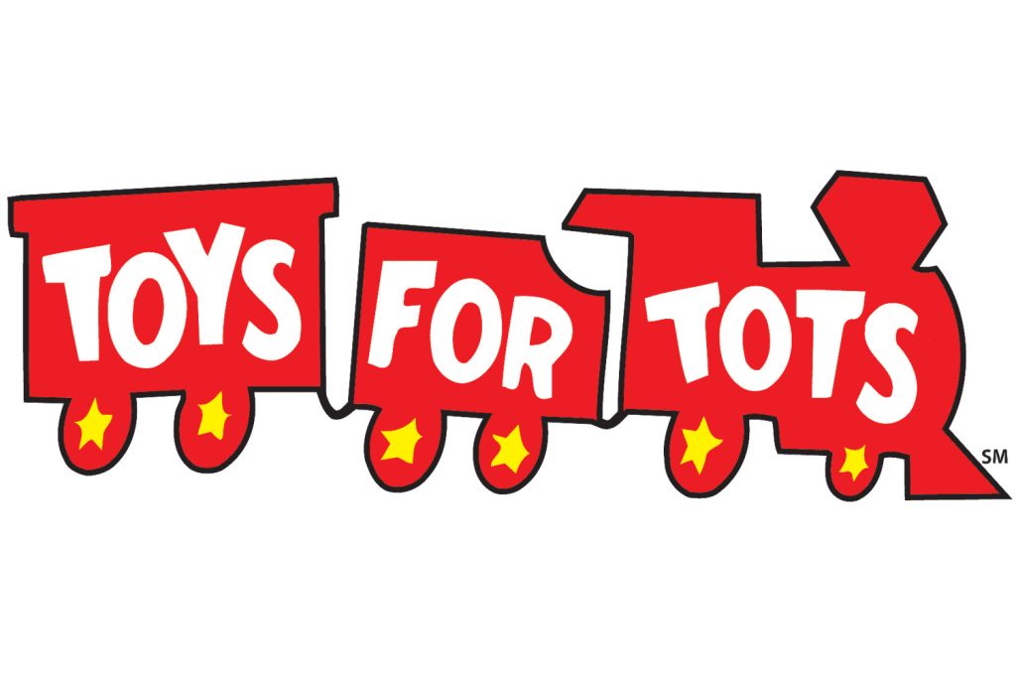
Family Registration Form
2019 T4T Season Charlotte, NC

1) Child’s Name (first, last): ________________________________________________________________
Age of child: _________________ Gender of child: __________________
2) Child’s Name (first, last): ________________________________________________________________
Age of child: _________________ Gender of child: __________________
3) Child’s Name (first, last): ________________________________________________________________
Age of child: _________________ Gender of child: __________________
4) Child’s Name (first, last): ________________________________________________________________
Age of child: _________________ Gender of child: __________________
Address: ______________________________________________________________________________________
Email:_________________________________________ Phone:_______________________________________
Adult Registering for children (first, last): ________________________________________________
Adult relationship to children:______________________________________________________________
- Proof of parent or guardianship for child
- Social security card
- Birth certificate
- Court documents
- Proof of residence
- Utility Bill (water, gas, electric) Lease or Mortgage
- Proof of low income status
- Tax records
- Enrollment document for government assistance program

I understand and agree that donated items received will not be sold to others & have not registered with another organization to receive toys for the children named above.

Applicant or Guardian Signature:__________________________________________________________

Organizations take responsibility for verifying each child’s eligibility to receive Toys for Tots toys. The family must provide proof for each of the three sections above; copies are not needed by the Charlotte T4T Campaign. Once all forms are completed contact Charlotte T4T (CharlotteT4T@usmc.mil) or (704) 728-9791, to turn in the forms. Once the forms are turned in we will arrange a date for you to pick up your organizations toys. One completed form equals gifts for one family. Toys must be picked up at the warehouse location on the date arranged with T4T staff. If the organization fails to pick up the toys at the prescribed day and time, those toys will be added back to the inventory and redistributed to other groups.

Verifying Organization: _____________________________________________________________________

Verifying Official: ____________________________________________________________________________

Verifying Official Signature: ________________________________________________________________

