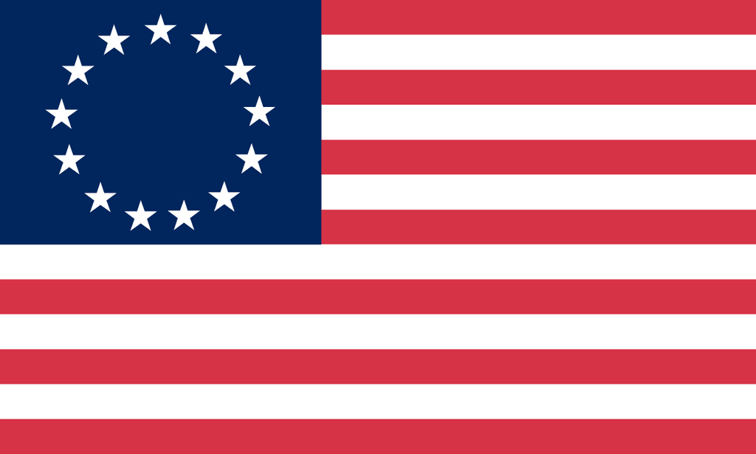U.S. History with Mr. Brown Name _______________________________ Period _____
Vocabulary Terms
Ch 6 The Road to Revolution

Directions: Use the text book to define the vocabulary terms in the space provided below.

King George III
Quartering Act
Revenue
Sugar Act
Stamp Act
Patrick Henry
Boycott
Sons of Liberty
Townshend Acts
Samuel Adams
Boston Massacre
John Adams
Committee of Correspondence
Boston Tea Party
Intolerable Acts
First Continental Congress
Paul Revere
Lexington and Concord
Loyalists
Patriots
Ethan Allen
Second Continental Congress
Continental Army
Benedict Arnold
Declaration of Independence
Thomas Jefferson

