Knights of the Armor Force

**M24 Chaffee Light Tank**

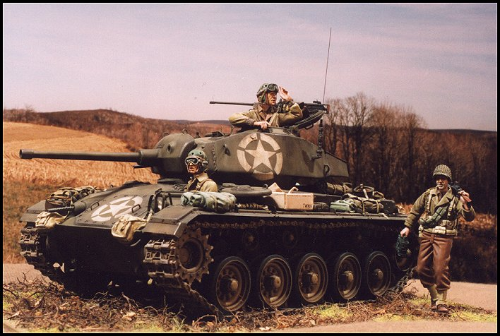

The M24 Chaffee -- arguably the best light tank of World War II -- was a fast light armored vehicle with the ability to deliver relatively large caliber direct fire with the excellent 75 mm M6 gun. The secondary armament was a Browning M1919A4 mounted in the hull and on a coaxial mount. A Browning M2 .50 machine gun was mounted on top of the turret. More than 4.000 M24 tanks were produced by Cadillac and Massey-Harris during 1943-45. The first reached Europe in late 1944, where they proved very effective and highly reliable and had a range of 100 miles before refueling. It remained in American service until 1953, by which time it was totally replaced by the M41 Bulldog.

After 1945 the M24 Chaffee was used by many American allies. The French army used them in Indo-China, including at the battle of Dien Bien Phu. Though obsolete by the mid-1960's, it remains in service in some countries. One of those countries is Taiwan. Due to its size, the M24 is very suitable for maneuver on this highly populated island country. The Taiwan Army platform has been re-equipped with a 90mm gun.

[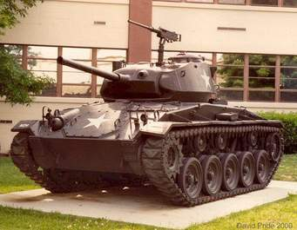](http://search.tb.ask.com/search/picdetails.jhtml?searchfor=M24+chaffee+tank+at+Chaffee+Hall&p2=%5eUX%5exdm245%5eS10474%5eus&n=77FD35DB&ss=sub&st=hp&ptb=14275B6D-2055-4F04-83BD-31968CB2539C&si=CD15543&tpr=sbt&ts=1414035196572&surl=http://search.tb.ask.com/search/AJimage.jhtml?searchfor=M24+chaffee+tank+at+Chaffee+Hall&p2=%5eUX%5exdm245%5eS10474%5eus&n=77FD35DB&ss=sub&st=hp&ptb=14275B6D-2055-4F04-83BD-31968CB2539C&si=CD15543&tpr=sbt&ts=1414035196572&&purl=http://www.davidpride.com/Army/us_ft_knox_05.htm&iurl=http://www.davidpride.com/Army/images/US_Ft_Knox_05.jpg&imagename=US_Ft_Knox_05.jpg&iw=590&ih=460&ord=17&)

M24 on display at the Home of Armor, Fort Knox Ky.