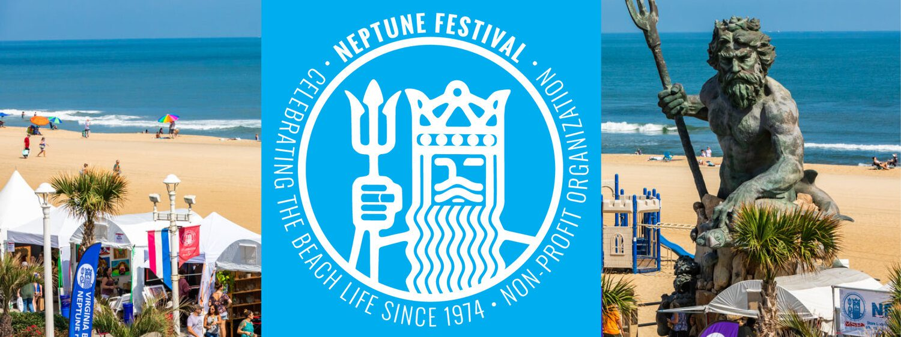

***Ocean City AARP Chapter 1917 presents***

***ANNUAL VIRGINIA BEACH NEPTUNE FESTIVAL*** *3 Days—2 Nights*

September 28-30, 2023

*Your package includes*:

* Deluxe roundtrip motor coach transportation //
* Two nights’ accommodations at *BEST WESTERN HOLIDAY SANDS, a* Chesapeake *Bay waterfront hotel that features two great breakfasts, outdoor pool and a sandy beach.*
* Evening visits to the ***VIRGINIA BEACH BOARDWALK’S NEPTUNE FESTIVAL*** *featuring unique art & crafts, live entertainment, elaborate sand sculpture and lots more*
* Dinner at ***STRIPER’S WATERSIDE RESTAURANT,*** Norfolk, VA
* A second delicious dinner at a local restaurant TBD
* A visit to the ***HAMPTON ROADS NAVAL MUSEUM, including a visit to the USS Wisconsin***
* A visit to ***THE NORFOLK BOTANICAL GARDENS,*** *with a tram ride tour and**free time to explore*
* Before leaving town, we’ll stop at the ***VIRGINIA BEACH FARMER’S MARKET.*** *You’ll find fresh local produce, meats and seafoods, baked items; floral, gift, craft, garden shops; even* ***live performances!***
* **All taxes and gratuities are included**

***This fun filled trip is available for:***

***$530.00 per person, double occupancy and $719.00 single occupancy***

*Refunds by replacement only/trip insurance available*

***For additional information: contact Fran Smith, 410-726-6166 or*** [***frans524@yahoo.com***](mailto:frans524@yahoo.com)

***--------------------------------------------------------------Detach and return--------------------------------------------------***

**Name(s): _____________________________________________________________________**

**Street Address: ________________________________________________________________**

**Home Phone: _________________ Cell:________________ Email:________________________**

**Payment: ( ) Cash:______________ Amount: $________________ Check #:________________**

**I/WE ACKNOWLEDGE THAT I HAVE BEEN OFFERED TRIP INSURANCE: ( )DECLINE ( )ACCEPT**

**I/WE ACKNOWLEDGE I HAVE READ THE TRAVEL-TRIP RULES AND AGREE TO ACCEPT THEM ( )**

**SIGNATURE: ___________________________________________ DATE:_________________**

**MAKE CHECKS PAYABLE TO: AARP 1917 TRAVEL MAIL TO: PO BOX 4193 OCEAN CITY, MD 21843**

*DISCLAIMER: These trips are a project of and are offered to the Ocean City, MD Chapter 1917 of AARP. The chapter and any agent it may use in arranging these or any other trips are not responsible in whole or in part to the traveling member for any loss, damage, or injury, whether financial or otherwise, to persons or properthowever caused during or in with these or any other trips. These trips are activities conducted by Ocean City, MD AARP 1917 and are in no way offered, sponsored or conducted by AARP, which has no responsibility with such trips.*