Texas History with Mr. Brown Name _______________________________ Period _____
Chapter 4 Native Texans
Picture Search p. 74 - 93
Directions: Use the pictures, maps, graphs, Info boxes, and their captions to find the following information.
1) “Do not speak of it no more”, Comanche Chief _________________________
2) What tribe made the painted elk hide on p.74?
3) In what year did Spaniards begin to explore Texas?
4) When did the Apaches tame horses?
5) Who did Herald Bugbee paint hunting buffalo?
6) From 6000 BC to AD 700 was the ________________ prehistoric period.
7) A clovis point spear tip is from the ______________ period.
8) Prehistoric Texans hunted giant mammals such as _________________ using spears tipped with stone.
9) Which period are the pictographs from Panther Cave estimated to be from?
10) What number was the Mayan number system based on?
11) By the year 1700 the West Texas climate had become:
12) What is this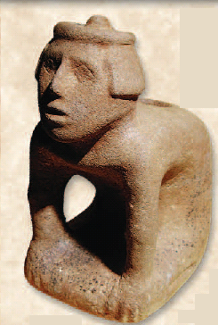?
13) How was a dugout canoe made?
14) What kind of bone was the gardening hoe made from?
15) What made it possible to grow crops in East Texas?
16) Who is the only woman a Texas county is named for?
17) Native Americans of the plains were extremely skilled at using the:
18) What are a large stone metate and a small mano used for?
19) What plant was used to treat cuts and snake bites?
20) Name two things done at a Powwow:

