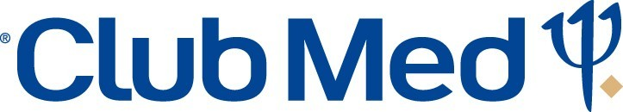

Cancun Oct 20-27, 2018
Credit Card Authorization Form
6505 Blue Lagoon Drive #225 Miami, FL, 33126
Attn: Accounting Department
Fax: 305-925-9266

IATAN: 10569403

Agency Name: USA Travel Network Transaction #: ________________

Group Name : XGO Friends & Family Agent Name : Steven Riely

Phone : 512-547-9254 Date:______________________

Club Med Group Coordinator: _________________

Agency Address: 2101 S Andrews Ave #201 Ft Lauderdale, FL 33316

I _______________________________________________ hereby authorize Club Med Sales to charge my
(Name of Cardholder)

________________ _______________-______________-_______________-_______________
(Credit Card Type) (Credit Card Number)

________/__________ ____________
(Exp. Date) (CCV 3 digit number/4 digit for AMEX)

in the amount of $________________ for vacation/air payment for myself and/or

_____________________________________________________________________________
(Full name(s) of guest(s) if other than the cardholder)

Traveling to our village Cancun on the date of Oct 20-27, 2018 (Village)

Credit Card Holders address______________________________________________________________________

_______________________________________ _____________________________
(Authorized signature) (Date)

******Cancellations must be made in writing and are subject to contract penalty fees***********
****Credit card forms are not kept on file and destroyed upon charging. A new form will be required for each payment****

Updated Jan 2016

