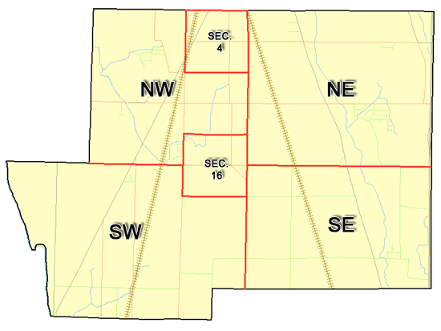 | Pleasant Township  Zoning Commission Minutes  1035 Owens Rd W.  Marion, Ohio 43302
Meeting called by: | Scheduled | Type of meeting: | Regular Monthly
Co-Chairperson: | Mr. Leib | Secretary: | Stephanie Barkley
Timekeeper: |  | Date: Aug 17th,2023 | Time 7:30 pm
Call to Order by: | Mr. Holler Moment of silence followed by the pledge to the flag.
Roll Call: | Jack Dean, Harry Holler, Tom Leib, Dwight Williams, Joe Thompson, Tyron Canterbury  Stephanie Barkley
Minutes: | Read and approve minutes from previous meeting.  Motion to approve minutes by: Mr. Thompson Seconded by Mr. Williams: All approved
Attendees Address Board: Have sign in sheet on desk by door.
Type in attendees and addresses: see attached.
.
----- Agenda Topics -----
Business
Zoning Reports: | Zoning Inspector goes over reports and provides copy to board.
Unfinished:
New:
Announcements: | Next meeting will be Sept 21st, 2023
Adjournment: | Motion to adjourn by: Mr. Dean and seconded by Mr. Williams all in favor all approved

Pleasant Township
Zoning Commission Minutes

1035 Owens Rd W.
Marion, Ohio 43302
Business Notes:

 | Discussion:
 | Conclusions:
 | Action items: |  | Minutes signed by: | Date approved:
 | Provide copy of approved minutes to Zoning |  | Chairperson:
 | Inspector. File original in township office. |  | Secretary:
Other Information
Trustees Present: |  | Mr. Creasap
Zoning Inspector:
Special Guests:

Minutes
The Pleasant Township Zoning Commission met for their regularly scheduled monthly meeting Aug 17th, 2023, at the Pleasant Township Senior Centre Zoning Commission Board Members were present: Mr. Dean, Mr. Leib, Mr. Thompson, Mr. Williams, and Secretary Miss Barkley and trustee Mr. Creasap. Absent Mr. Holler Mr. Canterbury and Mr. Baker
- Minutes were read from the July 20th, 2023 regularly scheduled Zoning Commission meeting. There were no corrections to be made. A motion to approve the minutes was made by Mr. Thompson and second by Mr. Williams motion carried.
- Mr. Tom Baker Pleasant Township Zoning Inspector was unable to be present he sent the Zoning report were 8 permits for July. Mr. Creasap gave a report there was 2 appeals on 8/16 that was approved. Mr. Chuck Hall from the prosecutor’s office attended the trustees meeting on the 8/22/23 and stated that there will be no filing is the prosecutor’s office on properties through the township it needs to through Mr. Mark Russell through the court system, nothing is a guarantee if they will do anything. Mr. Hall also shared that the charges against Troy Leffler was dismissed, but the State of Ohio is still involved.

4. There being no additional business for discussion Mr. Dean made motion to adjourn, seconded by Mr. Williams all members in attendance agreed and the meeting was adjourned. The next Board Meeting will be held on Sept 21st,2023 at 7:30 PM.

