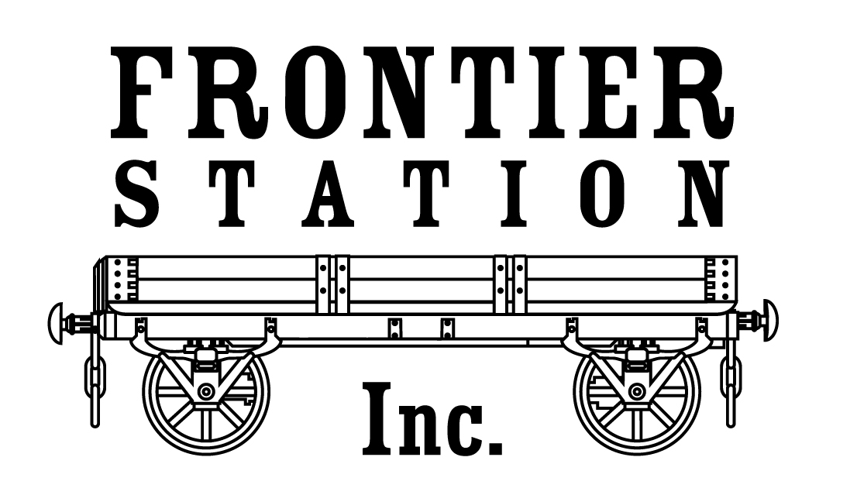
P.O. Box 1515 Phone: 970-824-8200
277 S. Ranney St. Fax: 970-824-5139
Craig, CO 81626 E-mail: mail@frontierstation.biz
_______________________________________________________________________________________________________________

Seed Mixes

Frontier Station Plains Dryland Mix
Intermediate Wheatgrass 20%
Pubescent Wheatgrass 20%
Common Crested Wheatgrass 20%
Slender Wheatgrass 20%
Perennial Rye 20%

Frontier Station Premium Dryland Mix
Manchar Smooth Brome 20%
Regar Meadow Brome 20%
Pubescent Wheatgrass 20%
Slender Wheatgrass 20%
Perennial Rye 20%

Frontier Station Premium Pasture Mix
Manchar Smooth Brome 20%
Regar Meadow Brome 20%
Paiute Orchard 20%
Tall Fescue 20%
Perennial Rye 20%

Frontier Station Irrigated Meadow Mix
Manchar Smooth Brome 30%
Potomac Orchard 25%
Tall Fescue 25%
Timothy 10%
Perennial Rye 10%

