GFWC BWC NEWS

CHRISTMAS SOCIAL

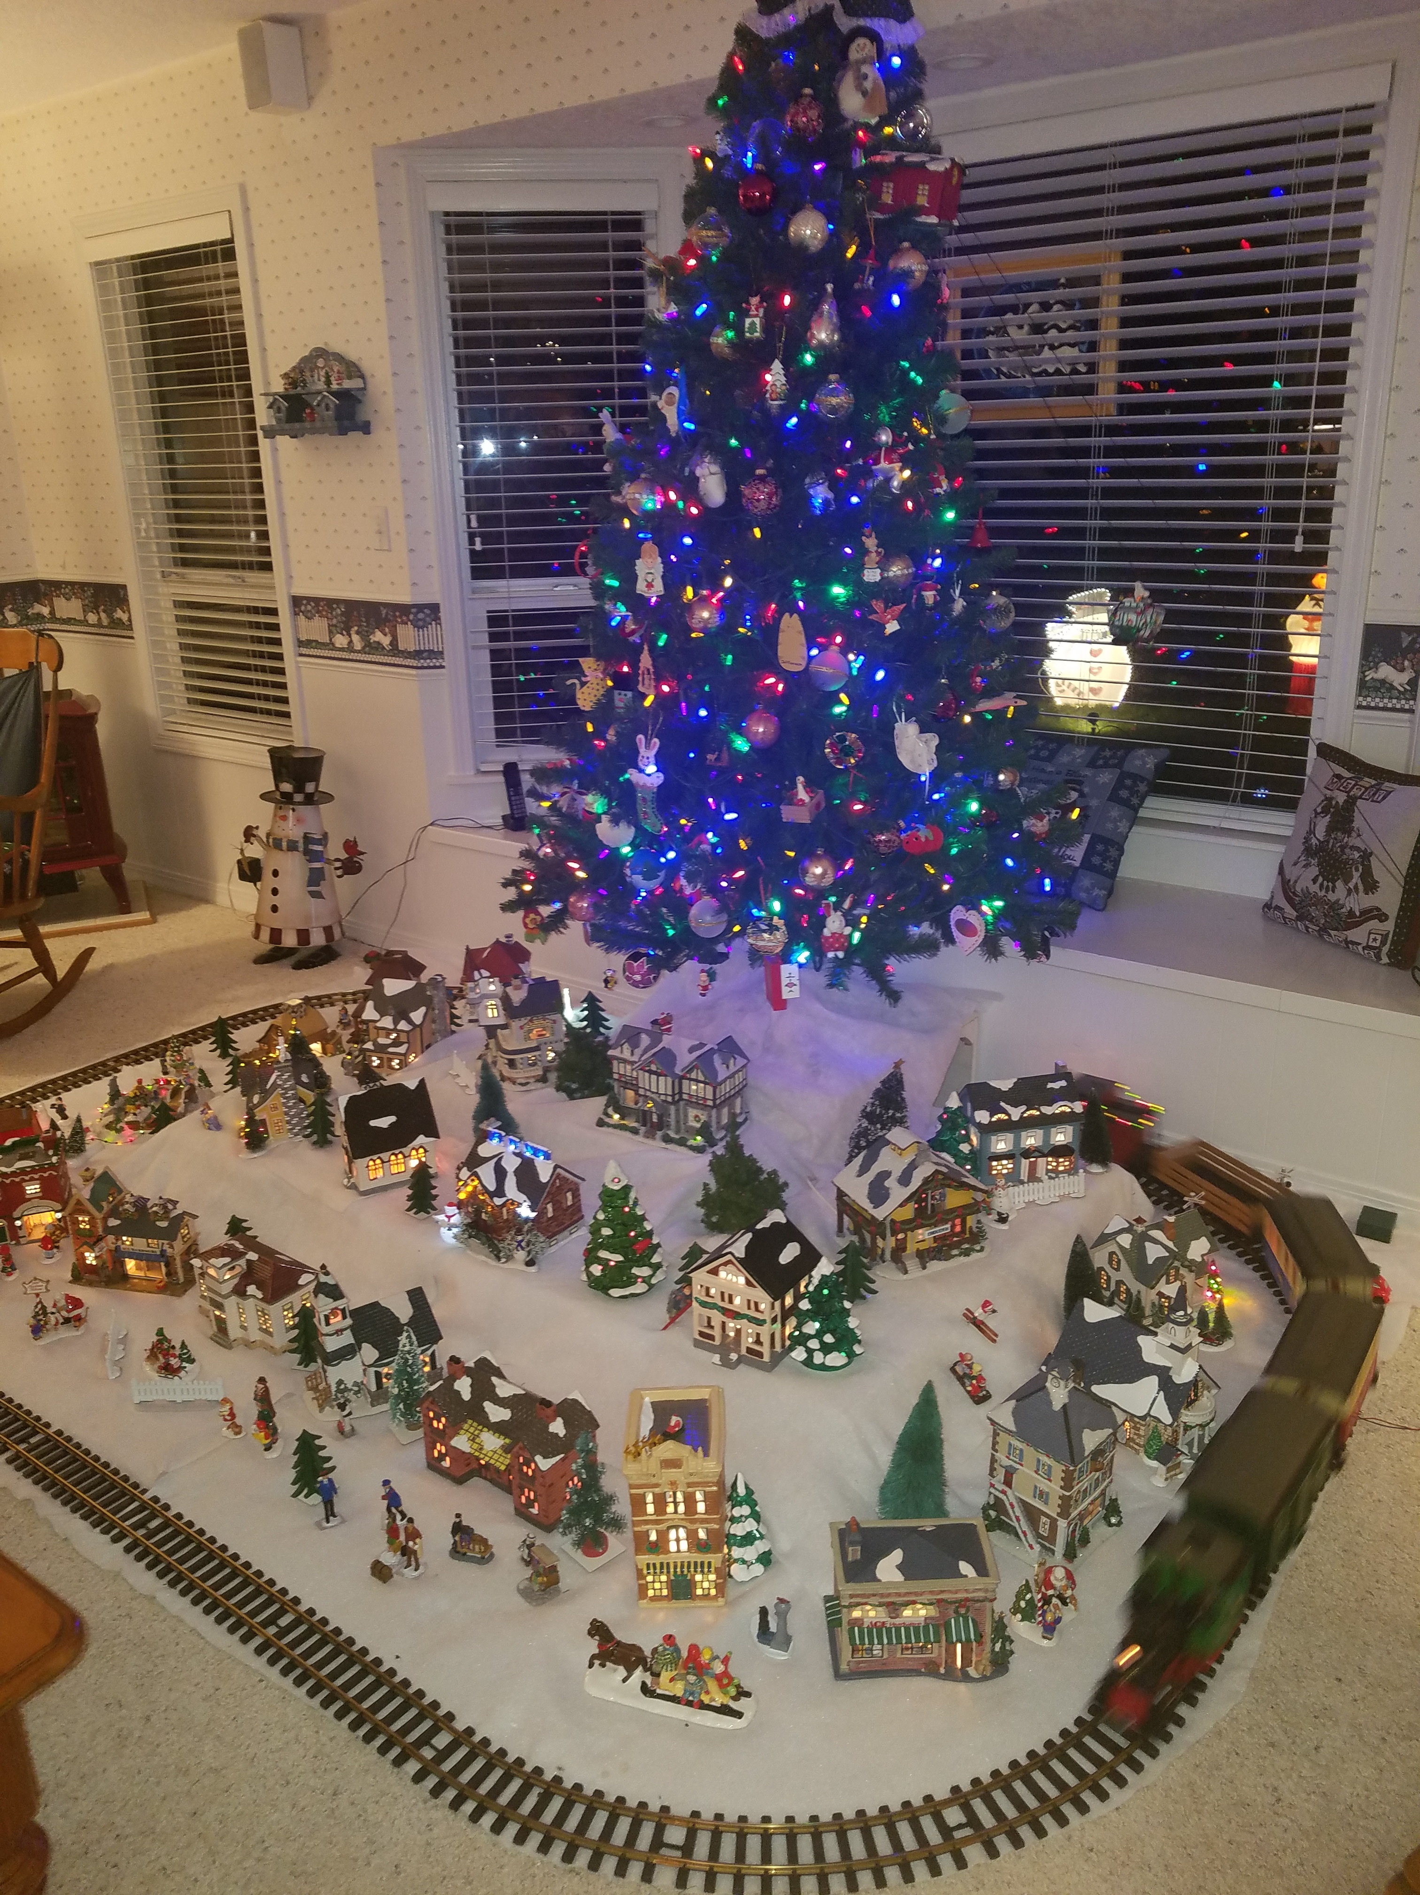

|  |  |  |  |
| --- | --- | --- | --- |
| A person standing in a room  Description automatically generated Two people in a red shirt  Description automatically generated Glenda receives a 40 year member pin. | Above: Members show off the blankets we made for Project Linus.  Left: Vicki initited as one of our new members.  Above: Sue Pike hosted at her house. She decorated with Christmas items EVERYWHERE!!    **A picture containing indoor, table, sitting  Description automatically generated** A picture containing ground, red  Description automatically generated  Items were donated to the women at a Domestic  Woman’s Shelter. Stockings were filled all of these fun items.  Check out our WEBSITE  <http://www.beavertonwomansclub.com/> |  |  |