June 5, 2016
Via Electronic Filing
Ms. Kimberly D. Bose, Secretary
Federal Energy Regulatory Commission
888 First Street, N.E.
Washington, D.C. 20426
Re: FERC Project No. P14425-000
Scott's Mill Hydropower Project,
Liberty University, Inc.
Seventh Six-Month Preliminary Permit Progress Report
Dear Ms. Bose:
On December 6, 2012, the Federal Energy Regulatory Commission (Commission) issued a Preliminary Permit to Liberty University, Inc. ("Liberty") regarding the Scott's Mill Hydropower Project No. 14425 ("Project"). Pursuant to Article 4 of the Preliminary Permit, Liberty University, Inc. hereby submits its seventh, six-month progress report. During the seventh, six-month period of the Preliminary Permit, Liberty and Luminaire Technologies have:
- Conducted the Joint meeting on December 2, 2015
- Continued to consult with state and federal resource agencies and other interested parties on the study plan.
- Prepared and distributed draft study plans
- Met with Virginia Department of Environmental Quality on April 19, 2016 to discuss the study plans and Virginia Water Protection permit application
- Revised the draft study plans based upon comments by state and federal agencies
- Continued engineering studies with Natel Energy
- Commenced implementation of the study plans
Over the next six months, Liberty intends to:

- Complete the study plan

- Prepare a draft license application

- Continue the engineering studies
- Continue researching potential grants that would offset the cost of installing next generation turbines and apply for said grants as appropriate.
- Continue research on innovative turbine design.
Please contact the undersigned at (916) 719-7022 if you have any questions or comments regarding this progress report.
.

Respectfully submitted,

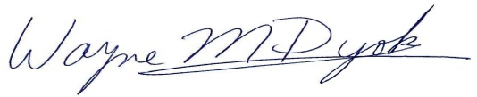
Wayne M. Dyok for
LIBERTY UNIVERSITY, INC.

