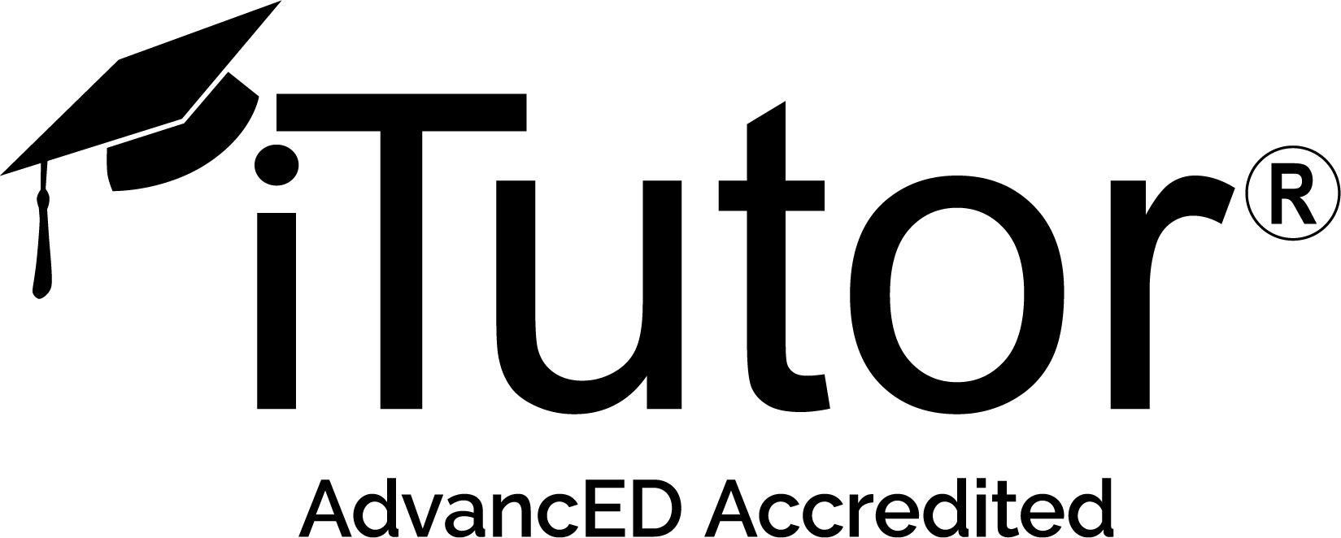
Educator Digital Curriculum Resources
Science
OER Commons  (https://www.oercommons.org/oer) | OER Commons is a freely accessible online library that allows teachers and others to search and discover open educational resources (OER) and other freely available instructional materials.
PHET Interactive Simulations  (Also found through Nearpod)  (https://phet.colorado.edu/) | Founded in 2002 by Nobel Laureate Carl Wieman, the PhET Interactive Simulations project at the University of Colorado Boulder creates free interactive math and science simulations. PhET sims are based on extensive education research and engage students through an intuitive, game-like environment where students learn through exploration and discovery.
CK-12 Chemistry Simulations  (https://interactives.ck12.org/simulations/chemistry.html) | Nearly two dozen simulations cover topics like average atomic mass, solubility with rock candy, and freezing point depression with salting icy roads.
BioInteractive  (https://www.biointeractive.org/classroom-resources?search=&f%5B0%5D=resource_type%3A17) | The virtual labs are fully interactive simulations in which students perform experiments, collect data, and answer questions to assess their understanding. The labs combine animations, illustrations, and videos to convey key information and engage students in the process of science.
Pivot Interactions  (https://www.pivotinteractives.com/) | Show your students the world of science outside the classroom. With Pivot Interactives, your students can perform authentic science investigation using libraries of high-resolution video and classroom-ready, interactive lessons they can access 24/7 from any web-connected device.
Gizmos  (https://www.explorelearning.com/) | Gizmos are interactive math and science simulations for grades 3-12. Over 400 Gizmos aligned to the latest standards help educators bring powerful new learning experiences to the classroom.
Virtual Labs (MERLOT)  (http://teachingcommons.cdl.edu/virtuallabs/) | Science faculty throughout the world are adopting virtual labs to engage students in learning through active participation rather than passive observation. Technological advances, combined with bandwidth maturity and mobile access make virtual labs an increasingly viable part of teaching and learning.  We invite you through this site to learn about current and innovative virtual labs technologies, lab experiments, and simulations used in teaching the science, technology, engineering, and math disciplines in higher education.
Titration Screen Experiment  (https://edu.rsc.org/resources/titration-screen-experiment/2077.article) | Get students ready for a hands-on titration by allowing them to run one virtually first.
goREACT Virtual Chemistry Lab  (https://www.msichicago.org/experiment/games/goreact/) | This drag-and-drop lab environment from Chicago’s Museum of Science and Industry lets you experiment with different reactions.
Oersted’s Compass  (https://nationalmaglab.org/education/magnet-academy/watch-play/interactive/orsted-s-compass) | Interactive Oersted’s Compass.

