**D R A F T**

EYEMED

Work Packages **WORK PACKAGE 1 (WP1)**

**PROJECT MANAGEMENT AND COORDINATION**

WP1 Project Management and Coordination

WP2 Communication / Dissemination

WP3 Content

WP4 EU Pilots

WP5 MENA Pilots

WP6 Evaluation / Exploitation

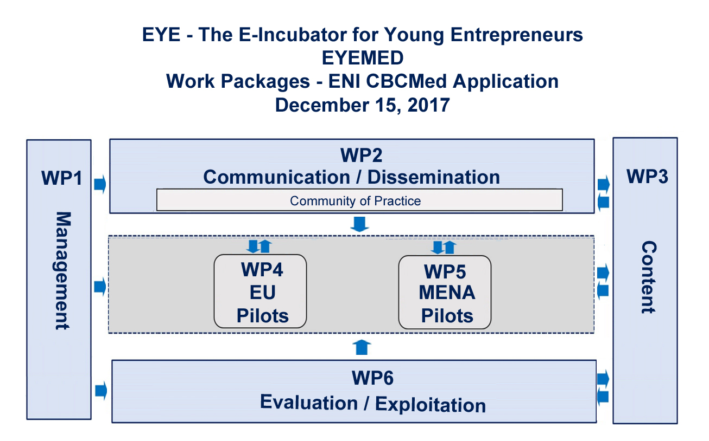

WP1 Partners:

WP Manager: BEN - Qualifica/Escola de Comercio

Partner PP1 - Global Skills Network – GSN / EU Pilots

Partner PP4 – Jordan University of Science & Technology - JUST / MENA Pilots

WP1 - Project Management and Coordination

**Objectives:** Adequatelycoordinate and organisethe project at strategic level, and to safeguard a smooth and target-oriented implementation in line with the time and budgetary restrictions, ensuring:

* Project follow-up (project progress control and planning)
* High level commitment with in depth demonstration interactions
* Content for Project Director’s continuous update of project status to the European Commission
* Decision-making consensus
* Suitable project administration, fiscal control and reporting

Accordingly, WP1 interacts with all other WPs and is the interface between the project and the EC.

**Roles and Responsibilities:** The Project Office will receive project funding from the European Commission and will manage finances and the reimbursement of costs to the EYEMED Partners in a timely manner and maintain the necessary records. The Project Office will assign a Project Director (Antonio Jorge) who will be responsible for the internal consortium management and coordination, for the administrative, contractual and financial aspects of the project, and be the sole interaction point with the European Commission. In addition, the responsibilities of the PD include monitoring the progress, scheduling and organisation of project meetings and reviews.

The Steering Committee is also responsible for approving major changes in project plans, including changing partners' budgets as may be required to realize project plans and objectives, including terminating and/or adding partners. The consortium agreement(s) will specify the conditions by which responsibility and corresponding EU funding will be reassigned to another partner(s) in case of persistent failure to meet delivery schedules. All the details of the decision mechanism will be considered in a Consortium Agreement that will be prepared and signed before the project starting date.

**Activities:**

The Project Director is Antonio Jorge, Qualifica/Escola de Comercio. He will provide a draft consortium agreement and complete documentation required for the submission of EYEMED’s application to the ENI CBCMed call. The Project’s Administrator is Sandra Lund-Diaz, Global Skills Network. She will establish procedures to facilitate activity reporting by Partners. facilitate progress through day-to-day contact with all consortium Partners and work package leaders whenever needed, by means of e-mail distribution lists, the EYEMED worksite (http://www.erasmusactions.org/eyemed.html), as well as email, video and telephone conferences via Skype, and by convening sessions in the Community of Practice on the iPortal. She will also initiate and secure the consortium agreements from all partners as well as other documentation required (i.e. financial capacity, administration cost budgets, etc.)

Other activities include:

⏺ Convene the Steering Committee, constituted by one representative of the identified partners (Qualifica, Global Skills Network and JUST) and chaired by the Project Director to act on the following:

- Taking responsibilities for the total content and quality of the Project;

- Taking final decisions in case of conflict or defaulting partners;

- Deciding on whether milestones and deliverables (including planning)

are reached;

- Adjusting planning, priorities or project course, whenever appropriate and

necessary in consultation with the European Commission project officer.

- Holding evaluation meetings in order to discuss the progress and quality of

the project;

- Taking decisions on the implementation/exploitation of the project results;

- Attention to coordination meetings with other relevant projects as required

⏺ Produce the workplan, monitor it and maintain it throughout the life-cycle of the project; Coordinate all of the work packages’ activities of and to orchestrate all these activities throughout all of the phases of the project making sure that the work package teams reach their specific goals and responsibilities across the overall project.

⏺ Financial Management objectives include the effective financial control and distribution of project budget among partners. The Steering Committee will be held accountable for the process, while the Project Director and Project Office will be held responsible.

- Inputs: agreements/budget plans

- Outputs: distribution of budget through timely payments, financial reporting

including reporting on the use of budgets/resources (input for reporting).

⏺ A Quality Assurance Plan will be designed for management of problems reported by project partners or identified by the Steering Committee.

- Inputs: reports, trouble/problem notifications

- Outputs: effective reaction, countermeasures to remove problems and avoid their recurrence, records on the handling of problems.

⏺ Develop Problem/Trouble handling Policies

- All problems shall be reported and recorded to be classified, analyzed, prioritized and, if necessary, escalated in an effective and appropriate manner;

- The impact of problems shall be minimized through adequate measures;

- Preventive action shall be taken to reduce potential problems;

- Changes or improvements to the project required to correct the underlying cause of problems shall be initiated by the Project Director.

- Problem resolution shall be monitored, reviewed and reported on for effectiveness.

⏺ Project Reporting will adhere to policies established for internal and external reporting. Every work package will be assigned a leader who will report to the coordinator of area pilots (EU area and MENA area). Reporting will be required for both internal project adherence as well as for reporting to the European Commission.

- Inputs: Reporting requirements from Agreements

- Outputs: Timely delivery of all reports with the agreed contents. Interim, periodic and final reports will be compiled by the Project Director based on input from the work package leaders, who will be required to provide monthly reports during the time a work package is operational.

- Accountability: Steering Committee

- Responsibility: Project Director for official reports; consortium partners for work package reporting.

⏺ Risk Management: - Elaborate a Risk Management plan that foresees risks, estimates the impacts, and creates response plans to mitigate them.

⏺ Communication, Dissemination: The Steering Committee will oversee WP2 work package and monitor its activities throughout the course of the project.

⏺ Project Evaluation / Exploitation: The Steering Committee will work with PP6 ISG for evaluation and exploitation outcomes. Monitoring and evaluation must align with the Result Based Management approach (RBM) articulated by the ENI CBC MED document, “INDICATIVE MONITORING AND EVALUATION PLAN”, Annex 2. OECD’s Framework for Addressing and Measuring Entrepreneurship guide could be useful in establishing parameters to measure the success of the project that includes the LOGIC model, quasi-experimental designs, descriptive research to produce useful assessment data, and other instruments recommended by ISG.

- Monitor and evaluate the progress of the project with respect to the defined objectives;

- Project Director will maintain contact with the European Commission and manage the reporting for administrative and financial aspects of the project that will contribute to the overall project evaluation;

- Make provision for the future success of EYEMED by demonstrating the real value of the service to stakeholders and decision-makers, and thus underpin future funding and ensure effective dissemination of any relevant information generated by the project.

⏺ **Sustainability:** Promoting the coursework and training for sale to other areas where entrepreneurship can alleviate the problems associated with unemployment or to those areas/target populations ripe for the growth of an entrepreneurial culture will sustain operations beyond the project term, providing the opportunity for replication of the model. Sustainability assessment includes:

- Design an appropriate business model for the long-term self-sustainability of EYE – The E-Incubator for Young Entrepreneurs as a service that is economically viable, which can be delivered in a repeatable manner, and benefits to a wide range of stakeholders;

- Perform a cost benefit analysis and build an economic model for EYE – The E-Incubator for Young Entrepreneurs;

- Identify market development activities necessary to bring the EYE – The E-Incubator for Young Entrepreneurs as a tested blue print to a fully functional, operational and sustainable service.