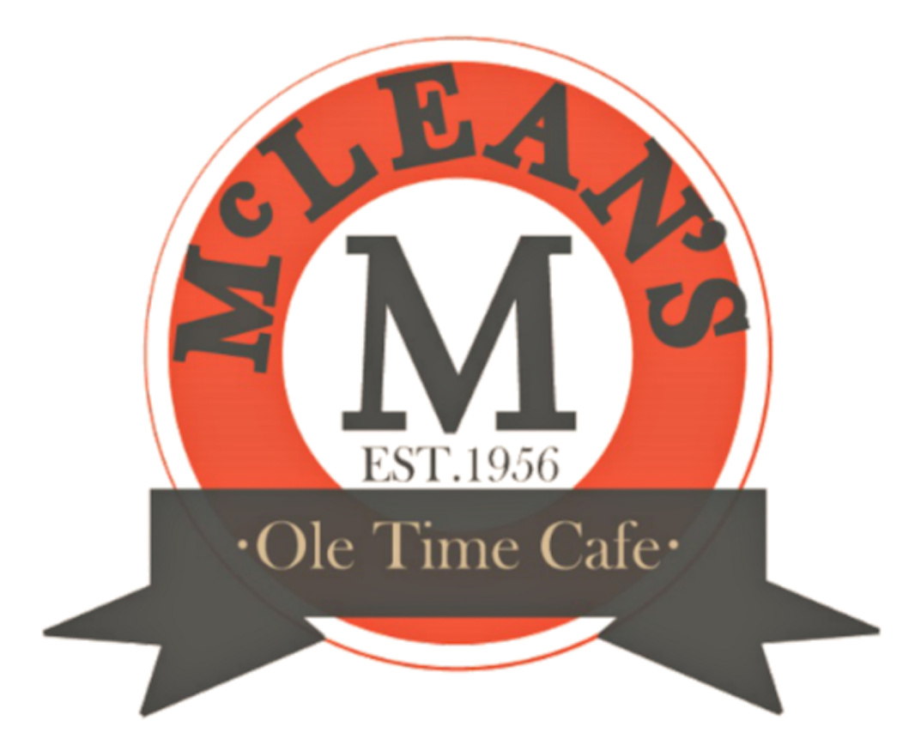

MCLEAN’S PARTY TRAYS
919-269-0125

FRUIT TRAY Served with a sweet Fruit Dip
: SMALL 15PPL $40.00
: MEDIUM 30PPL $75.00
: LARGE 50PPL $120.00

VEGETABLE TRAY Served with Ranch Dressing
: SMALL 15PPL $40.00
: MEDIUM 30PPL $75.00
: LARGE 50PPL $120.00

CHICKEN TENDERS Large Chicken Tenders battered and fried to a crisp. Served with your choice of sauce
: SMALL 15PPL $48.90
: MEDIUM 30PPL $97.50
: LARGE 50PPL $163.00

MIXED CHEESE AND CRACKERS Cheddar, Swiss and Pepper Jack cubes
served with Club Crackers
: SMALL 15PPL $55.00
: MEDIUM 30PPL $109.00
: LARGE 50PPL $180.00

BBQ MEATBALLS Our only tray served in an aluminum pan to retain heat and sauce. Our homemade Honey BBQ Sauce is both sweet and tangy
: SMALL 15PPL $29.00
: MEDIUM 30PPL $59.00
: LARGE 50PPL $93.00

HolidayPartyTrays2023
MCLEAN’S PARTY TRAYS
919-269-0125

MINI HAM & TURKEY SANDWICHES Thinly sliced Ham & Turkey served w/rolls
: SMALL 15PPL $65.00
: MEDIUM 30PPL $129.00
: LARGE 50PPL $210.00

**Add lettuce, tomato, mayo and American cheese for $15.00 more per tray

HAM AND TURKEY ROLLS (NO BREAD) Ham and turkey served rolled
up and placed decoratively on a round platter
:SMALL 15PPL $49.00
:MEDIUM 30PPL $95.00
:LARGE 50PPL $155.00

PAW PAWS FAMOUS MINI COUNTRY HAM BISCUITS Mouth-watering mini butter biscuits stuffed with country ham

:SMALL 15PPL $49.95
:MEDIUM 30PPL $99.00
:LARGE 50PPL $149.00

COOKIE TRAY Choice of chocolate chip, sugar, peanut butter, or oatmeal raisin cookies assorted on a round tray

:1 DOZEN $18.00
:2 DOZEN $36.00
:3 DOZEN $54.00
HolidayPartyTrays2023

