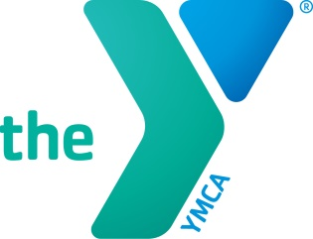

Virtual Training Guide:
BPSM Program Managers

As you hire new candidates for the Healthy Heart Ambassador role, consider the following before recommending a candidate for a virtual training:
- Does the candidate have previous experience delivering virtual programs?
- Are the candidate’s facilitation skills strong enough to facilitate virtually?

Please prepare your candidate with the following:
- Do they have the capacity to participate in a virtual training?
  - Time (training may be conducted over 1 or 2 days depending on availability of trainer and trainees)
  - Technology

- Distribute all necessary training materials to the candidate prior to their virtual training
  - Blood pressure cuff
  - Printed Training materials
  - Space
  - Chair
  - Table

