**Bio 175 Lab 2: Microscopes**

# **Objectives:**

1. Review the principles of light microscopy and identify the major parts of the microscope.

2. Learn how to use the microscope to view slides of several different cell types, including the use of the oil immersion lens to view bacterial cells.

3. Learn about the shapes and arrangements of some common types of bacteria.

# **Introduction**

The first microscope was developed in 1590 by Dutch lens grinders Hans and Zacharias Jansen. In 1667, Robert Hooke described the microscopic appearance of cork and used the term cell to describe the compartments he observed. Anton van Leeuwenhoek was the first person to observe living cells under the microscope in 1675—he described many types of cells, including bacteria. Since then more sophisticated and powerful scopes have been developed that allow for higher magnification and clearer images.

Microscopy is used by scientists and health care professionals for many purposes, including diagnosis of infectious diseases, identification of microorganisms (microscopic organisms) in environmental samples (including food and water), and determination of the effect of pathogenic (disease-causing) microbes on human cells. This exercise will familiarize you with the microscopes we will be using to look at various types of microorganisms throughout the semester.

## **The Light Microscope**

What does it mean to be microscopic? Objects are said to be **microscopic** when they are too small to be seen with the unaided eye—they need to be magnified (enlarged) for the human eye to be able to see them. This includes human cells and many other types of cells that you will be studying in this class.

The microscope you will be using uses visible light and two sets of lenses to produce a magnified image. The total magnification will depend on which objective lens you are using—the highest magnification possible on these microscopes is 1000X—meaning that objects appear 1000X larger than they actually are.

**Resolution vs. magnification:**   
**Magnification** refers to the process of making an object appear larger than it is.  
**Resolution** is the ability to see objects clearly enough to tell two distinct objects apart. Although it is possible to magnify above 1000X, a higher magnification would result in a blurry image. (Think about magnifying a digital photograph beyond the point where you can see the image clearly). This is due to the limitations of visible light (details that are smaller than the wavelength of light used cannot be resolved). The **limit of resolution** of the human eye is about 0.1 mm, or 100 microns. Objects that are smaller than this cannot be seen clearly without magnification. Since most cells are much smaller than 100 microns, we need to use microscopes to see them. The limit of resolution of the light microscope you will be using today is about 0.1 m, or 100 nm. This means that we can view objects that are 1000X smaller than what we can see with our eyes alone. Biologists typically use microscopes to view all types of cells, including plant cells, animal cells, protozoa, algae, fungi and bacteria. The nucleus and chloroplasts of eukaryotic cells can also be seen—however smaller organelles and viruses are beyond the limit of resolution of the light microscope

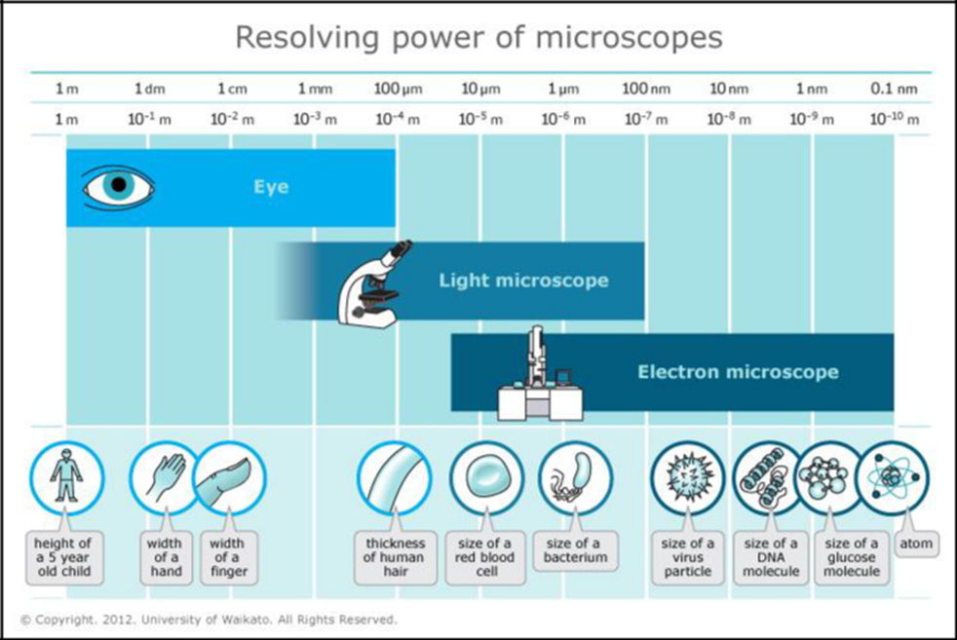

## **Basic Rules for Using the Microscope**

1. Always carry the microscope with two hands.

2. Clean the lenses with lens cleaner (Windex) and lens tissue before and after use.

3. Report any problems with the microscope to your instructor immediately.

4.Oil must be cleaned off completely before returning the microscope to the cabinet. If you accidentally get oil on the 40X objective, clean it immediately. Microscopes must always be returned to the cabinet clean.

5. Microscopes should always be put away with a low power objective (4X) over the stage.

6. Always lift the microscope to reposition it—do not drag it across the surface of the table!

# **Activity One- Identifying Objective Lenses and Calculating Total Magnification Total Magnification**: The microscope you are using has two sets of lenses that both contribute to the total magnification of the image. The ocular lenses magnify your image 10X. There are 4 different objective lenses—each with a different magnification. The total magnification is calculated as follows:

**Total magnification= ocular magnification x objective magnification**

Since the ocular magnification of our microscope is 10X, determining the total magnification of an object with this microscope simply requires multiplying the objective magnification by 10. (Note: other microscopes may have ocular lenses with a different magnification, for example 12X.)  
**Please determine the total magnifications of your compound scope.   
  
Activity Two- Learning to Use a Microscope**1. Position the scanning power objective (4X) face down.  
2. Move the stage all of the way down using the course adjuster knob.   
3. Place your slide on the stage and make sure that it is level and held firmly in place with the slide holder. Your sample  
 should be facing upwards (you can see the slide identification label).  
4. Use the knobs located below the stage to move the slide left and right, and up and down until the stained area of the   
 slide is centered over the light source.  
5. Use the course adjustment knob to bring the stage up as you look through the ocular lenses until the specimen comes   
 into view.  
When using the scanning or low power objectives the **working distance** (the distance between the lens and the slide) is large enough so that the slide will never make contact with the lens. This is not the case when using the high-dry and oil immersion lenses, where the working distance is significantly less.   
 ***This is why the coarse adjustment knob can only be used with the two low-power lenses.***6. Rotate the fine adjustment knob until the image comes into clear focus. After viewing the slide at scanning power,   
 move the slide so that the area you want to focus on is in the **center** of the field of view. Since your scope  
 is **parcentric**, when you increase magnification you will be zooming in at the center of the field of view. Objects that   
 are not centered at low power may be out of the field of view at high power.  
You will not be able to make out much detail at this power—the purpose is to find where your specimen is on the slide so that it is easier to locate when you switch to high power. Low power objectives have a large **field of view** (the circular area seen when looking through the microscope) and a **large depth of field** (the thickness of a specimen that is in sharp focus). As magnification increases, both the field of view and depth of field decrease, which is why it is easier to locate your specimen using a low power objective.  
7. Rotate the objective lens nosepiece so that the 10X objective is in place over the slide.   
 Re-focus and adjust the light (if needed) under the 10X objective.  
The microscope you are using is **parfocal**—this means that when it is in focus with one lens in place the same stage position will be in focus with all other lenses. ***Therefore when switching objectives,   
 DO NOT use the course adjuster knob to change the position of the stage  
 just click the objective you wish to use into place.***

8.After focusing at 10X, rotate the objective lens nosepiece so that the 40X objective is positioned over the slide. Re-focus using the fine adjustment knob and adjust the light if needed.

Note: ***Remember that you CANNOT use the coarse adjustment knob at high power (40X or 100X objectives).*** When you are using the high-power lenses the lens is very close to the slide (small working distance) therefore using the coarse adjustment knob at high power could result in damage to the lens, damage to the slide, or both.

**Practice using your microscope by choosing 2 different slides from the slide box and following the steps outlined above.**

# **Activity Three- Oil Immersion**

1.Obtain a bacterial types slide from the slide box and place it on your microscope. Since bacterial cells are very small, you will need to use the highest magnification (100X objective, or 1000X total magnification) to see them clearly—however, as with all slides, you should use a low-power objective lens to focus on the slide before moving to high power.

There are three areas of bacteria on the slide. The area closest to the slide label is the darkest and therefore the easiest to find: the area on the rightmost side of the slide is very faint and you may not be able to detect any stain with your eyes. Placing the slide on a white piece of paper can help you to see the area where the stained bacteria is located.

2.Focus with a low-power objective on the first area of the slide. The cells will still be very small at this magnification and you will not see any detail.

3. Once in focus, switch the objectives to 10X and then to 40X. Adjust light and focus as needed.

4. You are now ready to use the oil immersion lens. This lens requires the use of immersion oil, which has the same index of refraction as glass, to prevent light from scattering and focus it on your specimen (we need a lot of light to see clearly at this high magnification). **Immersion oil MUST be used with the 100X lens.**

5. Rotate the nosepiece so that there is no objective over the stage. Add 1-2 drops of immersion oil to the slide right above where your sample is.

6.Click the 100X objective into place. If done correctly, you should only need to fine focus a little bit to bring the cells into view. **Remember to NEVER use the coarse adjustment knob when focusing under 40X or 100X objectives.  
 Once there is oil on the slide you CANNOT use the 40X lens.  
 Make sure your specimen is in focus BEFORE you put oil on the slide.**

8. When you are finished, move the slide to the right to find the second area of cells (middle of the slide), and then to the third area of cells (right side of the slide).

9. When you are finished, **clean all oil off of the slide** and return it to the slide box.

## **Activity Four - Wet Mount Slides** 1. Prepare a wet mount slide of your cheek cells following my demo. **Preparation of a wet mount**

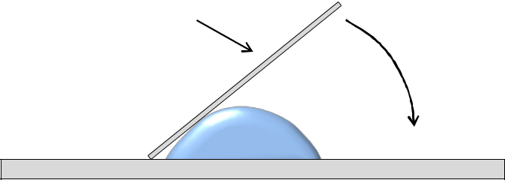

Coverslip

Lower slowly

2. Observe these slides under the microscope at 4x, 10x and 40x.  
  
  
**Activity Five- Live Organisms**  
  
1. Live protozoa: use a dropper to place 1-2 drops of a pond water sample onto a clean microscope slide. Take a cover slip and place it down over the water as shown in the diagram below (try to avoid air bubbles). OPbserve under 4x, 10x, 40x.  
  
2. Preparation of a live yeast culture: place one drop of the yeast (*Saccharomyces*) suspension and one drop of methylene blue onto a clean microscope slide, and prepare a wet mount as shown.