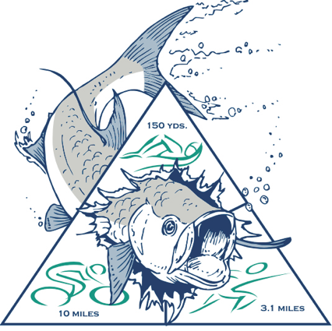
TWELFTH ANNUAL
August 1, 2020 – BAYOU BLACK, LA
All proceeds benefit the Bayou Black Swim Team
www.tarpontri.net

Race Start Time: 7:30 a.m.
Race Day check-In: 6:00 – 7:10 a.m.
*Mandatory meeting 7:15 a.m.

Where: Bayou Black Gym & Pool
3688 Southdown Mandalay Rd
Houma, LA 70360

Sprint Triathlon:
150 meter pool swim (staggered start)
10 mile bike (Helmet required)
3 mile run
(Race limited to 250 participants)

Age Groups Male/Female
- 14&U, Then in 5 year increments to 60+
- Youth Relay - average age of all participants is 18 or younger
- Adult Relay - average age of all participants is 19 and older

Awards
1st Overall Male / Female
1st, 2nd, 3rd in each age group
1st, 2nd, 3 rd youth & adult relays
** There is no fat tire division in this race
** There is no Athena or Clydesdale division

Entry Fees: Individuals / Relays
Received by July. 6th $45* / $90*
July 7th – July 29th $55* / $110*
July 30th – August 1st $75* / $150*
*plus additional USAT fees if not a USAT member
- Shirts & packet items are not guaranteed for registrations after July 6th.
- No Refunds.

Register online at:
www.legacy.imathlete.com/events/tarpontri2020

Or

Mail Registration with check payable to:
TPRD # 9
c/o Michelle Matta
3688 Southdown Mandalay Dr.
Houma, LA 70360

Packet Pick Up:
Bayou Black Rec Center Pool House.
Friday, 7/31/20, time TBA
Race Day 5:45 – 7:10 a.m. at race site

Awards, food, drinks and music after the race!

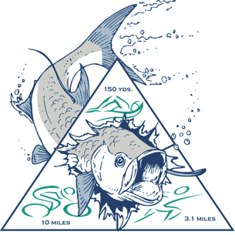
TWELFTH ANNUAL

August 1, 2020 – BAYOU BLACK, LA

www.tarpontri.net

Participant Name: ________________________________________ Phone:____________________________

Address: ___________________________________________________________________________________
Street

_____________________________________________ _______ _____________________________
city state zip code

Email:__________________________________________________________________

Emergency contact name & Number ____________________________________________________________

Any known medical conditions:________________________________________________________________
___________________________________________________________________________________________

Estimated 150 meter swim time: ____________ Gender: ___M ___F Birthdate: _________

USAT number:_________________________ (if not a USAT member, a one day membership will need to be purchased through the race director to participate in this race. ) A form will be provided to you to be filled out and sent back to the race director. A one day membership is $15 for an adult. A youth membership (17&under) is $10 & only available as an annual membership.

Shirt size: YS YM YL S M L XL XXL
Do you want a female fit shirt (Not available in youth sizes): Yes No

Participant type: ( Circle one) : Individual Relay ( If a relay, list other team member names & event):

______________________________________________________

_______________________________________________________

Relay team name: ____________________________________________________________

MUST SIGN LIABILITY WAIVER ON NEXT PAGE & SUBMIT WITH APPLICATION!!

Liability Waiver

*** Please note, each relay team member must fill out and sign a form to participate!!

Liability Waiver must be signed by all participants before submitting.
In consideration of my accepting this entry, I, the undersigned, intending to be legally bound for myself, my heirs, executors, waive and release any and all rights and claims for damages I may have against Bayou Runners Association, the city of Houma, Terrebonne Parish Consolidated Government, TPRD #9, Bayou Black Swim Team, USAT, and all sponsors, their representatives and successors from all claims or liabilities of any kind with my participation in this event. I attest and verify that I am physically fit and sufficiently trained for the competition of this event. Further, I hereby grant full permission to any and all foregoing to use photographs, videotapes, motion pictures, records or any other record of this event for any purpose whatsoever. I also acknowledge that this race has a no refund policy.

Participant name (please Print) _______________________________________________________________

Signature _____________________________________________________________ Date_____________________________
(Parent or guardian signature if under 18 years old)

