Golf Registration
1.Click “HERE” on the Tempaco Charity Golf Classic page on our website.
2.From there you can pick the number of golfers you are paying for; as well as purchase 50/50 Raffle Tickets additional Grand Prize Tickets (You will receive one entry into the grand prize drawing with your registration)
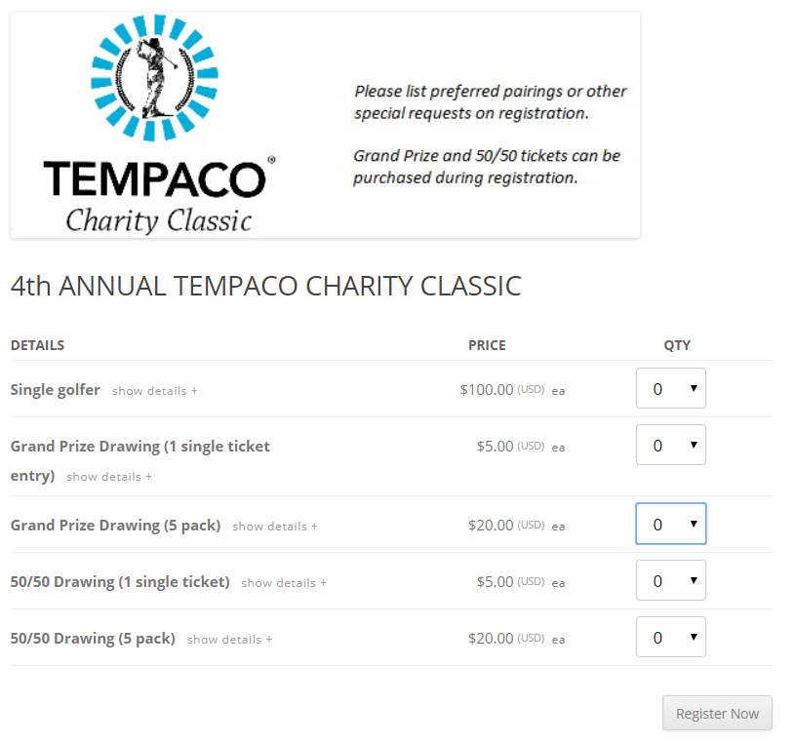
3.All fields must be filled on this page, for the preferred group/pairing field please enter the names of any players you wish to play with. If none, please enter N/A into this field. If you are paying for multiple players, you will have an attendee box for each player to enter info. If you are purchasing 50/50 tickets or additional grand prize tickets, please fill out all of the attendee boxes or there is a button to auto fill all the remaining boxes with the info you filled in on the first entry.
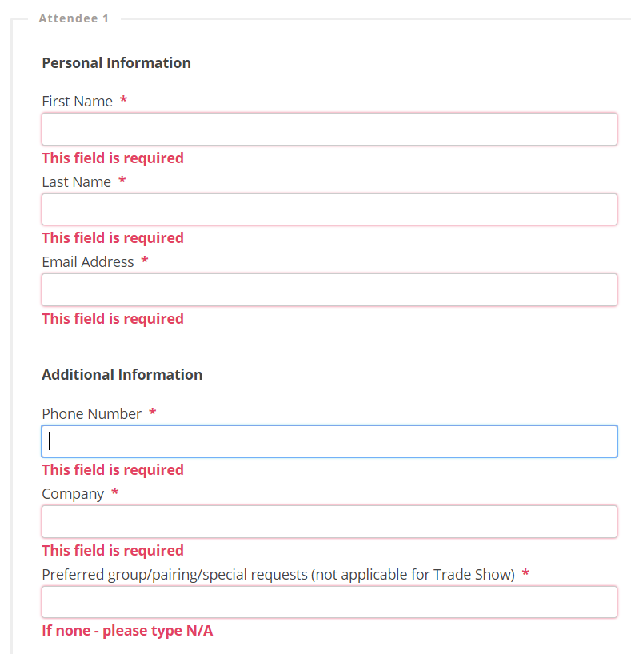

4.Payment options: For payment by Credit Card or PayPal select the PayPal option, for payment by check select the Tempaco logo option.
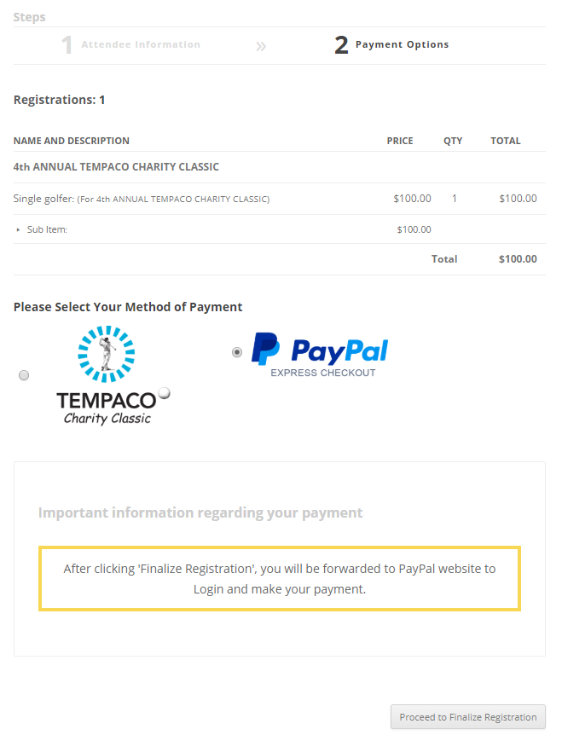
5.If paying by credit card or PayPal continue to step 6, if paying by check please skip to step 8.

6.Complete your purchase via the PayPal checkout. If you do not have a PayPal account, you can select “PayPal Guest Checkout” and pay using a credit card.
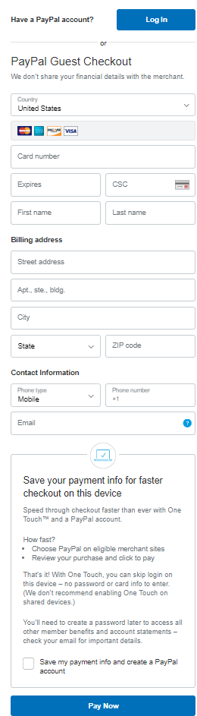

7.You can print a confirmation of your order as needed. You should also receive an email confirmation from Event Smart.
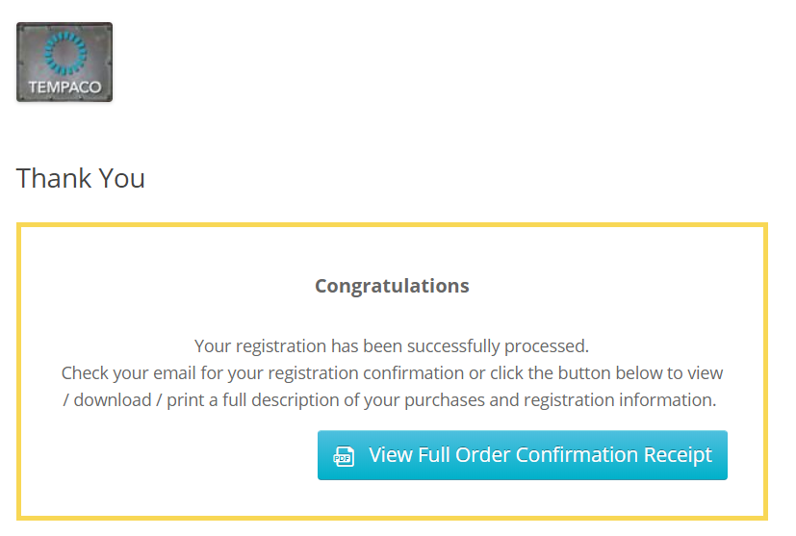

8.For payment by check click the View Invoice link on the bottom left side of the page. Please send a copy of the invoice along with your check to:
Tempaco Inc.
1984 West New Hampshire St.
Orlando, Fl. 32804
Attn. Marguerite King
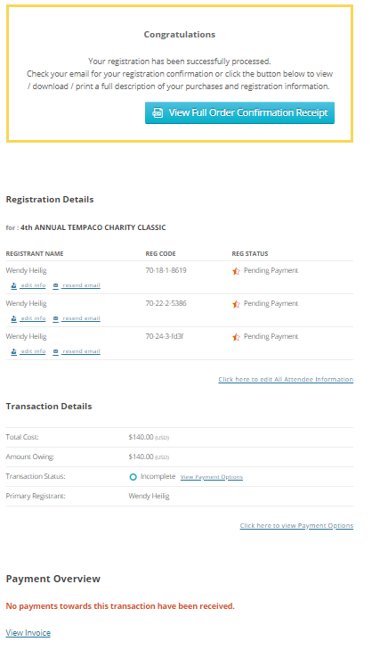

Thank you for supporting these two great charities.
If you have any questions or need help please contact Wendy Heilig at wheilig@tempaco.com

