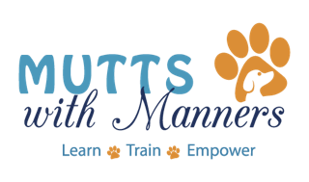

**Class Rules**

1. No sick dogs! If your dog is showing any signs of illness, please do not bring your dog to class so that others can remain healthy. We highly encourage you to attend to watch and learn so that you can take the information home and continue to work with your dog.
2. Dogs must be on leash at all times unless specifically instructed by the trainer otherwise.
3. Please clean up after your dog.
4. You will need to bring treats and/ or a favorite toy to each class. Preferred treats are soft and small in size, approximately the size of a pinky fingernail. The quantity of treats should be no more than a full meal.
5. Come prepared to class. Don’t forget your leash, rewards and poop bags.
6. If you enroll more than one dog for class, you must bring another person to train with each of the other dog or dogs.