MEDICAL QUESTIONNAIRE
Patient Name:
What problem/diagnosis brings you here today?
Side of Injury R L Date of Injury: Date of Surgery
Have you received therapy for this condition before? yes no
Have you received outpatient therapy services this calendar year? (indicate # of visits) PT OT
Have you had a similar condition before? yes no If yes, when?
Is this injury/condition related to an incident in which another party may be responsible? Circle one: workers compensation / No Fault motor vehicle accident / other
If so, whom is suspected of being responsible?
Claim #:
Contact/Adjuster Name/Phone #:
Case Manager Name/Phone#:
Have you hired or plan to hire an attorney to represent you in connection with this injury or illness?
Name of Attorney
Address/Phone:

Describe how this injury/condition occurred:
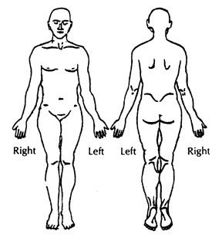
Current occupation: Regular Duty Light Duty
Shade areas of your pain/discomfort on the figure to the left
Rate your pain on a scale from 0-10 (0=no pain;10=emergency room )
Current ○ 0 ○ 1 ○ 2 ○3 ○4 ○5 ○ 6 ○ 7 ○8 ○9 ○10
At best ○ 0 ○ 1 ○ 2 ○3 ○4 ○5 ○ 6 ○ 7 ○8 ○9 ○10
At worst○ 0 ○ 1 ○ 2 ○3 ○4 ○5 ○ 6 ○ 7 ○8 ○9 ○10

What makes your pain better:
What makes your pain worse:
What activities at home, work or recreation are you unable to perform?
Goals for therapy:
Current medications:
Allergies:

