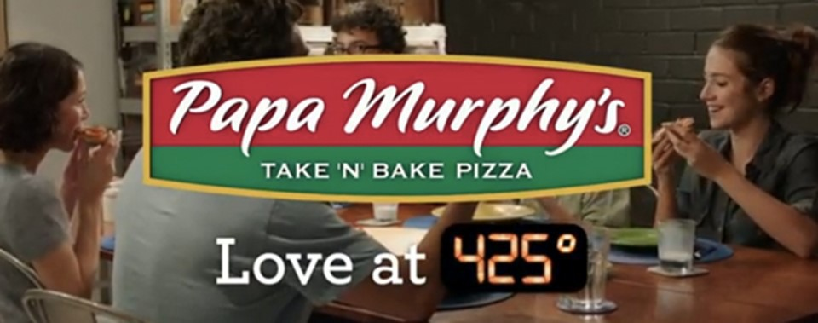
We are proud to help
Cedar Hills Elementary School
with their fundraising efforts
Join us at Papa Murphy’s
(3900 Stockton Hill Rd)
On Thursday, January 17th

20% of ALL in-store sales will go to the school

33% of ALL online sales will go to the school
(www.papamurphys.com)

