What are true wilderness experiences?
(Provided by: HighCountryExplorations.com)

[T]he love of wilderness is more than a hunger for what is always beyond reach; it is also an expression of loyalty to the earth, the earth which bore us and sustains us, the only home we shall ever know, the only paradise we ever need — if only we had the eyes to see. Original sin, the true original sin, is the blind destruction for the sake of greed of this natural paradise which lies all around us — if only we were worthy of it . . .. No, wilderness is not a luxury but a necessity of the human spirit, and as vital to our lives as water and good bread. A civilization which destroys what little remains of the wild, the spare, the original, is cutting itself off from its origins and betraying the principle of civilization itself.
—Edward Abbey, American writer, Desert Solitaire

Today’s appreciation of wilderness represents one of the most remarkable intellectual revolutions in the history of human thought about land. . . . Wilderness has evolved from an earthly hell to a peaceful sanctuary where happy visitors can join John Muir and John Denver in drawing near to divinity. Such a perspective would have been absolutely incomprehensible to, for example, a Puritan in New England in the 1650s.
—Roderick Nash, National Geographic, November 1998

Philosophical Questions Addressed in This Article
What is a true (authentic, genuine, real, high quality) wilderness experience? How important is it to seek out such experiences, as I define them? How important is it to talk, analyze and write about these kinds of experiences? What is the best way to develop a deeper appreciation and understanding of wilderness?

Introduction
Assuming most backcountry hikers, trekkers and backpackers deliberately seek out quality wilderness experiences, it is appropriate to explore this concept in some depth. In the process, I hope the reader will develop a clearer answer to the central question posed. A separate but related question, “Why go into the wilderness (backcountry)?” is the subject of another article on this website. Taken together, these two fundamental questions focus on the what and the why of this subject.
There are many ways of relating to and thinking about the concept of wilderness: travel in it, fully experience it, learn to enjoy and be comfortable in it, survive in it, live in it, contemplate and philosophize about it, write and talk about it, protect and preserve it, understand and appreciate it, and so on. In this article, the focus is mainly on this last item: developing an in-depth understanding of and a deeper appreciation for wilderness experiences.

True Wilderness Experiences: Thumbnail Sketches
The following perceptions and characterizations of wilderness experiences, in the form of thumbnail sketches, are presented for your consideration. These sketches come from many sources and are meant to cover the widest possible range.

Natural, Wild, Primitive State: A wilderness is an area uninhabited by humans that has been left in a mostly natural and wild state. Signs of human visitation are minimal. This is a place where human visitors practice a Leave No Trace (LNT) ethic and minimum impact camping. There are no roads. There is no mining or drilling. There is an absence of cabins and shelters. In the words of David Brower,

Wilderness is a place wherein the flow of life, in its myriad forms, has gone on since the beginning of life, essentially uninterrupted by man and his technology. It is a place where man respects what that life force built in the old eternity, and without man’s help—except in his willingness to come, see and not conquer.

Dr. George Wallace echoes the same philosophy in these words:

Wilderness areas are among the few places on earth where we have agreed to allow nature, for the most part, to operate on her own terms. Desirable behavior is more likely to occur if people understand how their actions affect the way nature operates.

Absence of Most Humans: In a true wilderness experience one goes for days seeing few, if any, other humans. Wilderness is an area unused by all but a few hardy souls because of its ruggedness or isolated location. A corollary of this characteristic is the experience of solitude, where the sounds and sights of human presence are minimal or non-existent.

Pure Water Sources: One sign of a wilderness is when you know you can trust the water sources; you can confidently drink the water without treatment or filtering.

Experiencing Large Scale Natural Features: Wilderness involves experiencing firsthand large-scale natural features like mountains, glaciers, forests, lakes, oceans, deserts and jungles with minimum encroachment of the most obvious marks of human civilization. It does not usually focus on natural “micro” entities (e.g., cells, bacteria, viruses, microbes, spores, seeds).

Private Experience of the Environment:

What I call the wilderness experience is essentially a one to one experience, an experience of the individual with the surrounding environment. It is not a social experience though it may be shared, at a particular moment, with others or in critique either during an excursion or after its conclusion . . .. But the essence of the experience itself, as distinct from sharing it, is an individual communion with one’s surroundings. And for that communion to take place the individual must have an undetermined period of time alone in a natural setting . . . There must be a continuity of experience and this continuity is too often and too quickly interrupted by socialization during a group excursion.
—Phil Arnot, The High Sierra—John Muir’s Range of Light, page 55

Travel By Primitive Means on Primitive Trails: Not only are there no motor powered vehicles (airplanes, snowmobiles, motorcycles, ATVs, jet skis), but also no human powered vehicles. Travel is only by “primitive” means by horse, mule or llama; or on foot, skis or snowshoes. There is much opportunity for travel on primitive, non-maintained or non-existent trails. There is a noticeable absence of graded and maintained trails with bridges, signs, shelters and campsites.

Backcountry Travel Without Trails: A true wilderness experience is one without trails. It is getting out of the trail mentality; it is avoiding them even if it makes the trip longer and more difficult. It is trekking for miles and miles off-trail without crossing trails or roads, without seeing other groups or individuals, without signs of civilization. In the words of Ryan Jordan, founder of the popular web site, Backpackinglight.com, says, “It's a wilderness thing, I guess. Trails, for me, are somewhat like sanitized umbilical cords to civilization.”

In the words of Australian Stuart Bilby, “Off trail finding your own way in three dimensions—like solving a puzzle with your body.”

Unexplored Territory: In the not too distant past, wilderness often meant traveling in unmapped and/or unexplored areas (“blank spots on the maps”). Since these are now almost nonexistent, this criterion often becomes more personal: exploring a new area that I have not yet explored. In the words of Gretel Ehrlich in Wyoming: The Solace of Open Spaces:

I try to imagine a world of uncharted land, in which one could look over an uncompleted map and ride a horse past where all the lines have stopped. There is no wilderness left; wildness, yes, but true wilderness has been gone on this continent since the time of Lewis and Clark’s overland journey.

Risky Engagement With Nature: True wilderness experiences involve the highest level of engagement.

Finding your way using skills, not technology, increases your level of engagement. Engagement is defined as the state of being committed, meshed, embedded in. Engagement is that state in which long distance hikers often realize after several weeks on the trail; that alpinists realize after passing the point of no retreat on a particular climb; and that soldiers realize once the first shot of a battle has been fired. Generally, wilderness engagement occurs as a state contrasting with one's normal urban affairs, and psychologically, is achieved in the greatest degree of depth when the awareness and perception of risk (not necessarily real risk) is heightened and barriers between the urban life and the wilderness life are maximized: elimination of technology and communications devices that connect the hiker to the world outside the wilderness break down these barriers and thus, must be assumed to inhibit wilderness engagement. Maximizing engagement increases adrenaline response and endorphin release, contributing to the natural high well known by endurance athletes, adventure racers, long distance hikers, and mountaineers, and remains as one of the greatest rewards of the wilderness experience. The extent to which you choose to maximize the strength of the urban-wilderness barrier is inversely proportional to the length of time required for wilderness engagement. This is why it is often easier for someone on a two-week hike in remote wilderness to achieve a deeper psychological engagement with wilderness than a long distance hiker on a six-month journey who stops into towns every three to four days for resupply.
—Ryan Jordan, founder of Backpackinglight.com web site

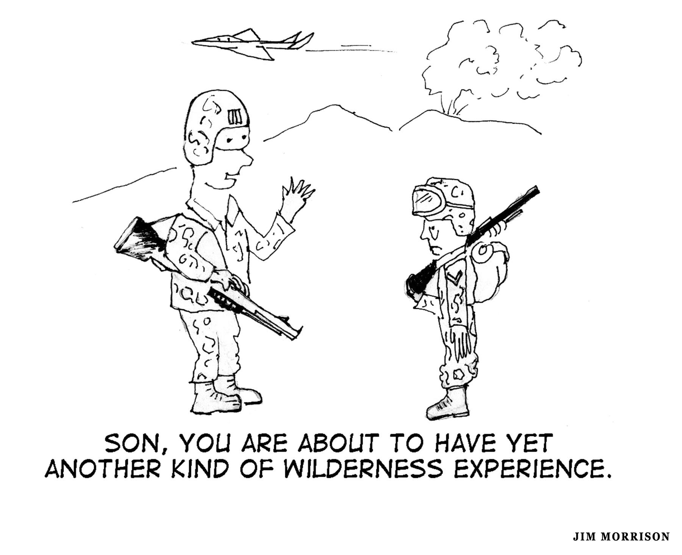

Noticeable Animal Population: An area inhabited by significant numbers of larger wild animals. In mountainous terrain, the obvious presence of animals like deer, elk, goats, moose, bear, wolves, lynx and cougar. It also includes an abundance of smaller animals like fish, birds, squirrels, rodents, snakes, etc.

Potential Threat From Animal Populations: An added dimension to the above wilderness characteristic is to be in ecosystems frequented by animals that are perceived as a potential threat to personal health and well-being (e.g., grizzly bears, moose, cougars, poisonous snakes). As one unknown writer put it, “It’s only wilderness if there’s a critter out there that can kill and eat you.”

Places to Fear: Wilderness is, by definition, something to fear. Historically, large wild areas have fostered fear in people, especially if they involve extensive, deep and dark forests. This fear might be learned or innate; whichever, it is not uncommon to be frightened of wild, untamed and uncivilized areas.

Complete Ecosystem: Wilderness means large, undeveloped spaces (i.e., whole ecosystems; whole watersheds) that provide a natural habitat for flora and fauna (as opposed to zoos and parks and backyards). It is a sanctuary for species of fauna and flora that need vast spaces for survival or have low tolerances for human intrusion. It is a place where biodiversity is more important than profits to be earned from harvesting the resources. Wilderness is a place where endangered plants and animals are protected and live in their natural state. Dr. Stephen Spurr, former dean of the School of Natural Resources, University of Michigan expresses this sentiment: “Wilderness is simply an ecosystem in which man is a relatively unimportant factor.” A similar perspective comes from Chris Townsend, The Backpacker’s Handbook (2005), page 2:

To be a viable ecosystem, a wilderness needs to be large—huge, even—providing space for wildlife to survive and live free and for the landscape to be complete from valley bottom to mountaintop, from foothills to highest peaks. These vast, pristine places are the prime places for backpacking, places of dreams and adventures.

Yet another perspective in this vein comes from outdoor writer Mark Jenkins:

Wilderness is not a mythical place, nor a region of virginal exquisiteness as the Transcendentalists would have you believe. Rather, it is a real, ecologically complex, necessarily human-managed geography where biodiversity matters more than money. Wilderness is in our backyard, and with the healing influence of minimal interference, it will endure. (“Destination Nowhere,” Backpacker, September 2008)

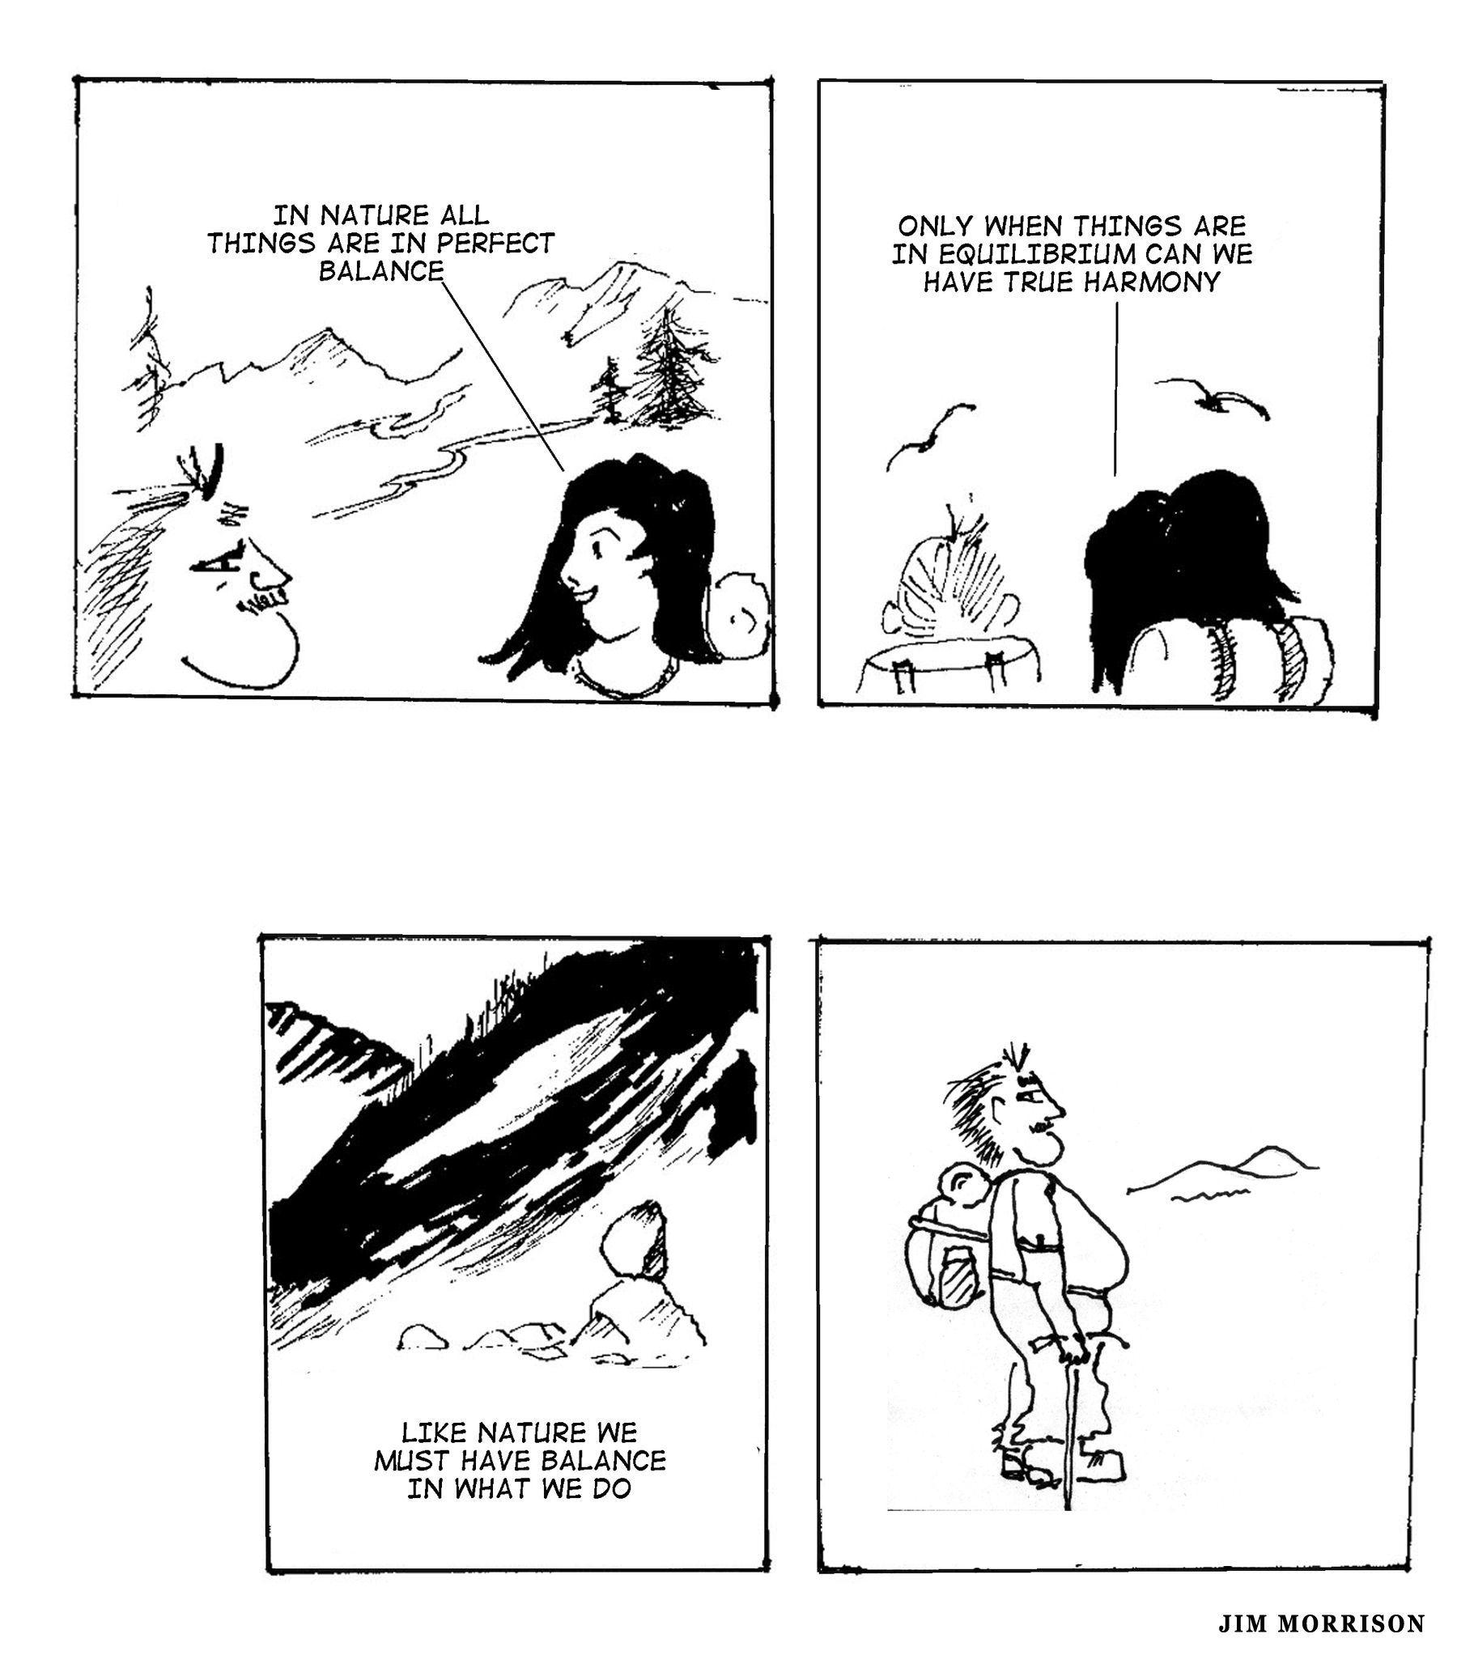

Wasteland: Wilderness areas are places where valuable resources are going to waste. Alternatively, it is a place with few known and desirable resources (i.e., a wasteland).

Legislative Designation: Traveling in areas designated as wilderness by a governmental body. For example, areas designated by the United States Congress under the Wilderness Act.

Unmanaged Area: An area with no rules, regulations or restrictions; an area where trail and camping fees are not assessed, where reservations and registration are not required. Any attempt at this kind of internal management is usually unsuccessful. The only external management would be to explicitly reject the concept of internal management.
_____________________________

The intent in the above thumbnail sketches is to present a wide range of ideas about true (authentic, real, high quality) wilderness experiences without bias and judgment. How well did I do? What was left out?
Some of the above sketches focus on nature without mentioning human interactions. Others focus on the human element and one’s relationship with nature. Still others do neither. Some are radically different from each other; others are just variations on a common theme. Which most resonate with your experience and understanding?

Reader Participation: Priority Characteristics of Wilderness Experiences
First, what is missing? Consider adding any characteristics of true, authentic wilderness experiences that you believe have been missed. Second, circle those definitions and characteristics that best fit your own understanding of a true wilderness experience. Third, evaluate how often your hiking and backpacking trips have been true wilderness experiences in, say, the last five years using adjectives like the following: all of them, most, many, some, none.

Author’s Priorities for Wilderness
Even though I can relate to most of the thumbnail sketches presented in this article regarding true wilderness experiences, three resonate the most for me. The first is captured in the following excerpt: “A wilderness is an uninhabited area that has been left in a mostly natural and wild state. Signs of human visitation are minimized.”
I am fortunate to live in a part of the country with many such places. This excerpt captures another priority characteristic: “A true wilderness experience is one without trails. It is getting out of the trail mentality; it is avoiding them even if it makes the trip longer and more difficult.” This second characteristic is one I have experienced most often while backpacking along high traverses (e.g., the Bailey Range Traverse in the interior of Olympic National Park or the Ptarmigan Traverse in North Cascades National Park). However, these traverses are popular and frequently traveled which detracts somewhat from their wilderness qualities. In the future, I would like to do more off-trail travel that includes more out-of-the-way and seldom-traveled places. The final characteristic of true wilderness experiences is expressed in the following excerpt: “exploring a new area that I have not yet explored.”
As I further ponder this question, the truest and highest quality wilderness experiences combine all three characteristics suggested by these three excerpts: exploring new-to-me primitive areas while traveling mostly off-trail.

Ansel Adams on Wilderness Experiences: A Dialogue
American photographer and conservationist, Ansel Adams, apparently had this to say about wilderness writing:

I hesitate to define just what the qualities of a wilderness experience are. Like music and art, wilderness can be defined only on its own terms. The less talk, the better.
—as quoted in Backpacker, June 2000

To explore and analyze this issue, consider the following imaginary dialogue.

Jones: When you say, “the less talk,” I assume that you would reject this entire article. If so, why is this an either/or? Why not use both our intellect and our senses, both our reason and our intuition to raise our appreciation and understanding of wilderness to a higher level? For example, understanding the cultural background of the artist will often enhance the experience of great music and great art. Understanding the various themes and meanings intended by the artist can enhance the experience. Understanding the structures and compositional styles by the artist can often add new dimensions.

Adams: The best way to move our appreciation and understanding of wilderness to a higher level is by experiencing it more often and for longer periods of time, by getting further away from our “civilized” life. Intellectual understandings are part of the “civilization” many are trying to escape by going into the wilderness. The best way to develop our appreciation of wilderness is by walking and living in it, by sharing our visual experiences with others, as I do by my photography.

Jones: Again, why is this an either/or? Why will carefully written words and phrases (including some poetry) take away from our experiences? In fact, they might bring into focus what we only vaguely felt before. They will often cause us to reflect upon new and different perspectives we haven’t thought much about. They might just allow us to experience the wilderness in whole new ways. Words and pictures (including your photographs) have the potential of expanding our sense of wilderness. They also have great potential to motivate people to spend more time out in the wilderness and energy in protecting it. The famous American forester and conservationist Aldo Leopold holds a position seemingly opposite of yours when he said, “Wilderness is the raw material of which man has hammered the artifact called civilization.”

Adams: Then again such “civilized” intellectualizing might cause us to doubt our own experiences, especially if they do not live up to some ideal of “true” wilderness experiences proposed by others. It might cause our analyzing to override our experiencing.

Jones: It seems as if part of your objections revolve around the mistaken notion that there are a fixed group of qualities that can never be put into words (“I hesitate to define just what the qualities of a wilderness experience are.”). Like the experience of art and music, there is no way to define wilderness experiences precisely in words. Like the experience of art and music, there are many, many qualities, some quite definable and others more esoteric and intangible. This is also true of wilderness.

Adams: I have met too many intellectuals and writers who seem to have little visceral and emotional connection with and appreciation of what they are writing about.

Jones: True, but I think it is time to let “the reader” make their own decisions about whether wilderness experiences are ultimately beyond words or whether it is useful to write and talk and think about them.

Final Thoughts
It is quite appropriate to let one of America’s most revered and well-known wilderness explorers speak the final thoughts in this article:

The clearest way into the Universe is through forest wilderness. The mountains are fountains of men as well as of rivers, glaciers, of fertile soil. The great poets, philosophers, prophets, able men whose thought and deeds have moved the world, have come down from the mountains — mountain dwellers who have grown strong there with the forest trees in Nature’s workshops.
—John Muir, American naturalist

Additional Issues for Reflection
- The Counsel of Ansel Adams: Is Adams correct that our time is better spent out experiencing the wilderness than thinking and writing and talking about it? Or is your author correct that these activities have the potential for raising our experience of the wilderness to a higher level.

- How Much Wilderness? Do we need more or fewer officially designated and legally protected wilderness areas? In your state? In the nation? In the world? How much is enough? Is the gradual encroachment of civilization into wilderness areas inevitable?

- Population Control: Is the increasing number of people in our nation and the world a serious threat to true wilderness experiences? If so, how best control human populations?

- Luxury vs. Necessity: Is wilderness a luxury or a necessity? For me? For our nation? For our civilization?

- Core Characteristic: What makes up the essence of a “wilderness” experience? Is there a core characteristic(s) that is essential to all wilderness experiences that everyone could agree to as a minimum? Would solitude be that characteristic? Open spaces? Absence of civilization?

- Solitude: How important is solitude and should we manage our wilderness areas to maximize this trait? How important is it to limit the number of hiking parties allowed into an area?

- Encouraging Wilderness Experiences: What is the best way to encourage more people (especially young people) to seek out wilderness experiences? Are wilderness training courses the best answer? Guide books? Books of essays, photographs and poetry?

- Discouraging Wilderness Experiences: Is it best to discourage visitation by others to areas of wilderness because it can potentially degrade one’s own experience?

- Signs of Human Visitation: Should shelters and cabins be maintained or removed from wilderness areas? Should trails and trail signs be maintained or abandoned in wilderness areas? Should wilderness trail systems be expanded or contracted?

- Management of Wilderness: Which federal and state agencies do the best job of managing designated wilderness areas? Do we need a separate arm of government whose sole responsibility is to manage wilderness areas?

- Legal and Illegal Uses: What should be allowed or disallowed in a wilderness area? Domesticated livestock? Mineral rights? Fishing and hunting? Allow only indigenous plants and animals? Restrict or prohibit fly-overs by most aircraft? Allow ski areas and groomed ski trails? Power lines? Motorized trail maintenance and firefighting equipment?

- Urban Wilderness: What about the concept of urban wilderness? Should pockets of “wilderness” be developed and maintained within suburban and metropolitan areas?

- Semantic Relationships: What are the interrelationships between concepts like “wilderness,” “wildness,” “wild places” and backcountry? How are they different?

- Acquired or Innate? Is an understanding and appreciation of wilderness inborn (innate) or learned (acquired from experience) or some of both? What about those who fear the wilderness? How much of this fear might be innate?

- Objectivity and Subjectivity: How much objective “truth” is involved in the phrases “true,” “real,” “authentic,” and “high quality” wilderness experiences? Are there characteristics of a wilderness experience that everyone in contemporary culture should recognize? Or are wilderness experiences totally subjective and a matter of developed taste? Are they both objective and subjective in nature?

