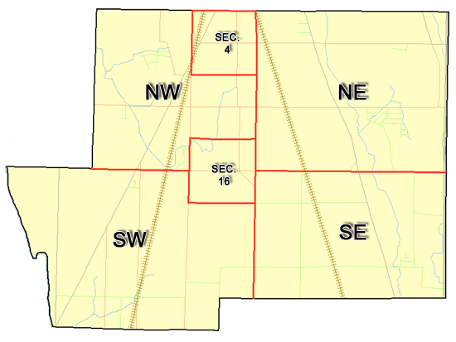 | Pleasant Township  Zoning Commission Minutes  1035 Owens Rd W.  Marion, Ohio 43302
Meeting called by: | Scheduled | Type of meeting: | Regular Monthly
Chairperson: | Mr. Holler | Secretary: | Stephanie Barkley
Timekeeper: |  | Date: May 18th, 2023 | Time 7:30 pm
Call to Order by: | Mr. Holler Moment of silence followed by the pledge to the flag.
Roll Call: | Jack Dean, Harry Holler, Tom Leib, Dwight Williams, Joe Thompson, Tyron Canterbury  Stephanie Barkley
Minutes: | Read and approve minutes from previous meeting.  Motion to approve minutes by: Mr. Williams Seconded by Mr. Leib: All approved
Attendees Address Board: Have sign in sheet on desk by door.
Type in attendees and addresses: see attached
.
----- Agenda Topics -----
Business
Zoning Reports: | Zoning Inspector goes over reports and provides copy to board.
Unfinished:
New:
Announcements: | Next meeting will be June 15th ,2023
Adjournment: | Motion to adjourn by: Mr. Leib seconded by Mr. Dean, all in favor all approved

Pleasant Township
Zoning Commission Minutes

1035 Owens Rd W.
Marion, Ohio 43302
Business Notes:

 | Discussion:
 | Conclusions:
 | Action items: |  | Minutes signed by: | Date approved:
 | Provide copy of approved minutes to Zoning |  | Chairperson:
 | Inspector. File original in township office. |  | Secretary:
Other Information
Trustees Present: |  | Mr. Schrote
Zoning Inspector: |  | Mr. Baker
Special Guests:

Minutes
The Pleasant Township Zoning Commission met for their regularly scheduled monthly meeting May 18th, 2023, at the Pleasant Township Senior Centre Zoning Commission Board Members were present: Mr. Dean, Mr. Leib, and Mr. Holler, and Secretary Miss Barkley and trustee Mr. Schrote and Zoning Inspector Mr. Baker was present. Absent was Mr. Thompson, Mr. Williams, and Mr. Canterbury.
- Minutes were read from the April 20th,2023 regularly scheduled Zoning Commission meeting. There were a couple corrections to add to the minutes. A motion to approve the minutes was made by Mr. Leib and seconded by Mr. Dean. All members present agreed to passage of the minutes.
- Mr. Tom Baker Pleasant Township Zoning Inspector present the report for April. There were 7 permits 2 violations sent out. Mr. Baker reported that the nursing rehab/skilled nursing facility was approved by the appeals board. Nothing else to report.
- The next meeting going to start placing zoning items in sections of the book. There being no additional business for discussion Mr. Dean made motion to adjourn, seconded by Mr. Leib Board Members in attendance agreed and the meeting was adjourned. The next Board Meeting will be held on June 15 th^{h} ,2023 at 7:30 PM.

1

