

# Summer 2018 Season

# Week 1 – 28.03.18

# Singles League Report

# 

**Remember if you cannot play on the scheduled fixture date; please try to play in advance.**

Well Jonny Hill’s unbeaten record was in serious threat losing the first game in the Premier League as Toby Northern returned to form to start the season winning 13 – 2, also handing Jonny a certificate. Jonny though changed terrain and his fortune taking a 12 – 0 lead before finally gaining a draw with a 13 - 4 win.

Matt Buesnel hoping to prove he’s not a one hit wonder took on Keith Pinel, but it wasn’t the ideal start as a draw was all he could manage dropping points early on.

Draws are becoming a bad habit for Andrew Bellamy-Burt as another one means he has 9 out of his last 11 matches!! This time to Brian Harris.

Matt Pinel did get a win as he beat Neil Selby to start the season off in the best possible way and an improvement as he also played Neil in the first match of the season in the winter season but could only draw that time.

Matches not played

Ross Payne v Callum Stewart

David Ibitson v Paul Le Moine

Alice Ibitson v Geoffroy Buffetrille

Division 1 saw title favourite Joey only manage to draw with the ever improving Cassie Stewart. Laurent Pellaton started his push for the Premier League with a draw against experience player John McGaw.

New comer Stephen Stoneman started off well in his first ever match against Richard Williams taking a 5 – 0 lead, but experienced showed as Richard triumphed in the end.

Alex Stewart is hoping to make it back to back promotions to the Premier League and started off well taking a very close match against Paul Bell, who is getting better with every game.

Harrison Marie also won, against Jean Stewart, so no draws in Division 1. Looks like it’s going to be a big scoring season.

Matches not played

David Le Gresley v Matt Hutchings

Brigitte Ibitson v Mo De Gruchy

**Super 6 Results**

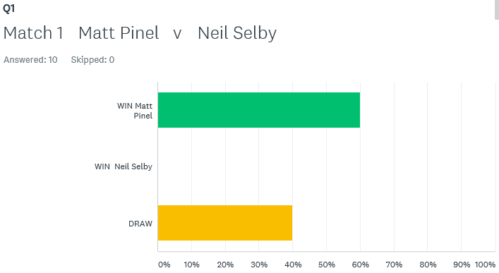

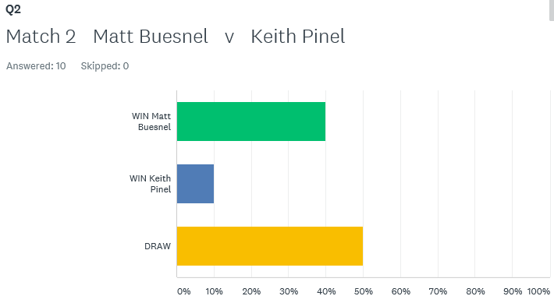

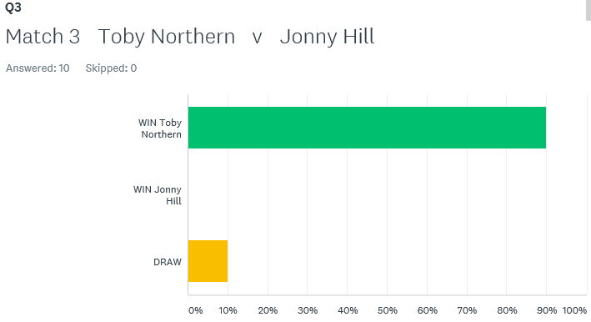

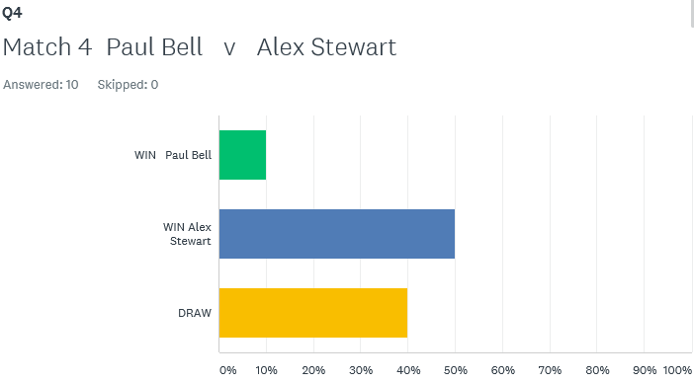

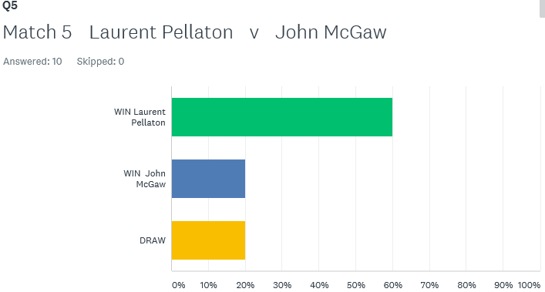

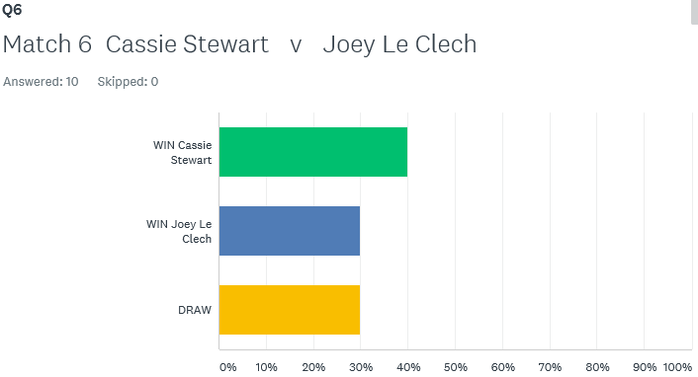

How would you have done on the **Super 6**? – next weeks out on Monday – have a go, see how good you are.

**First Open of the year is the Singles Open on Saturday 7th April – start time 8.45**

Best of Luck to everyone

***NEXT WEEK***

**4th April - Singles League – Week 2**

**WEBSITE** [**www.liberationpetanque.co.uk**](http://www.liberationpetanque.co.uk)

**EMAIL** [**liberationpc@gmail.com**](mailto:liberationpc@gmail.com)

**Kind Regards**

**Toby Northern**

**Chairman**

**Liberation Petanque Club**

# SPONSORED BY

# http://nebula.wsimg.com/135a1bd6338e1b589a50cdec98bd84d1?AccessKeyId=C6E923731F1A482DD910&disposition=0&alloworigin=1