DERRICK CITY VOLUNTEER FIRE DEPT.
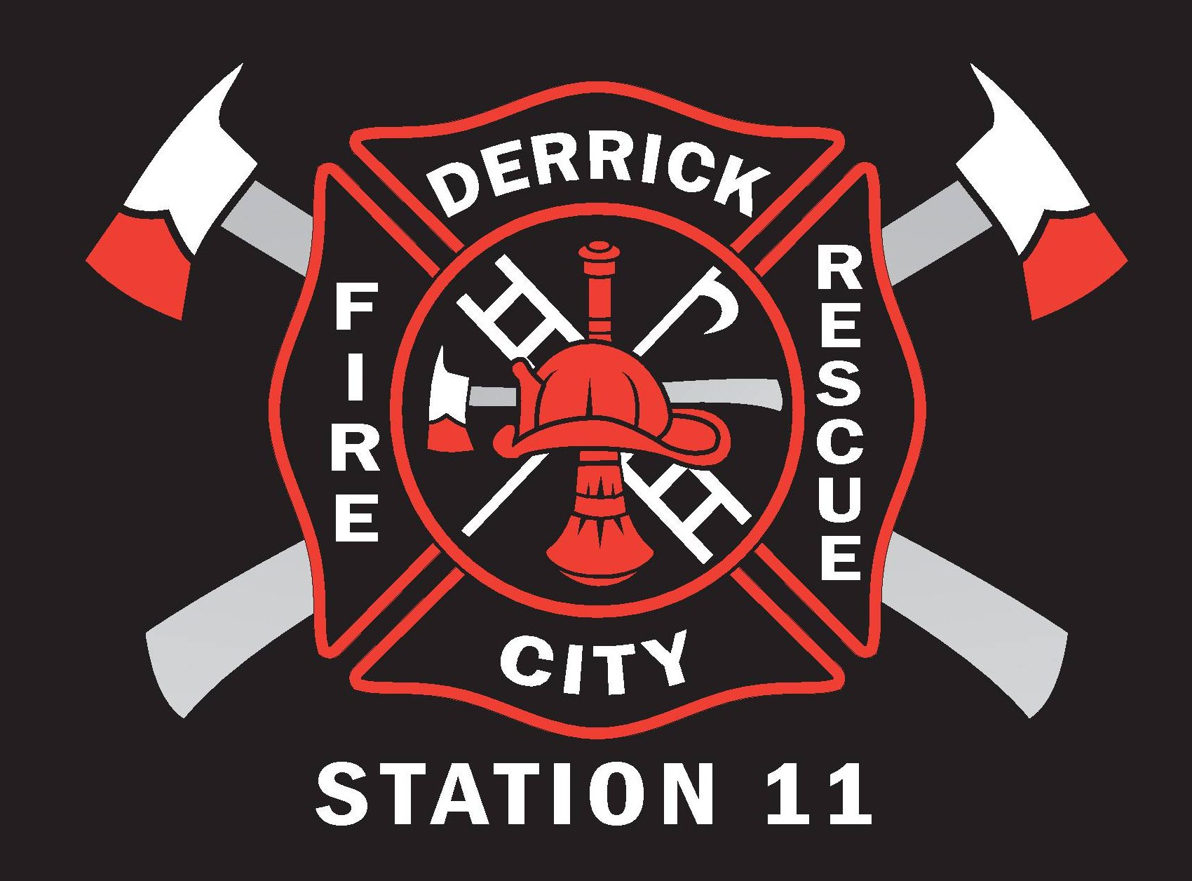
P.O. BOX 58

DERRICK CITY, PA 16727

Rules and Regulations for Junior Department Members

The Derrick City Volunteer Fire Department has adopted these rules and regulations to govern our Junior Emergency Services Program. Our goal is to prepare young people to be the safest and well-trained responders they can be and to provide the best opportunity for the future of our organization. These rules and regulations are to be strictly adhered to by all junior members of the Derrick City Volunteer Fire Department.
Being accepted to Junior Membership is a privilege granted to those members between 14 and 18 years of age who wish to serve and protect the community.

Prior to the acceptance into the Department, he/she must obtain a work permit and shall have an application signed by a parent or legal guardian. All documents must be kept on file.
The juniors will be directly supervised by the regular fire department members, and a junior committee made up of 4 members of the regular fire department, assigned by the Vice President and Chief, to act as the “Advisor/Liaison”, and “Junior Committee”.

Junior members shall obey the constitution, by-laws and all other company rules and regulations.
Duties of Junior Members
- Junior Members should make every effort to attend training sessions, work/service detail and responses when permitted by the Child Labor Law and Fire Department/Company guidelines.
- Junior Members shall follow the established chain of command and work with their Advisor/Committee.
- Junior Members will assist with cleaning apparatus and equipment after events.
- Junior Members can attend fund raising activities, if available.
- Junior Members may attend meetings, but do not have any voting privileges.
- All Junior Members will sign in and out when entering and leaving the building.
- All Juniors Members will maintain a good academic eligibility of 70% cumulative GPA or above in all school. Parents or legal guardians shall be required to notify the fire company if the student’s grade drops below a “C” average. Those who have their grades go below a “C” average or has an “F”, regardless of the overall averages, shall be suspended from ALL fire department activities. Please see attachment A (page 6 of this document) “Interscholastic Athletics Policy (No.123) for full details regarding to grades.
- Junior Members will serve a probationary period of 3 months as described by the organization. At the age of 18 he/she will be considered and adult, at this time he/she will need to submit a regular member application to the department. If the application is accepted he/she will be placed on a 3 month regular member probationary period.

Responding to Alarms
- Junior Members shall not answer fire alarms until given approval by the Fire Chief.
- Junior Members ages 14-15 shall respond from their assigned stations and/or with their parents or legal guardian.
- Junior Members will not be permitted to extinguish any fire of any type (Brush, Structural, Automobile, etc.).
- Junior Members will be permitted to respond to calls, if they do not make a truck, by personal vehicle. 14-15 year old members must ride with either their parent/legal guardian, or active department member. 16-17 year old members may drive themselves, however will not be permitted to use a blue courtesy light or hazard lights (four ways) while enroute to call, and must report to their respective station first.
- All traffic laws will be strictly obeyed. Permission to drive their vehicle directly to the scene of any alarm must be approved by the Fire Chief.
- Senior members have priority for seating on the fire response. Junior Members will be instructed by the officer or senior member in charge where they may ride on responding fire vehicles. If all positions are taken on the first responding unit, the junior must wait to respond on the second responding unit, if there is sufficient room to do so. If all positions are filled on all responding units, the junior may respond to the scene in a personal vehicle in a safe manner and park in an area that is not on the fire ground operational area.
- Junior Members shall don all protective bunker gear before boarding any piece of fire apparatus that is responding to a call unless otherwise instructed by a line officer.
- Wildfires: Junior firefighters 16-17 years old that have completed one of the required courses, may assist in the extinguishing of brush fires using Indian tanks, rakes, low pressure hoses, etc. If supervised. 14-15 year olds are prohibited from any firefighting activities.
- Junior Members must be seated and seat belted in an enclosed vehicle while responding to a call.
- Junior Members are not permitted to leave school to answer an alarm or attend training session or detail.
- Junior Members are not permitted to carry a pager to school at any time, if caught it will be revoked.
- Junior Members will not start, drive/operate or move any fire apparatus.
- If a Junior Member is the first to arrive on scene he/she must wait until at least 2 senior members arrive on scene to direct them in what to do.
- Junior Members can only respond to EMS calls if they have the appropriate certification. Such as First Responder, and EMT. They also must be under the direction of a senior member that is a First Responder or EMT.
On The Scene
- Junior Members must report and receive permission to leave the Fire Scene by the Officer in Charge.
- Junior Members must report to a piece of apparatus they are assigned to in full protective gear and place their accountability tag on that piece of apparatus. If their assigned apparatus is not on scene they will be assigned by the Officer in Charge. Free Lancing is prohibited.
- Junior Members may only operate equipment as directed by the Officer in Charge.
- Junior Members are not allowed to enter any burning structure.
- Junior Members responding to a mutual aid call into another department’s jurisdiction shall stay with our apparatus until ordered by one of our Line Officers on scene.
General Regulations
- On the scene of an incident the Officer in Charge/designee is responsible for the direct supervision. All juniors will be governed in accordance with the Child Labor Law, Bureau of Labor Law Compliance and Commonwealth of Pennsylvania.
- No use of profanity, horseplay, wrestling, physical sports or fighting shall be tolerated on or about the station.
- Junior Members shall be respectful to all members and the public. Officers should be addressed by their titles. Junior Members may attend Fire Department meetings, but shall not be permitted to make or second any motions, nor shall they be able to vote on any issues. With approval, they may attend all drills and fire schools scheduled
- Probation for the juniors shall be 3 months from the date of their acceptance into the department as defined by the company by-laws. At that time he/she, with a majority vote from the membership at a regular company meeting, will be a regular junior member off probation.
- Fire Department members shall process all applications for junior membership and recommend acceptance or rejection.
- Time restrictions: Juniors under the age of 16 are prohibited from engaging in fire department activities while school is in session and between the hours of 7:00pm to 7:00am (10:00pm to 7:00am during summer vacation) and cannot interfere with school attendance. However, they may attend training classes as part of a training program after 7:00pm during the school year.
- EXCEPTION: With Written Parental Consent the 7:00pm time is extended to 10:00pm during school year. During School Term Junior firefighters ages 14-15 years old are only allowed a total of 4 hours at the station on school days and 8 hours any other day.
- Time restriction: Juniors ages 16-17 years old on school nights: not to exceed 12:00am (Midnight). Non-school nights: not to exceed 1:00am, Friday night into Saturday, Saturday night into Sunday, or Night proceeding into a school holiday. No restriction during summer recess.
- All Juniors Members will maintain a good academic eligibility of 70% cumulative GPA or above in all school. Parents or legal guardians shall be required to notify the fire company if the student’s grade drops below a “C” average. Those who have their grades go below a “C” average or has an “F”, regardless of the overall averages, shall be suspended from ALL fire department activities. Please see attachment A (page 6 of this document) “Interscholastic Athletics Policy (No.123) for full details regarding to grades.
- A Junior Member may be reinstated before the next grading period if he/she receives a note from the instructor or guidance counselor, in writing and signed, on school letterhead, stating that the grade average has risen to a “C” average.
- The Junior Member will submit their report card to the Advisor/Committee member within 1 week after being issued. If the report card is not submitted, the Junior Member will not be permitted to participate in any company activities.
- All Junior Members shall be under suspension if enrolled in summer school program for failure to pass subjects during normal school for the duration of the summer program.
- Any equipment issued to a Junior Member shall be kept in good repair and maintained to Fire Department guidelines. He/she may use equipment that was personally purchased as long as the Chief approves such equipment use prior to being purchased.
- Junior Members shall not be permitted to take any fire department issued equipment to school.
- Junior Members will attend training as identified by the department/company. No junior may enroll in any courses offered through the department without the Chief/Membership approval.
- Junior Members are prohibited from using any tobacco products on Fire Company properties, fire ground operations, or any fire related public activities. Juniors who are under the influence of alcohol, or has the smell of alcohol or any alcoholic beverages or controlled substance in his/her possession and are on Fire Company property, fire ground, or any function held by the Fire Company may be immediately expelled. Any junior who is involved in any illegal activity outside of the Fire Company shall be subject to expulsion for the Department.
- Junior Members must comply with applicable Pennsylvania Child Labor Law Provisions. If found non-compliant, the member is subject to termination.
- Junior Members are covered by the company’s insurance policy at all functions
- Where Junior Member rules do not prevail, the regular department by-laws will act as the SOG’s.
- Failure by any member or the junior department to abide by these rules listed above will result in suspension and possible expulsion from the junior department.
- All rules and regulations governing juniors are subject to change at any time.

HOURS OF EMPLOYMENT – AGES 14 AND 15

During School Term Only at times that do not interfere with school attendance.
MAXIMUM OF 18 Hours per school week (Monday thru Friday)
3 Hours on school days
8 Hours on Saturday and 8 Hours on Sunday.
8 Hours on any other day (school Holiday)

DURING SUMMER VACTION
MAXIMUM OF 40 Hours per week, 8 Hours per day

Night Work Employment prohibited after 7PM and before 7AM
EXCEPTION: Summer Vacation/Written Parental Consent for training until 10PM.

HOURS OF EMPLOYMENT – AGES 16 AND 17
DURING SCHOOL TERM Only at times that do not interfere with school attendance
MAXIMUM OF 28 Hours per school week (Monday thru Friday)
8 Hours on Saturday, 8 Hours on Sunday
MAXIMUM OF Daily hours cannot exceed more than 8 hours per day

DURING SUMMER VACATION
MAXIMUM OF 48 Hours per week, 10 Hours per day

NIGHT WORK
During School Term: May not work after Midnight (Sunday thru Thursday) May not work before 6AM the entire week May work Friday night until 1AM Saturday morning May work Saturday night until 1AM Sunday morning.
Members of Volunteer Fire Companies may continue serving in answer to a fire call until excused by the Fire Chief
During Summer Vacation: May work until 1am. Members of Volunteer Fire Companies may continue serving in answer to a fire call until excused by the Fire Chief

MAXIMUM EMPLOYMENT 6 DAYS PER WEEK,
30 MINUTE MEAL PERIOD REQUIRED AFTER 4 HOURS OF WORK
WORK WEEK BEGINS ON MONDAY AT 12AM

Attachment A:

Interscholastic Athletics Policy (No. 123) Adopted: December 12, 1983 Revised: June 27, 2016

Eligibility Policy: (follows PIAA plus Bradford Area School District)

All student-athletes will be required to pursue a full-time curriculum as defined and approved by the Principal. Students must be passing (60%) at least four (4) full-credit subjects, or the equivalent, as of each Friday during a grading period. If students fail to meet this requirement, they will lose eligibility from the following Sunday through Saturday. Grades will then be re-evaluated for the following week along with all other student athletes.

In addition to the requirements outlined above, student athletes must maintain a cumulative GPA of 70% or better. Student-athlete's cumulative GPA will be reviewed every three weeks (1st Progress Report Period, 2nd Progress Report Period and at the conclusion of the 9-week marking period) during the season. If student athletes do not meet this requirement, they will be ineligible to participate in their sport(s), including practice, for a period of five (5) school days (to include the weekend days between the five (5) school days if applicable).

Students must have passed at least four (4) full-credit subjects or the equivalent during the previous grading period, except that eligibility for the first grading period is based on the student's final grades from the preceding school year. If students fail to meet this requirement, they will lose eligibility for at least fifteen (15) school days of the next grading period, beginning the first day that report cards are issued.
Students for whom an Individualized Education Plan (IEP) is on file, at the time that they would be declared ineligible under the above standards, shall automatically be afforded a review of their case. The review shall be conducted by the principal, athletic director, the student’s guidance counselor and the student’s special education teacher. This review committee shall have the right to waive the eligibility requirement if, in their professional judgment, the student has made every effort possible to meet the standard.

