Summer 2019
16th March 2019
Club Precision Shooting Cup
The 2019 Precision Shooting Cup saw 15 members take part in windy conditions. With each player getting two goes at the five different challenges from each of the 4 distances.
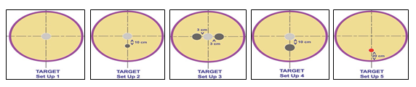
Round 1
James Rondel started us off scoring 4 points in his first ever go at the Precision shooting, something to work up from.
Stephen Stoneman scored on his first one with 3 points and improved on his second go by hitting the coche on the first go to get 5 points. Jean Stewart score 5 points and Laurent Pellaton 4 points on their first go.
After round 1 the top four were:
Geoffroy Buffetrille - 27
Matt Pinel - 20
Brian Harris - 13
Keith Pinel - 12*
Ross Payne - 12*

Unfortunately in round 2, Andrew Bellamy-Burt started a trend of scoring zero as James Rondel and Alex Stewart followed suit.
Cassie Stewart though improved in round 2 scoring 13 points to move into the top four this meant both Ross Payne and Keith had to take their second go. Keith improved with 17 points to move into third place, however Ross only scored 3 points on his second go to miss out on the semi-finals.
Brian Harris also got his second go needing to beat 13 to move into the top four but as with Ross found the going tougher the second time round scoring 9 points.
But just as the top four seemed to have been found Toby Northern had everyone gasping in amazement as heimproved on his first score of just 3 to score the second highest total of the day 22 to finish second.
This meant for the first time in three years there was a different player making the semi-finals with Andrew Bellamy-Burt the player dropping out.
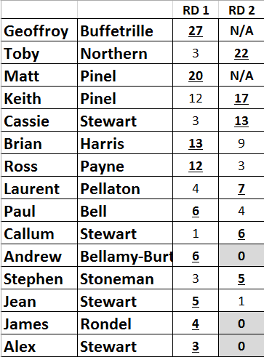
Preliminary Rounds Highest Scores
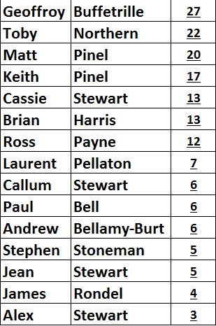

So an all Grantez Team semi-final, no wonder they won the JPA League with matches to spare.
The first Semi-final was between Geoffroy and Keith. This was a close affair with Geoffroy just staying ahead after each discipline, but only four points in it with just the coche to go. Unfortunately despite Geoffroy missing everyone Keith also did resulting in an 18 – 14 win for the 2017 champion.
In the second semi-final Matt Pinel set his stall out early scoring 10 points in round one to Toby 6. Toby though got to within just one point after round 4 with a perfect over the top caurreaux to go into the coche round 18 – 17 in Matt’s favour. Again though neither pair hit one coche so the 2018 champion made the final hoping to make back to back wins.
Well the final didn’t live up to expectations as maybe a combination of tiredness and a lit bit of pressure affected both players. The result was a win for Geoffroy by just two points but the score was just 8 – 6.
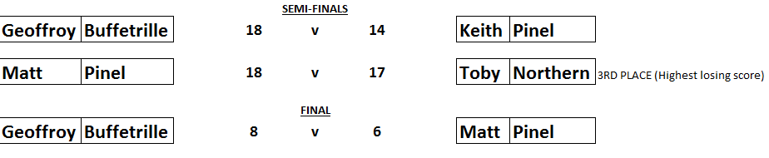

Some new members trying the shooting format out for the first time and having fun whilst acknowledging the skill required and some more experienced members struggling, just shows the time, effort and practice required to obtain the skill required to be at the top level of the game.
On the back of this Matt Pinel & Geoffroy will be helping out on coaching for members, giving up their valuable free time to support our members development. Invite will be coming out soon.
Special thanks to everyone who helped on the day, especially Matt Pinel who did a huge amount of work on the day.
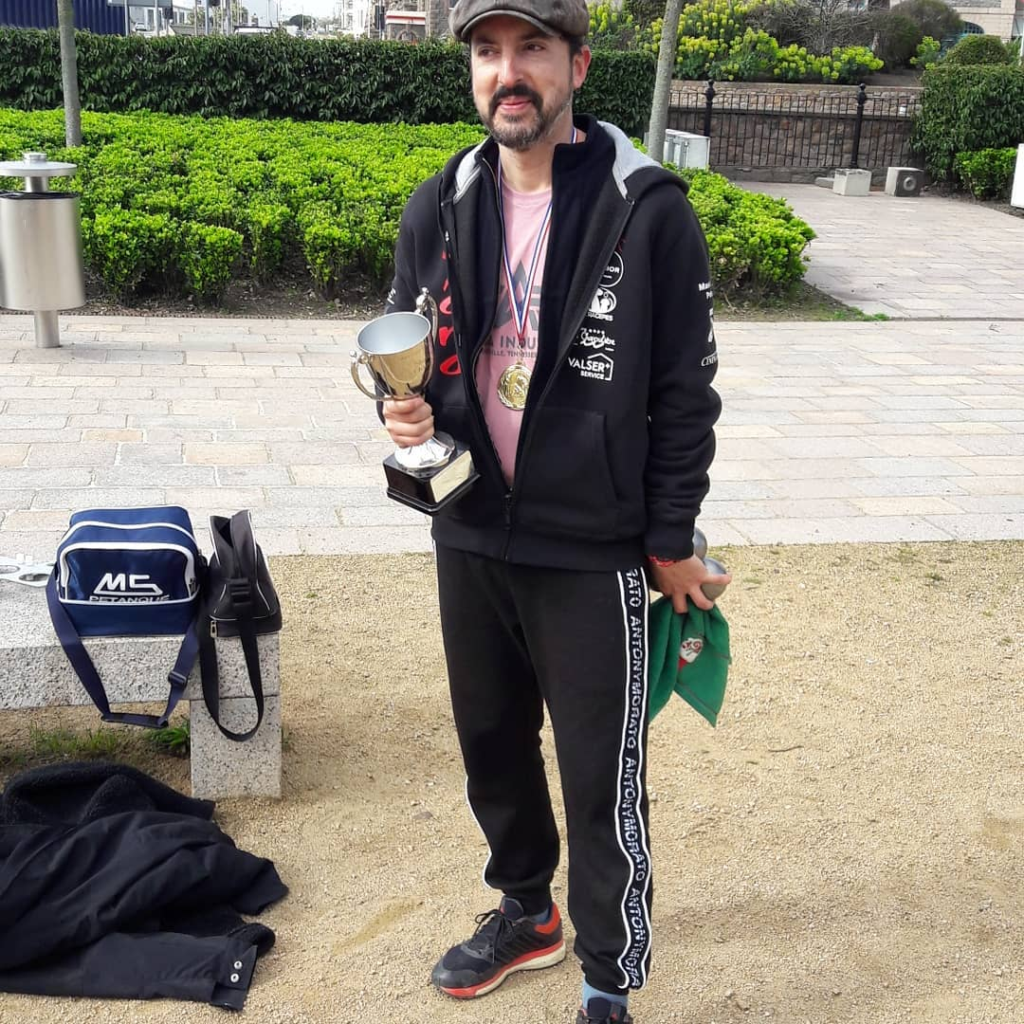

Club email address - liberationpc@gmail.com

Club Website - www.liberationpetanque.co.uk

Kind Regards

Toby Northern

Chairman

Liberation Petanque Club

SPONSORED BY

