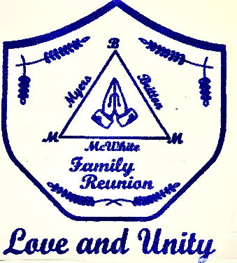
This past year of 2022 has come and gone and for me, it happened so fast! Does anyone else feel that way? Well. It is that time again . . . time for the BMM Family Reunion! As you may have already heard, the Baltimore, Maryland Chapter is hosting the Britton, Myers & Mc White Family Reunion for 2023 and we are so very excited to welcome you to our city! This is what we have planned for the 45th Britton, Myers & Mc White Family Reunion for 2023. You will need to use GPS or carpool with other family members for this exciting destination weekend.
The Family Dues for this exciting weekend are as follows: Children -newborn to age 3 is FREE. Children ages 4 to 17 is $55 and 17+ including Adults is $85. We kept the cost as economical as possible. All planned activities are wheelchair and handicap accessible. Due to the reservation of activities and the need for a head count, we have included a registration form that must be completed and returned with your money order or certified checks for your Family dues. We will not accept personal checks. Family dues must be received prior to June 1, 2023 so we can make this weekend enjoyable for the entire family.
The Hotel accommodation is with the Hampton Inn Baltimore/White Marsh. It is located at 8225 Town Center Drive Baltimore, Maryland 21236. It is $149 per night + taxes. It includes free hot breakfast, free parking, free Wi Fi in the guest rooms, a Fitness Center and an outdoor swimming pool. The last day to reserve your hotel room is June 21, 2023. Call 1 (410) 931-2200 for reservations under the BMM Family Reunion for the above rate. Now, for the rest of the weekend

Friday, July 21, 2023 PM CHAT & CHEW (Hotel Splash Party) 3:30 pm thru 6:30 pm which will
include registration, installation of a communication software, greet and reacquaint yourself with Family, enjoy games and food.

Saturday, July 22, 2023 AM The National GREAT BLACKS In Wax MUSEUM which is our Black History activity. It explores local African American heritage through themes of family, community and slavery. Free parking yet GPS and carpooling is required.

Saturday, July 22, 2023 PM SPIRIT OF BALTIMORE CRUISE Any combination of white and blue Dressy-casual attire (such as nice slacks and a collared shirt), is recommended. No jeans, shorts, tank tops, halter-tops, gym shoes, or flip-flops are to be worn. Lunch provided. $8 parking per vehicle (at your expense) & carpooling is encouraged. GPS is required.

Sunday, July 23, 2023 AM SUNDAY MORNING WORSHIP starts at 9 am and GPS & carpooling is required. It is only for 1.5 hours. Hampton Inn Hotel check out time is 11am and those attending church should check out prior to departure for Worship Service at Life Source International Church. Immediately following the worship service, we will have a buffet at the Charm City Buffet & Grill at a discounted price. A Gift will be given to offset the cost of the meal per family.
Please be sure to complete this entire form and return it with your Total amount of Family Reunion Dues no later than June 1, 2023. We need to recognize all recent graduates in 2023, all Veterans regarding of Branch served. Please write his/her full name clearly. The cost for the Family Reunion Dues for all children ages 3 and under is free, children ages 4 to 17 is $55 and for children 17 and older and all Adults is $85. Family Reunion dues are payable by money order only. No dues will be accepted at the Family Reunion because the monies must be used to reserve the planned activities for the weekend.

Deadline for Registration & Family Dues is June 1, 2023.

2023 Britton, Myers & Mc White Family Reunion Registration Form

Name Registration Fee Recent Veteran?
Graduate? (Branch) Adult Child
EXAMPLE:  ie: Mary Jane Brown  ie: Joseph Brown Jr.  1.  2.  3.  4.  5.  6. | $85 | $55 | Western Univ 2023  Middle School 2023 | Navy__________

Total Amount of Money Order/ Dues: $__________

Mail the form to & make all money orders/certified checks payable to:

Bernadette McFadden
3124 Brendan Avenue
Baltimore, Maryland 21213

Please make copies of this form and forward registration packets via mail, email, text to family members that we may have missed. For questions, please contact us by phone at (443) 687-5995 or by e-mail at LTX308@gmail.com.

Remember the DEADLINE for the Family Dues is June 1, 2023.
Don’t forget your hotel reservation, please reserve your room early!

