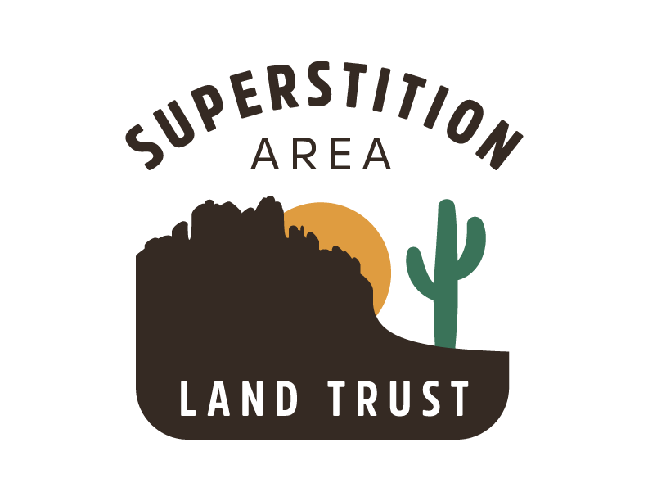
P.O. Box 582
Apache Junction, AZ 85117
480-983-3454
www.azsalt.org
info@azsalt.org

December 21, 2020

Dear Supporters,

The Superstition Foothills are widely known for beautiful vistas, iconic flora and fauna, precious water resources and remarkable recreational opportunities.

Please help SALT (Superstition Area Land Trust) fulfill its mission to conserve the natural Sonoran desert open spaces surrounding the Superstition Wilderness Area, thereby retaining the vistas, environment, and feel of the Apache Junction/Gold Canyon area.

Your membership, and that of many others, will demonstrate your support for SALT’s efforts to retain the character of the Apache Junction/Gold Canyon area and their surroundings.

These open spaces were designated as conservation lands in the Superstition Area Land Plan developed by SALT in the early 2000's. It appears there are only two possible long-term outcomes for these open spaces:

- Sold to the private sector for some type of development
- Sold for conservation at fair market value, likely as some type of Regional Park or as a National Monument or National Recreation Area.

How you can help support our mission

By becoming a member, you will demonstrate your support for SALT’s efforts to conserve the open spaces designated in the Superstition Area Land Plan. You will also receive up to date access to information on progress toward SALT’ s mission as well as volunteering opportunities to support SALT’s efforts.

Your membership fee will also help us raise funds toward purchase of these conservation lands, which are nearly all held in trust by the Arizona State Land Department. According to the State Constitution, State Trust Lands MUST be auctioned when put up for sale. We would therefore encourage you to consider joining at the maximum level you can afford. Membership levels are outlined on the SALT website at azsalt.org , and on the enclosed envelop.

NOTE - SALT has long had Sponsors, and some of you have been very loyal long-time Sponsors. We trust and request that you continue that support now that SALT’s BOD has approved switching from Sponsorships to Memberships; the BOD feels being a Member implies a closer mutual relationship and identity than does Sponsorship.

Thank you for your consideration and continued support of our mission. Donations can be made at www.azsalt.org/give-now or charity.gofundme.com/superstition-area-land-trust - as well as with the enclosed envelop.

Sincerely,

Charlie Goff,
President
SALT Board of Directors

