**Ladies in Training: Session 2: September 18th, 2015**

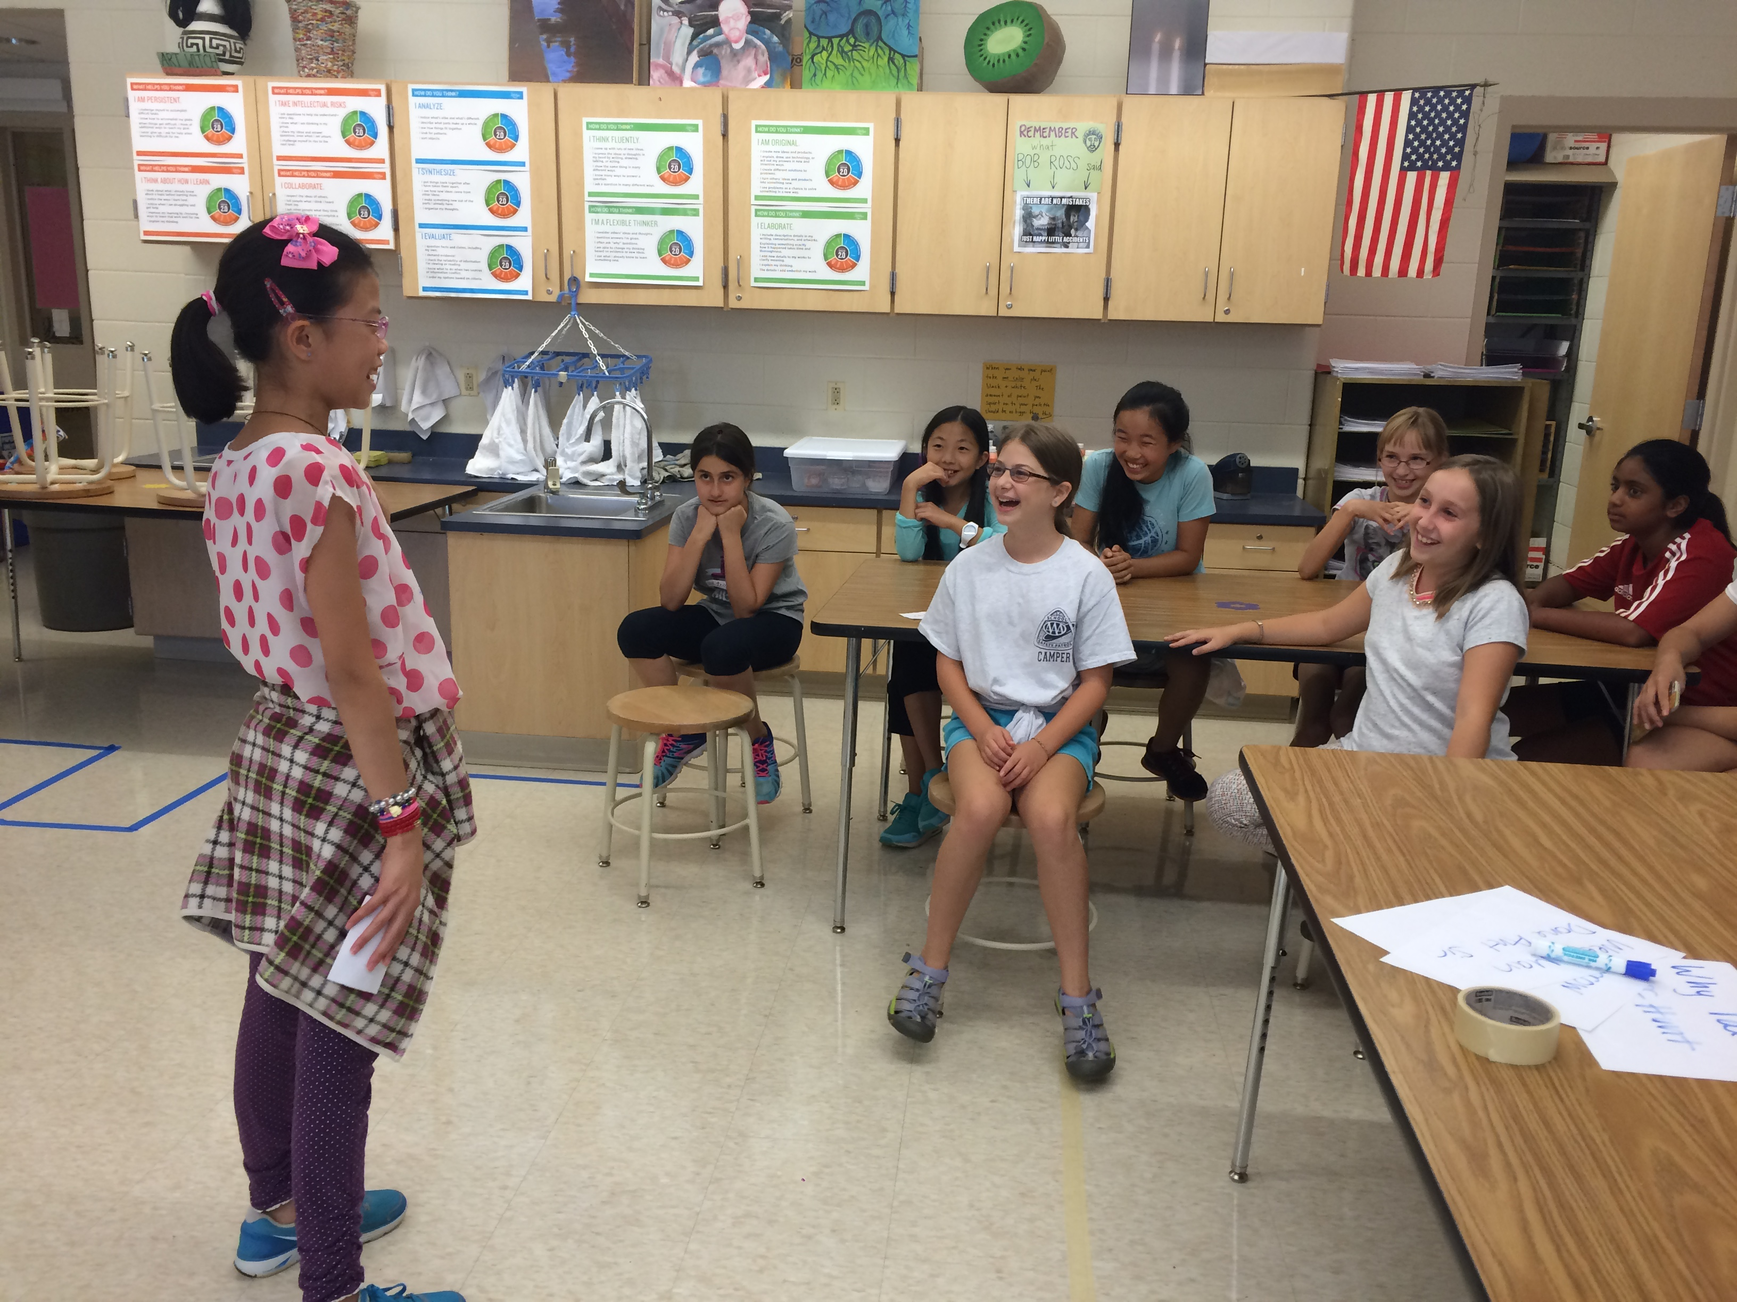This week at LIT, we focused on tips and tricks on how to be a better public speaker!

We first went over some focus points such as speaking with a loud and clear voice, maintaining eye contact, and using slight hand gestures to emphasize topics.

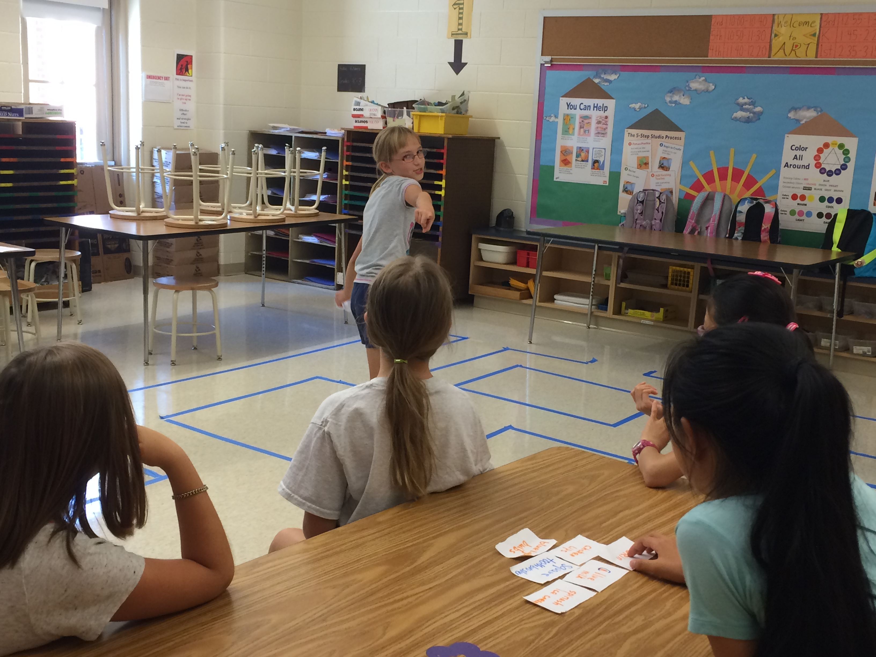We then played a fun presentation game to let the girls practice their delivery skills. The girls were each given a random topic (ex: banana peels or blue lights) and had to present a 30 second speech about it. Here’s the catch: they only had 10 seconds to prepare. Through this activity, the girls got to practice their improv skills and had lots of fun listening to each other’s entertaining speeches! Next session, we will be giving the girls individual feedback on how they can improve.

We then brought the well-known computer game Pac-man to life! We recreated a life-size Pacman maze on the floor, and used candy as the “food”. The girls were first split into two teams. They then had a mission to collect as much candy as they could through the maze without being tagged by the ghosts (Emily and Carissa). It was so much fun!

