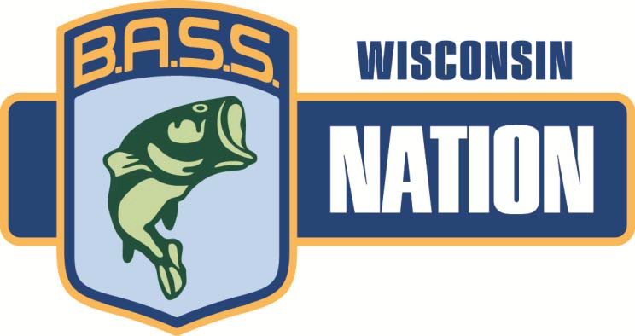

2018 WBN State Championship

Where: Winniconne Chain / Lake Winnebago

When: September 15th-16th, 2018 – Official Practice Date is Sept. 14th – All B.A.S.S./WBN rules will be adhered to on official practice days.

Take Off/Weigh-in: Waterfront Park

Pre-Tournament Meeting: Critters/Woodeyes – 7p.m. Registration starts a 5:30p.m.
Anglers must be OFF tournament waters by 5:00 p.m on Friday.

already.
Lodging: Hotels are at a premium – Do not hesitate finding and reserving rooms as they are available if you haven’t

BOUNDARIES:

The WBN Board would like to invite everyone to the WBN 2018 State Tournament Weekend.

Entry Forms must be in or postmarked by August 24th, 2018! Clubs are responsible to send an equal number of boaters and non-boaters. UNDER THE NEW FORMAT - DO NOT SEND AN UNEVEN NUMBER OF PARTICIPANTS!

All WBN tournament rules and regulations will apply and are posted on the WBN website: www.wisconsinbassnation.com.

For a renewing member:
- Must have their dues paid for by March 1st. If a renewing member pays for their dues after March 1st a $25.00 administrative fee per person will be required.
  - If a renewing member submits their tournament entry form after the listed deadline but prior to 3 days before the tournament, they will be charged a late fee of 50% of the tournament entry fee they are submitting the entry for.

For a new member:
  - If a new member’s dues are paid prior to March 1st, the new member will be eligible to compete in the State Tournament of the same year. If a new member’s dues are not paid by March 1st, the new member will not be eligible to compete in the same year’s
State Tournament.
    - If a new member’s due are paid before March 1st of the current year and submits their tournament entry form after the listed deadline but prior to 3 days before the tournament, they will be charged a late fee of 50% of the tournament entry fee they are
submitting the entry for.

Any questions regarding the tournament – please contact Tournament Director – Kyle Carpenter : 920-819-5731

WBN 2018 STATE TOURNAMENT INDIVIDUAL ENTRY FORM

Name: _
Club:

B.A.S.S. #

Please Check One: *Boater:
or *Non-Boater:

*Boaters and alternate boaters must send a copy of boat insurance with a minimum of $300,000 Liability along with this Form unless previously supplied for the current year. * ***All WBN tournament rules and Regulations will apply and are posted on the WBN web site www.wisconsinbassnation.com*** Copies of BASS cards will not be required to be submitted with this form but have them available if needed.

Tournament Fee: $150.00 boater/ $100.00 Non-boater

Having acquainted myself with the rules, I have completed this application and submit it for my Tournament entry. By signing this application, I hereby agree to be bound by and comply with all Tournament rules and regulations. I expressly assume all risks associated with the Tournament and hereby release W.B.N., the host, B.A.S.S. sponsors, and tournament officials from
all claims of injury and/or damage incurred in connection with this tournament. I further understand and agree that the Tournament Committee reserves the right to reject my application for any reason. I am currently a member in good standing of B.A.S.S. and the Wisconsin B.A.S.S. Nation.

Signature

Entry Forms must be in or post marked by August 24, 2018! PAY YOUR CLUB DIRECTLY. Your club is responsible to send in ONE CLUB CHECK, (Made payable to: WBN) with all entry forms, insurance copies and the CLUB ASSIGNMENT SHEET form completed.

Any questions please contact Chris Fredrick at 715-897-0668. Make club check or money order payable to “WBN” and mail to:

Brent Te Kulve 213 Main St.
Luxemburg, WI 54217
Phone: 920-370-5957
brent.tekulve@gmail.com

Any questions regarding the tournament – please contact Tournament Director – Kyle Carpenter : 920-819-5731

WBN 2018 STATE TOURNAMENT CLUB ASSIGNMENT FORM
To Be Filled out by each Club and sent in with ONE CLUB CHECK for all Club Participants with all entry forms and copies of insurance attached.

Please print legibly:

Club Name:

Club Contact:
Phone #

Boaters: 1 2
8 Phone#
9

3 10
4 11
5 12
6 13
7 14

Non-Boaters: 1 8
2 9
3 10
4 11
5 12
6 13
7 14

You must submit an equal number of boaters and non-boaters. * Please indicate if you are linked with another club member

Total # Boater Entry Fees:
@ $150.00 each = $_

Total # NonBoater Entry Fees:
_@ $100.00 each = $

Club Check #_

Grand Total Paid By Club = $

Entry Forms must be in or postmarked by August 24, 2018! Please pay for your entire club with one check. Send in all completed entry forms along with a copy of each boaters and alternate boaters insurance. Any questions please contact Chris Fredrick at 715-897-0668. Make out check or money order to “WBN” and mail to: Brent TeKulve – address below.

Club: |  |  | WBN 2018 State Championships
1. | Boater: | Name:
1. | Non-boater: | Name:
2. | Boater: | Name:
2. | Non-boater: | Name:
3. | Boater: | Name:
3. | Non-boater: | Name:
4. | Boater: | Name:
4. | Non-boater: | Name:
5. | Boater: | Name:
5. | Non-boater: | Name:
6. | Boater: | Name:
6. | Non-boater: | Name:
7. | Boater: | Name:
7. | Non-boater: | Name:
8. | Boater: | Name:
8. | Non-boater: | Name:
9. | Boater: | Name:
9. | Non-boater: | Name:
10. | Boater: | Name:
10. | Non-boater: | Name:

*Boaters that have not previously submitted a current copy of boat insurance with a minimum of $300,000 Liability MUST submit that document with this entry form. Please insure that the expiration date is not prior to this tournament. Copies of boat insurance are retained for the current year.

Tournament Fee: $150/boater $100/Non-Boater

***Please indicate if you have a “linked” boater or non-boater***

Make check or money order payable to “WBN” and mail check, entry form, AND COPY OF BOAT INSURANCE (if needed) to:

Brent Te Kulve 213 Main St.
Luxemburg, WI 54217
Phone: 920-370-5957
brent.tekulve@gmail.com

