Women Holocaust Survivors That Called
North Carolina Home

A. Video and Audio Testimony

Abramson, Gizella (Raleigh)
Internet Archive – Audio
World War II: A Symposium – 1995
https://archive.org/details/wwii186symposium/WWII_186_Session3_Holocaust.mp3
Gizella speaks from 26:22 to 35:00
Gizella speaks from 1:26:28 to 1:28:05

Addler, Hanna (Charlotte Metro)
Interview by WSOC-TV (3m55s)
https://www.wsoctv.com/news/local/i-was-there-i-saw-it-happen-charlotte-holocaust-survivors-hope-others-never-forget/OCZJLDVSFBALZM6SN2Y4M55LVQ/

Aranyi, Agnes Grossman (Charlotte Metro)
USHMM Oral History - 1990
https://collections.ushmm.org/search/catalog/irn504526

Boyd, Zohara (Western NC)
Center for Judaic, Holocaust, and Peace Studies
Appalachian State University -2019
Interviewed at a local middle school
https://holocaust.appstate.edu/library/center-lectures-and-testimonies/genocide-survivor-testimonies/z-boyd-child-holocaust

Cernyak-Spatz, Susan (Charlotte Metro)
USHMM Oral History – 1979
https://collections.ushmm.org/search/catalog/irn47955
USHMM Oral History – 1994
Three parts (total of 6 hours)
http://collections.ushmm.org/search/catalog/irn509009
Susan’s Introduction to the Protective Custody Audio Book
https://youtu.be/mLS0y2Bh68M

Center for Judaic, Holocaust, and Peace Studies Symposium (2015)
Appalachian State University
https://holocaust.appstate.edu/library/center-lectures-and-testimonies/genocide-survivor-testimonies/s-cernyak-spatzl-auschwitz
Wingate University: The Holocaust Remembered (2014)
https://www.youtube.com/watch?v=0AvWapLx_1M&t=104s

Chenkin, Suly (Charlotte Metro)
2012 Chapel Hill/Durham Community Holocaust Memorial Service
Suly speaks from 11:45 to 39:57
https://vimeo.com/266520921
Interview by WSOC-TV (2m19s)
https://www.wsoctv.com/news/local/i-was-there-i-saw-it-happen-charlotte-holocaust-survivors-hope-others-never-forget/OCZJLDVSFBALZM6SN2Y4M55LVQ/

Renate Chernoff (Durham)
USHMM Oral History – 2005
Note – This is an audio recording.
https://collections.ushmm.org/search/catalog/irn517206

Falk, Gabrielle (Triangle)
CVNC: An Online Arts Journal in North Carolina
This site contains a 4-part video on Gabrielle. The segments are entitled Family Historian; Gabrielle; Kristallnacht, and Falk Finale).
http://blog.cvnc.org/2019/04/29/gabrielle-falk-devoted-friend-of-chamber-music-and-musicians/

Fink, Renee (Triangle)
USHMM Oral History -2006
https://collections.ushmm.org/search/catalog/irn607950
The Holocaust Speaker’s Bureau
On the Back of a Stranger’s Bike: The Renee Fink Story (4 Parts)
https://www.youtube.com/watch?v=eJAiC7fJXSo&list=PL_fMIWKr6JjZHWrS7GgLop0qz4kNoA35r
North Carolina Council on the Holocaust Webinar with Renee
https://youtu.be/MQAfcGbo_ns
Finkler, Kaja (Chapel Hill area)
USHMM Oral History Collection
https://collections.ushmm.org/search/catalog/irn611761
Holocaust Education Center – Milwaukee
https://youtu.be/mzksr_7M2jA

Gelissen, Rena Kornreich (Hendersonville)
Salem Collage (1994)
https://youtu.be/J4J3afVzo5s
There are 8 parts to this testimony. Each segment is between 4 and 10 minutes in length.
USC Shoah Foundation -1996
https://www.youtube.com/watch?v=G3pasgc2I7s

Hauser, Rebecca (Triangle)
The Holocaust Speaker’s Bureau
A Greek Girl in Auschwitz: The Rebecca Hauser Story (7 Parts)
https://www.youtube.com/watch?v=UbPudYTSWgs&list=PL_fMIWKr6JjZOLkq3fT_OtPcrnF3iMZyv

Hirshfeld, Frances (Gaston County)
USHMM Oral History
https://collections.ushmm.org/search/catalog/irn520364

Hoffman, Hildegard (Asheville)
UNCA Ramsey Library Video Production

It Could Happen to Me: Hilde's Story
https://www.youtube.com/watch?v=VQSp6sK5kCU

Kizhnerman, Raya (Greensboro)
USC Shoah Foundation -1998
https://vhaonline.usc.edu/viewingPage?testimonyID=50735&returnIndex=0
USHMM Oral History -2006
(Rachel with Shelly Weiner)
https://collections.ushmm.org/search/catalog/irn607952
Return to Rivna: A Centropa Film
Tells how Shelly Weiner and Raya Kizhnerman survived the Holocaust.
https://youtu.be/wzo4H7QWl_Y

Lederman, Esther Gutman (Triangle)
Holocaust Speaker’s Bureau
Hiding for Our Lives: The Esther Lederman Story (4 parts)
https://www.youtube.com/watch?v=J1mvWa2ky5M&list=PL_fMIWKr6JjYuUkFpF_rdlUoMzo3T5Qc-

Lipman, Simone (Triangle)
USHMM Oral History (Audio Only) -1998
https://collections.ushmm.org/search/catalog/irn506653
USHMM Oral History Collections -2006
https://collections.ushmm.org/search/catalog/irn607951
USHMM Oral History Collection - 1990
https://collections.ushmm.org/search/catalog/irn504630
Defying Genocide, conversation with Simone Weil Lipman and Damas Gisimba, director of an orphanage in Rwanda that was besieged by militias during the 1994 genocide. (USHMM) – 3 parts
https://youtu.be/TbM4ux8SKII

Lobree, Margot (Winston-Salem)
North Carolina Council on the Holocaust Webinar with Margot
https://youtu.be/DnReR93vm1g
NC Council on the Holocaust Webinar: A Conversation with Kindertransport Survivor Margot Lobree
https://youtu.be/UAeckw9taCY
Zoom with a Class: Margot and Lynda Moss
https://drive.google.com/file/d/19Ne7Lmc4962aKYPbIYZeIq7wYYi7YRv5/view?ts=620ea0e0

Meissner, Margit (Black Mountain College Student -Asheville)
USHMM Oral History Collection
https://collections.ushmm.org/search/catalog/irn706900

Merlin, Bronia (Wilmington)
*Possibly an interview conducted by her grandchildren
https://youtu.be/7iVSxBIBNwI

Miller, Marianna (Wake County)
One of 5 Wake County Holocaust Survivors featured in the film, “Where Can I Go?
https://www.thejusticetheaterproject.org/where-can-i-go
The film is available for rental on Vimeo OnDemand.
https://vimeo.com/ondemand/wherecanigo

Roberts, Marianne (Triangle)
USHMM Oral History Collection (audio) - 2012
https://collections.ushmm.org/search/catalog/irn46823
USHMM – Mary Cohn Roberts Collection (147 Digitized Items)
https://collections.ushmm.org/search/catalog/irn46682#?rsc=132485&cv=1&c=0&m=0&s=0&xywh=-427%2C0%2C1657%2C1085

Rodbell, Barbara (Triangle)
USHMM Oral History -1984
https://collections.ushmm.org/search/catalog/irn520379
USHMM Oral History -1990
https://collections.ushmm.org/search/catalog/irn504687
USHMM Oral History (Audio Only) - 1998
https://collections.ushmm.org/search/catalog/irn506651

Ross Edith Neuberger (Triangle)
USC Shoah Foundation – 1997
https://www.youtube.com/watch?v=dXifQsbQ-ZA

Schoenfeld, Margaret (Charlotte)
USHMM Oral History
Note – This is an audio testimony.
https://collections.ushmm.org/search/catalog/irn42727

Shapiro-Rieke, Daisy (Charlotte)
Interview by WSOC-TV (1m52s)
https://www.wsoctv.com/news/local/i-was-there-i-saw-it-happen-charlotte-holocaust-survivors-hope-others-never-forget/OCZJLDVSFBALZM6SN2Y4M55LVQ/

Stahl, Helen Rosenwald (Durham)
https://collections.ushmm.org/search/catalog/irn611760

Frieda Roos Van-Hessen (Charlotte Metro)
Escaping the Shadow of the Holocaust
https://play.inspirationtv.com/programs/friedas-testimony-escaping-the-shadows-of-the-holocaust

Frieda Roos Van-Hessen: From Singer to Holocaust Survivor
https://www.youtube.com/watch?v=Cmqiwb0QQ9k
USC Shoah Foundation
https://sfi.usc.edu/video/frieda-roos-van-hessen-moving-bad-job-career-singing

Vogelhut, Runia (Charlotte)
Internet Archive – Audio
World War II: A Symposium – 1995
https://archive.org/details/wwii186symposium/WWII_186_Session3_Holocaust.mp3
Runia speaks from 43:50 to 49:03

Weiner, Shelly (Greensboro)
NCHERO At NCCAT -2011
https://libresearch.uncg.edu/holocaust/eyewitnesses/testimonies.html
USHMM Oral History -2006
(Shelly with Rachel Kizhnerman)
https://collections.ushmm.org/search/catalog/irn607952
North Carolina Council on the Holocaust Webinar with Shelly
https://youtu.be/ccF22MsK3ZM
Return to Rivna: A Centropa Film
Tells how Shelly Weiner and Raya Kizhnerman survived the Holocaust.
https://youtu.be/wzo4H7QWl_Y

Weinerman, Eva (Wake County)
One of 5 Wake County Holocaust Survivors featured in the film, “Where Can I Go?
https://www.thejusticetheaterproject.org/where-can-i-go
The film is available for rental on Vimeo OnDemand.
https://vimeo.com/ondemand/wherecanigo

B. Reading from The North Carolina Survivor Narratives
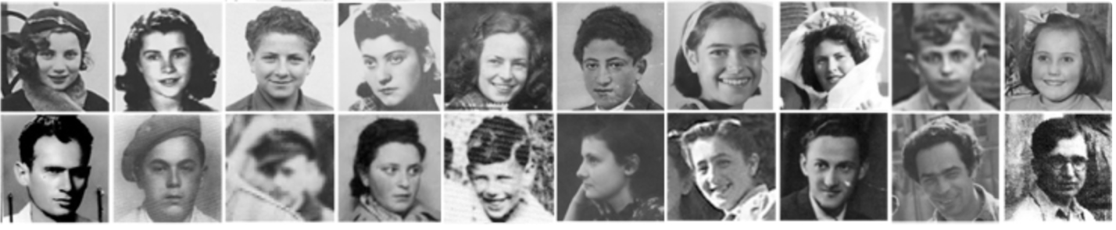

These are Holocaust survivor narratives found in The Holocaust: A North Carolina Teacher’s Resources.
https://www.dpi.nc.gov/districts-schools/classroom-resources/academic-standards/programs-and-initiatives/nc-council-holocaust/teachers-guide-holocaust
The North Carolina Survivor Narratives is located here:
https://www.dpi.nc.gov/districts-schools/classroom-resources/academic-standards/programs-and-initiatives/nc-council-holocaust/holocaust-survivor-narratives

These are the Narratives from Women:
Hitler’s Rise: Young Jews Become Aware
Includes Testimony from Barbara Ledermann Rodbell, Simone Weil Lipman, and Susan Eckstein Cernyak-Spatz.
https://www.dpi.nc.gov/media/10314/open

Ghetto: Gizella in the Lutsk Ghetto
Testimony from Gizella Abramson
https://www.dpi.nc.gov/media/10317/open

The Camps: Esther and Elias Are Sent to Auschwitz
Includes testimony from Esther Mordechai
https://www.dpi.nc.gov/media/10320/open

The Camps: Susan Aims for Survival
Testimony from Susan Eckstein Cernyak-Spatz.
https://www.dpi.nc.gov/media/10321/open

The Camps: Rena Makes a Promise
Testimony from Rena Kornreich
https://www.dpi.nc.gov/media/10325/open

Resistance: Gizella Joins the Resistance
Testimony from Gizella Abramson
https://www.dpi.nc.gov/media/10326/open

Resistance: Barbara Gets False ID Papers
Testimony from Barbara Ledermann
https://www.dpi.nc.gov/media/10327/open
Resistance: Simone Saves Refugee Children
Testimony from Simone Weil
https://www.dpi.nc.gov/media/10328/open

Hidden Children: Shelly and Rachel Hide on a Farm
Testimony from Shelly Weiner and Rachel Giralnik
https://www.dpi.nc.gov/media/10329/open

Hidden Children: Renee Hides with a Catholic Family
Testimony from Renee (Laser) Fink
https://www.dpi.nc.gov/media/10330/open

Hidden Children: Esther’s Rescuers Are Honored
Includes testimony from Esther Gutman
https://www.dpi.nc.gov/media/10331/open

Liberation: Edith is Freed in Auschwitz
Testimony from Edith Neuberger
https://www.dpi.nc.gov/media/10333/open

C. Books

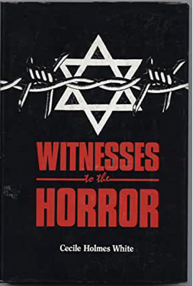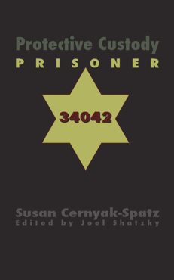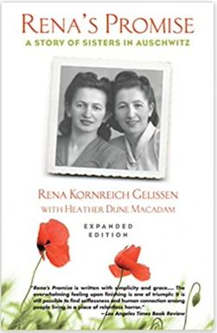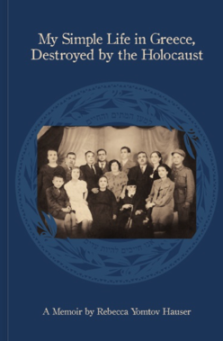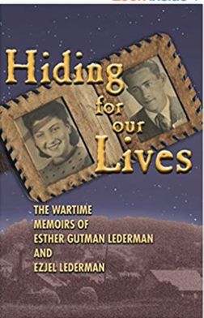
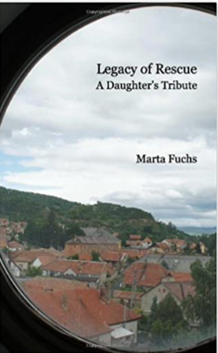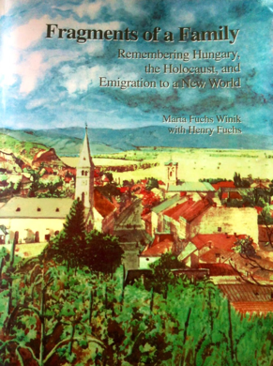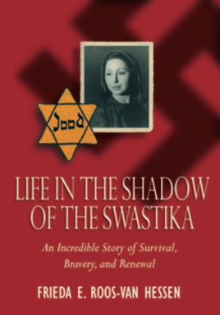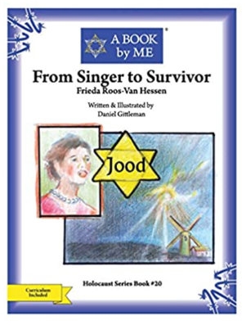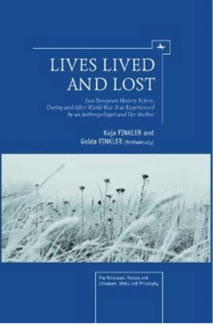

The following books recount experiences by women survivors who later called North Carolina their home

Witness to the Horror: North Carolinians Remember the Holocaust by
Cecile Holmes White. North Carolina Council on the Holocaust, 1987.
A pdf of the book is available here:
http://divinityarchive.com/bitstream/handle/11258/6330/witnessestohorro00whit.pdf?sequence=1&isAllowed=y
The following women have testimony and narratives located in the book: Gizella Abramson, Susan Cernyak-Spatz, Florence Goematt, Klari Kletter, Esther Mordechai. Eva Weiner, and Shelly Weiner.

Protective Custody: Prisoner 34042 by Susan Cernyak-Spatz; ed. Joel Shatzky. N & S Publishers. New York, 2005.
https://www.amazon.com/Protective-Custody-Prisoner-Susan-Cernyak-Spatz/dp/0975326848/ref=sr_1_2?crid=26MBSOJYIOOAJ&keywords=Protective+Custody%3A+Prisoner+34042&qid=1645152892&s=books&sprefix=protective+custody+prisoner+34042+%2Cstripbooks%2C55&sr=1-2

Rena’s Promise: A Story of Sisters in Auschwitz by Rena Kornreich Gelissen with Heather Dune Macadam, Beacon Press, Boston, Massachusetts, 2015.
Note – See lesson plan in Section
https://www.amazon.com/Renas-Promise-Story-Sisters-Auschwitz/dp/0807093130

My Simple Life in Greece…Destroyed by the Holocaust by Rebecca Yomtov Hauser, Lulu Books, 2012.
Note – See lesson plan in Section
https://www.lulu.com/en/us/shop/rebecca-yomtov-hauser/my-simple-life-in-greecedestroyed-by-the-holocaust/hardcover/product-22753970.html?page=1&pageSize=4

Hiding For our Lives: The Wartime Memoirs of Esther Gutman Lederman and Eziel Lederman, BookSurge Publishing, 2007.
Note – See lesson plan in Section
https://www.amazon.com/Hiding-Our-Lives-wartime-Lederman/dp/1419680021

Legacy of Rescue: A Daughter’s Tribute by Marta Fuchs. Lulu Books, Csaladnak Press, 2012.
Note – This book is primarily the story of the author’s father (Morton Fuchs) but there are sections that focus on her mother, Ilona Fuchs.
Note – See lesson plan in Section
https://www.amazon.com/Legacy-Rescue-Daughters-Marta-Fuchs/dp/0977873501

Fragments of a Family: Remembering Hungary, the Holocaust, and Emigration to a New World by Marta Fuchs and Henry Fuchs.
Note – This book contains the story of Ilona Fuchs and her husband Morton Fuchs.
Note – This book is out of print. Segments of the book can be found here:
https://www.martafuchs.com/fragments-of-a-family

Life in the Survival in the Shadow of the Holocaust: An Incredible Story of Survival, Bravery, and Renewal by Frieda E. Roos-van Hessen, Harvest Day Books, 2006.
Note – See lesson plan in Section
https://www.amazon.com/Shadow-Swastika-Frieda-Roos-van-Hessen/dp/0974134589/ref=sr_1_2?crid=NL172GH89YDS&keywords=Frieda+Roos+Van-Hessen&qid=1645156834&s=books&sprefix=frieda+roos+van-hessen+%2Cstripbooks%2C116&sr=1-2

From Singer to Survivor: Frieda Roos-van Hessen (A BOOK by ME) by Daniel Gittleman, CreateSpace Independent Publishing, 2015.
https://www.amazon.com/Singer-Survivor-Frieda-Roos-Van-Hessen/dp/1514299577/ref=pd_lutyp_rtpb_2/138-0036157-7485355?pd_rd_w=04GSc&pf_rd_p=6c79b04b-ecbc-4460-96b6-0cddfcbe676e&pf_rd_r=FS7RY6P77H7T0T4E4NKW&pd_rd_r=b7d673bc-dcfd-4702-8c70-0d837900b82b&pd_rd_wg=OnL4a&pd_rd_i=1514299577&psc=1

Lives Lived and Lost: East European History Before, During, and After World War II as Experienced by an Anthropologist and Her Mother by Kaja Finkler and Golda Finkler, Academic Studies Press, 2012.
Note – Contains the story of Kaja Finkler
https://www.amazon.com/Lives-Lived-Lost-Experienced-Anthropologist/dp/1936235900/ref=sr_1_1?crid=UV4EUM4QAAPZ&keywords=Lives+Lived+and+Lost%3A+East+European+History+Before%2C+During%2C+and+After+World+War+II+as+Experienced+by+an+Anthropologist+and+Her+Mother+%28The+Holocaust%3A+History+and+Literature%2C+Ethics+and+Philosophy%29&qid=1645157157&s=books&sprefix=lives+lived+and+lost+east+european+history+before%2C+during%2C+and+after+world+war+ii+as+experienced+by+an+anthropologist+and+her+mother+the+holocaust+history+and+literature%2C+ethics+and+philosophy+%2Cstripbooks%2C137&sr=1-1

D. Films

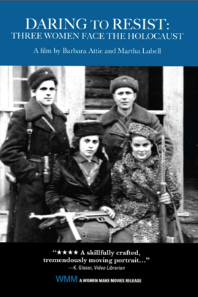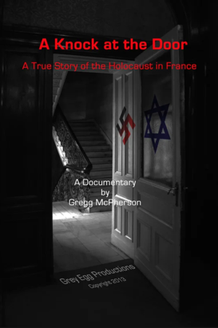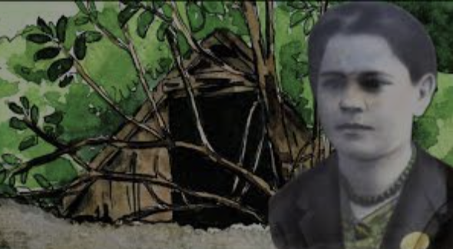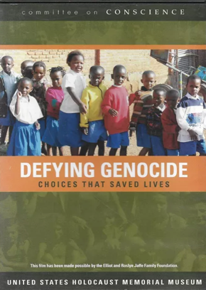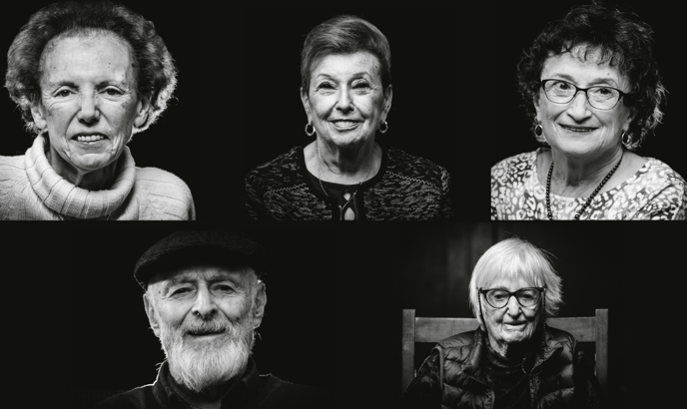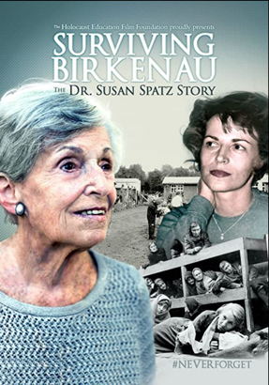
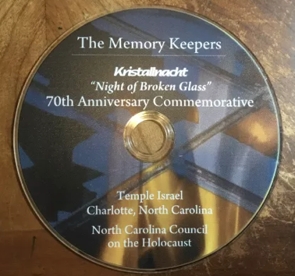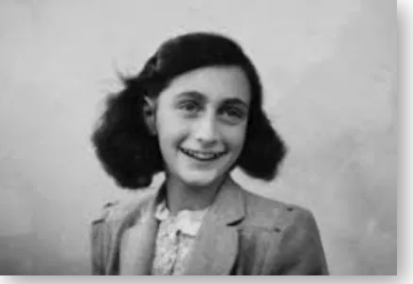

Daring to Resist: Three Women Face the Holocaust
Note – Includes the story and testimony of Barbara Rodbell
IMDb: https://www.imdb.com/title/tt0988962/
For Sale ($19.95) at Women Make Movies
https://www.wmm.com/catalog/film/daring-to-resist-three-women-face-the-holocaust/
For Rent ($4.99) at Vimeo
https://www.wmm.com/catalog/film/daring-to-resist-three-women-face-the-holocaust/

A Knock at the Door
Note – The subject of the is Paulette Terwilliger (Durham area)
IMDb: https://www.imdb.com/title/tt4814946/?ref_=fn_al_tt_5
Website for the Film: http://aknockatthedoor.weebly.com
The film is available on Vimeo on Demand
https://vimeo.com/ondemand/aknockatthedoor
The cost is $1.99 to rent and $8.00 to own.
A DVD can be purchased for $15.

Return to Rivna: A Holocaust Story
Centropa, 2015
https://www.centropa.org/centropa-cinema/return-rivne-holocaust-story?language=en
This site contains the film, the script, a study guide, and lesson plans.

Defying Genocide
USHMM
https://www.ushmm.org/genocide-prevention/countries/rwanda/video-defying-genocide
Note – Features Simone Weil Lipman

Where Can I Go?
https://www.thejusticetheaterproject.org/where-can-i-go
The film is available for rental on Vimeo OnDemand.
https://vimeo.com/ondemand/wherecanigo

Surviving Birkenau: The Dr. Susan Spatz Story
Dreamscape
IMDb: https://www.imdb.com/title/tt9437984/?ref_=fn_al_tt_1
Note – Available for free streaming on Amazon Prime
Note: Available for purchase (($17.74)
https://www.amazon.com/gp/product/B07MGJ6WJK/ref=as_li_qf_asin_il_tl?ie=UTF8&tag=soundmed1-20&creative=9325&linkCode=as2&creativeASIN=B07MGJ6WJK&linkId=f24332acf33343dcd6cf7afa4c9f0b9c

Kristallnacht: The Night of Broken Glass: 70th Anniversary Edition
The Memory Keeps
Temple Israel: Charlotte
Note – Includes testimony from women survivors.
Note – Contact Lee Holder (historyhawk308@gmail.com) to borrow a DVD copy.

Anne Frank: North Carolina Students Respond
Portions were produced by students at Kiser Middle School and Grimsley High School in Greensboro, N.C. in 1988.
Note: Contact Lee Holder (historyhawk308@gmail.com) to borrow a DVD copy

E. Drama/Theater

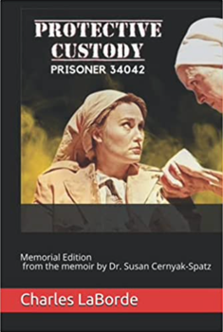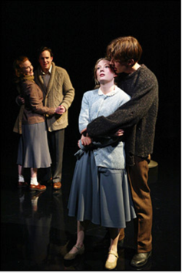

Protective Custody Prisoner 34042: Memorial Edition by Charles LaBorde, Independently Published, 2021.
https://www.amazon.com/Protective-Custody-Prisoner-34042-Memorial/dp/B094T5SDLC/ref=sr_1_1?crid=3389W0LFZ80H0&keywords=Protective+Custody+Prisoner+34042%3A+Memorial+Edition&qid=1645159276&sprefix=protective+custody+prisoner+34042+memorial+edition+%2Caps%2C140&sr=8-1

The Last Bridge by Wendy Kesselman
Note – based on the Life of Barbara Lederman Rodbell
Reviews:
https://www.nytimes.com/2003/04/06/nyregion/theater-review-a-theater-of-witness-the-story-of-a-survivor.html

https://www.communitynews.org/princetoninfo/artsandentertainment/drama-review-the-last-bridge/article_f2842d94-3f8f-50d3-9e28-c3b85a5fc1b2.html

F. Oral Histories Archived at USHMM or at USC Shoah Foundation
Note – These testimonies require a visit to the USMM or an institution that has access to the USC Shoah Foundation testimonies.

The Arnold S. Task Collection at USHMM Oral Histories Collection
*The following testimonies are not digitized but are available to be viewed at USHMM.
1. Dr. Susan Cernyak-Spatz
2. Florence Goemaat
3. Ursala Hekler (with her husband, Norman Hekler)
4. Clari Kletter
5. Esther Mordechai

USHMM Oral Histories Collection
*The following testimonies are not digitized but are available to be viewed at USHMM. This testimony is on 2 DVDs and can possibly be viewed by contacting USHMM.
1. Renia Chadajo
2. Agnes and Robert Heller
3.Charlotte Wertheim

USC Shoah Foundation
Note – Can be viewed at Appalachian State University, Duke University, UNC -Chapel Hill, UNC-Greensboro, UNC – Wilmington, and Wake Forest University.
A partial list of testimonies that are available include:
- Agnes Aranyl
2. Susan Cernyak-Spatz
3. Renee Fink
4. Ilona Fuchs
5. Esther Gutman Lederman
7. Frieda Ross Van-Hessen
8. Runia Vogelhut
9. Eva Weiner

G. From Shoah to the Mountains- The UNC Asheville Special Collections and University Archives

This collection contains summaries and transcripts of oral history interviews, and photocopies of additional materials such as photographs, documents, etc. There are a small number of audio recordings.
http://toto.lib.unca.edu/findingaids/oralhistory/SHOAH/default_shoah.html

Note- The following women have testimonies archived at this site. They are:
- Ruth Chicurel
- Trube Heller
- Hildegard Hoffman
- Janice Kahn
- Lotte Meyerson
- Rita Reiser
- Miriam Rudoe
- Jeanette Vanderwart

“Choosing To Remember: From the Shoah to the Mountains”
Notes: The is a digital poster exhibit set that features survivors from the Holocaust that settles in western North Carolina after the World War II. It was created by the Center for Diversity in Asheville. Each poster is rich with information and photographs. The website to access the 20-poster set is:
http://toto.lib.unca.edu/findingaids/oralhistory/SHOAH/choosing%20to%20remember.pdf
Note: the following women are highlighted in this poster set:
Hilde Cohn Hoffman Ruth Marx Chicurel
Edna Lichtenfel Miriam Figatner Rudow
Lore Schiftan Jeanette Goldberg Vandewart
Janice Lakin Kahn Lily Gluck Lerner
Carla Sikerstein Sandler Cecilia Atberger Baumgarten
Rivka (Rita) Klahr Reiser Lotte Straus Meyerson
Trude Schonthal Heller Irma Majerowicz

H. Lesson Plans

- A Greek Girl in Auschwitz- Rebecca Yomtov Hauser’s Story
Carolina K-12
https://k12database.unc.edu/wp-content/uploads/sites/31/2015/04/RebeccaHauser.pdf

- Women in Auschwitz (Yad Vashem)
Holocaust Memorial Activity
(Recommended for use with Susan Cernyak-Spatz’s book and testimony. It is also applicable for use with Rena Kornreich Gelissen’s book and testimony.)
https://www.google.com/search?client=safari&rls=en&q=www.yadvashem.org%2Feducation%2Feducational-+materials%2Fceremonies%2Fwomen-auschwitz.html&ie=UTF-8&oe=UTF-8

- Rena’s Promise Website which contains an education section. This section has an interactive Timeline, an area for teachers, and an area for students.
http://www.renaspromise.com

- Survival and Resistance: Hidden Children of the Holocaust
Carolina K-12
Note – Uses the testimony of Renee Fink
https://k12database.unc.edu/wp-content/uploads/sites/31/2015/01/HiddenChildren.pdf

- How & Why Did the Holocaust Occur?
Exploring Action and Inaction through the Survival Story of Esther Gutman Lederman
Carolina K-12
https://k12database.unc.edu/wp-content/uploads/sites/31/2016/06/ActionInactionHolocaustLederman.pdf

- Using the Centropa Film, Return to Rivna, in the Classroom
North Carolina Council on the Holocaust Webinar – 3/16/21
Note – Four experienced classroom teachers share their lesson idea
https://ncholocaustcouncilworkshops.org/spring-2021-webinars/

- Daring to Resist: Three Women Face the Holocaust
Note – Includes the story and testimony of Barbara Rodbell
https://www.pbs.org/daringtoresist/barbara.html

- Life in the Shadow of the Swastika
Note – This is the website for Frieda Roos Van-Hessen
http://www.ahavahpublishing.com

I. Magazine, Journals, and Newspaper Articles

“All that Remains”
Charlotte Magazine
10 Charlotte Area Holocaust Survivors
The women that are included are Agnes Aranyi, Suly Chenkin, Susan Cernyak-Spatz, Lore Schiftan, and Juliana Toth (SC)
https://www.charlottemagazine.com/all-that-remains/pic/15883/

Gizella Abramson
“May you always walk on the sidewalk”
https://www.newsoforange.com/news/article_0cc1c458-c768-582e-b9a8-8fdcb288c39e.html

Hanna Adler
“We Remember”
https://congregationemanuelnc.com/we-remember-holocaust-survivors-moving-story-shared/

Marlene Appley
“Words from a Holocaust Survivor: Marlene Appley”
https://www.elon.edu/u/news/2012/04/17/words-from-a-holocaust-survivor-marlene-appley-tuesday-april-17/
“Remembrance Through the Eyes of a Survivor”
https://www.elonnewsnetwork.com/article/2012/04/remembrance-through-the-eyes-of-a-survivor

Zohara Boyd
“Wilkes Woman: A Holocaust Survivor”
https://the-record-newspaper.tumblr.com/post/173068918495/wilkes-woman-a-holocaust-survivor-part-ii

Dr. Susan Cernyak-Spatz
“Prisoner No. 34042: Susan Cernyak-Spatz Survives Holocaust with Realism, not Faith”
https://theappalachianonline.com/prisoner-no-34042-dr-susan-cernyak-spatz-survives-holocaust-with-realism-not-faith/

Suly Chenkin
“Holocaust Survivor Speaks on Her Journey to Freedom”
https://panthernow.com/2021/01/28/holocaust-survivor-speaks-on-her-journey-to-freedom/

Renee Fink
Nancy Lefenfeld, “Memory, Knowledge, and Family Love,” on Renée Fink’s experience as a hidden child and her life after the war, Prism: An Interdisciplinary Journal for Holocaust Education, Spring 2017, 25-34.
https://www.yu.edu/sites/default/files/inline-files/PRISM-2017.pdf

Kaja Finkler
“Holocaust Survivor Tells Her Story for the First Time”
https://www.technicianonline.com/news/holocaust-survivor-tells-her-story-for-the-first-time/article_6ea7993e-c57e-11e5-be07-1bd818e252f1.html

Rena Kornreich Gelissen
“How Two Sisters’ Love Helped Them Survive Auschwitz”
https://www.nationalgeographic.com/culture/article/150415-ngbooktalk-nazis-auschwitz-holocaust-survivors
Agnes and Robert Heller
Share Stories of Sorrow, Triumph During Holocaust Remembrance Day
https://www.elon.edu/u/news/2020/02/14/agnes-and-robert-heller-share-stories-of-sorrow-triumph-during-holocaust-remembrance-day/

Hildegard Hoffman
“Remembering the Holocaust: The Hilde Hoffman’s Story”
http://libjournals.unca.edu/specialcollections/jewish-life-in-western-north-carolina/remembering-the-holocaust-part-1-hilde-hoffmans-story/

Esther Gutman Lederman
“Holocaust Survivor Tells Story to Base”
https://www.pope.af.mil/News/Article-Display/Article/242751/holocaust-survivor-tells-story-to-base/

Margot Lobree
“Survivors Remember the Holocaust”
https://www.elkintribune.com/news/28698/survivors-remember-the-holocaust

Margit Meissner
“As American Awareness Fades, Holocaust Museum Refreshes the Story”
https://www.ideastream.org/news/as-american-awareness-fades-holocaust-museum-refreshes-the-story

Helen Rosenwald Stahl
“Revisiting the Russell School”
https://www.ourstate.com/revisiting-the-russell-school/

Frieda Ross Van-Hessen
https://www.fox5atlanta.com/news/north-carolina-holocaust-survivor-celebrates-103rd-birthday

Ronia Vogelhut
“Holocaust Subject of WPCC Forum”
https://www.wpcc.edu/archives/speakerforums/1995_Forum_Neighbor.pdf

Shelly Weiner
“Holocaust Survivor Speaks About Experiences, Indifference to Injustice”
https://www.johnsoncitypress.com/living/features/holocaust-survivor-speaks-about-experience-indifference-to-injustice/article_b9725921-ef14-5bf1-96da-7c0a6fef6331.html

J. North Carolina Council on the Holocaust

Resources on Women in the Holocaust
Faces of Resistance: Women in the Holocaust
https://ncholocaustcouncilworkshops.org/faces-of-resistance/
Traveling Exhibits (6)
- Women in Resistance
- Everyday Life in the Ghetto
- Armed Struggle in the Ghetto
- Women Partisans: Fighting in the Forest
- Resistance in the Camps
- Final Solution to the Jewish Question

Traveling Suitcase Exhibits
https://ncholocaustcouncilworkshops.org/suitcase-exhibits/
There are 2 suitcases related to educational resources on a young girl and 3 suitcases related to educational resources for a woman. The website linked above details the items in each suitcase. All 5 of theses suitcases are unique.

Triumph of Life: Jewish Resistance to Nazi Oppression
https://ncholocaustcouncilworkshops.org/triumph-of-life/
Note – Many of the 44 panels relate to women.

Fences, Walls, and Butterflies: Children Confront the Holocaust through Art
Note: Many of the 15 framed panels of original art was created by young Israeli girls.
https://ncholocaustcouncilworkshops.org/fences-walls-and-butterflies/

K. Miscellaneous

Women of the Shoah
Note – North Carolina’s first and only women’s Holocaust monument, an original sculpture by artist Victoria Milstein, will honor the strength and resilience of all women.
https://womenoftheshoahjp.org

Women and the Holocaust: Courage and Compassion
United Nations Outreach Program in partnership with the USC Shoah Foundation Institute for Visual History and Education, Vad Vashem, and The Holocaust Martyr’s and Heroes’ Remembrance Authority
Study Guide
https://www.un.org/sites/un2.un.org/files/women_and_the_holocaust_english.pdf

Vad Vashem
Spots of Light: Women in the Holocaust
https://www.yadvashem.org/yv/en/exhibitions/women-in-the-holocaust/index.asp
Panels (21)
https://www.yadvashem.org/yv/en/exhibitions/ready2print/pdf/spots-of-light-21.pdf
Panels (30)
https://www.yadvashem.org/yv/en/exhibitions/ready2print/pdf/spots-of-light-30.pdf
Note – These are not for copying. They are for viewing. They can be requested through the Ready2Print program at Vad Vashem. There are other exhibits also available for purchase through Ready2Print.

USHMM
Women in the Holocaust
https://encyclopedia.ushmm.org/content/en/article/women-during-the-holocaust

Heller, Agnes (Alamance County)
Read by Sophie Thompson (a Middle School Student) for a Class Project
The Ghettoization and Bombing of Hungary During WWII – Audio
Use Your Words Podcast (2003)
https://anchor.fm/useyourwords/episodes/Agnes-Heller-The-Ghettoization-and-Bombing-of-Hungary-during-WWII-eftnc8

Agnes Heller
Webpage on the Virginia Holocaust Museum Website
https://www.vaholocaust.org/agnes-heller/

Fuchs, Ilona
Exile and Return: The Personal Story of Ilona Engel Fuchs
https://kehillahsynagogue.org/wp-content/uploads/2012/08/fuchs-speech.pdf

Chenkin, Suly
The Levine JCC Butterfly Project
http://www.charlottejcc.org/clientuploads/Butterfly%20Project/Suly%20Chenkin.pdf

Rena’s Promise: A Story of Sisters in Auschwitz
Note – History Place: A Writer’s Corner
https://www.historyplace.com/specials/writers/promise.htm

Beltline to Broadway Podcast
“Where Can I Go? A Candid Conversation with Five Survivors of the Holocaust”
April 26, 2021
Note – Contains conversations with Marianna Miller and Eva Weinerman.
https://beltlinetobroadway.org/2021/04/26/ep-95-where-can-i-go-a-candid-conversation-with-five-survivors-of-the-holocaust/

L. Women Holocaust Survivors Who Came to Call North Carolina Home

Note: The following is not a complete photographic list. For a more comprehensive presentation of photographs please lick the Goggle Slide link.
A special thanks to Marianne Wason for providing the photographs, slides, and collages.
https://docs.google.com/presentation/d/1gynFaJlfvvFiQcJnt-rpmFHKygh-YnpOmxQosYml2bs/edit?usp=sharing

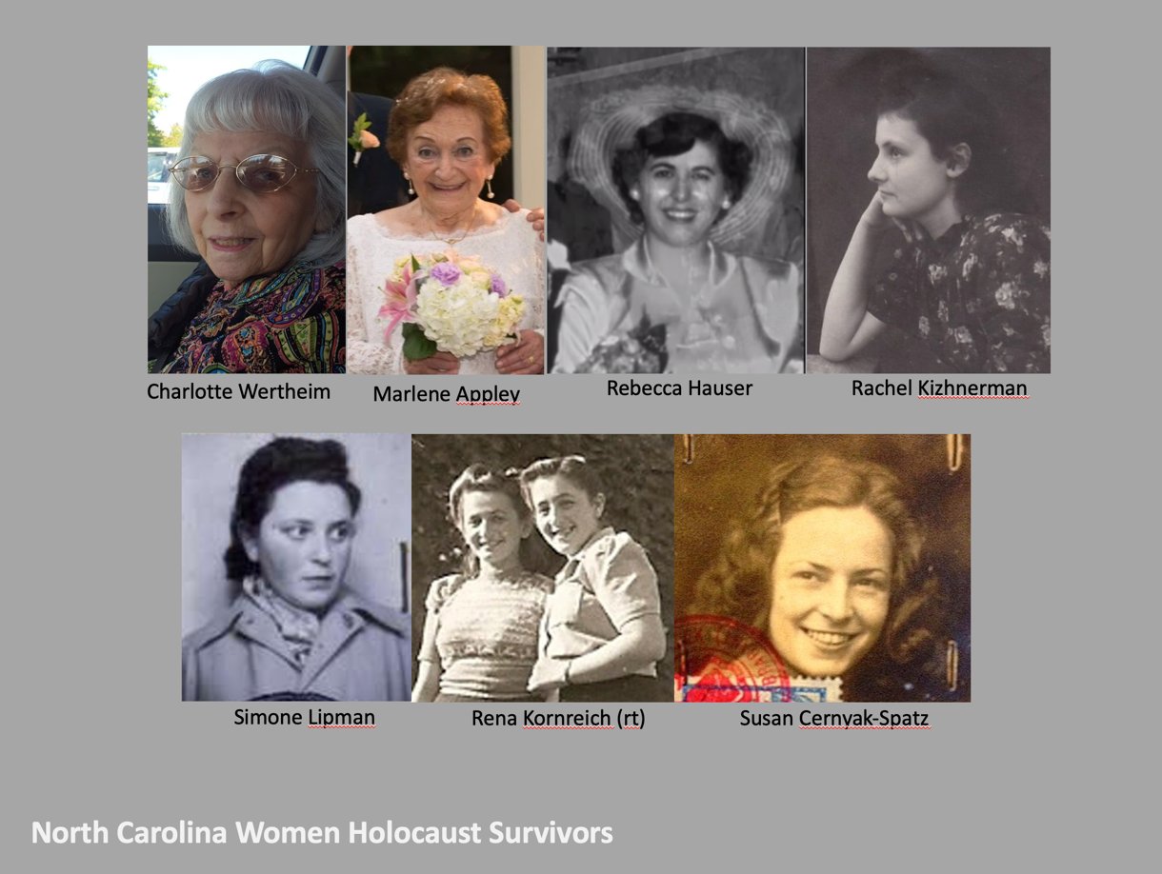
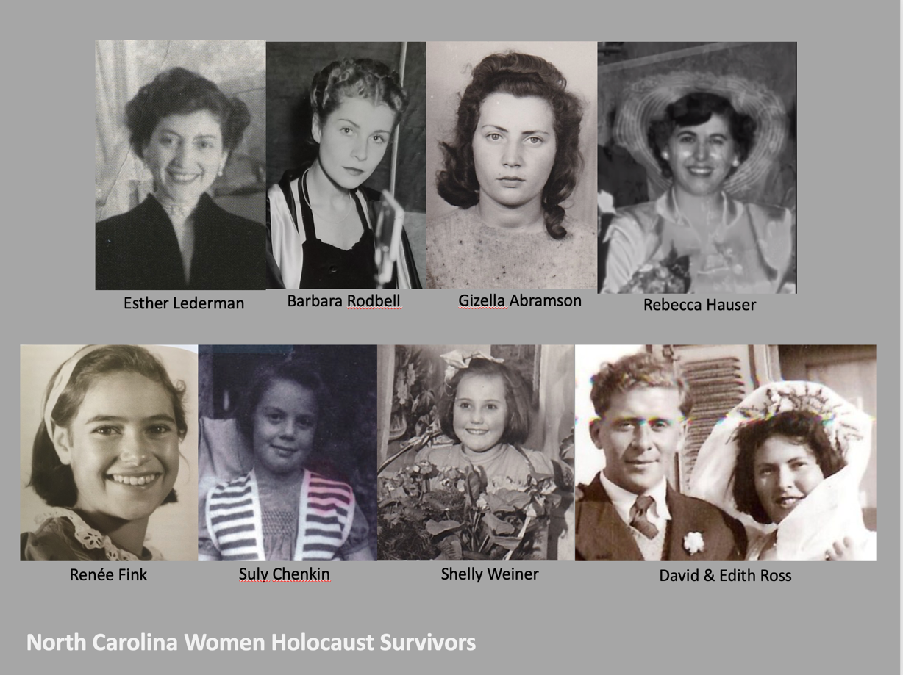

M. Message

There were (and are) other women Holocaust survivors that came to call North Carolina home. If you know of anyone, or have resources to share, please contact the Chair of the North Carolina Council on the Holocaust, Mike Abramson at mabramson919@gmail.com.You can also contact Lee Holder (a member of the North Carolina Council on the Holocaust) at historyhawk308@gmail.com

