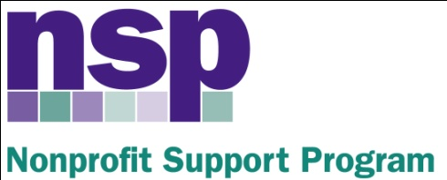

Hartford Foundation for Public Giving
Nonprofit Support Program
Building Evaluation Capacity (BEC) Program
Class of 2017, Session 4 (8), Year 2

April 5, 2017

AGENDA

8:30 – 8:40 | Introduction and Updates
8:40 – 9:40 | Critical Read, (Read the Parachute Article)
9:40 – 10:25 | Re-Thinking Proof and Attribution
10:25 – 10:35 | BREAK (Check your certificate, sign up for May consultation)
10:35 – 11:00 | Activity: Re-Thinking Proof and Attribution
11:00 – 11:20 | Future Plans (Conference, Roundtables, Alumni Group)
11:20 – 11:40 | Final Team meeting (Final Report, Ripple and Evaluative Thinking)
11:40– 12:00 | Vocabulary Changes, Wrap Up – Final Questions

HW: Make final changes per the peer review or using final data. Submit to Anita no later than April 28, 2017. You will be receiving feedback on your report by the first week of May. Please use the remainder of your time to revise and complete your reports

https://goo.gl/forms/GlN31sV5c7esUuWJ2
Anita Baker
Evaluation Services
www.evaluationservices.co

