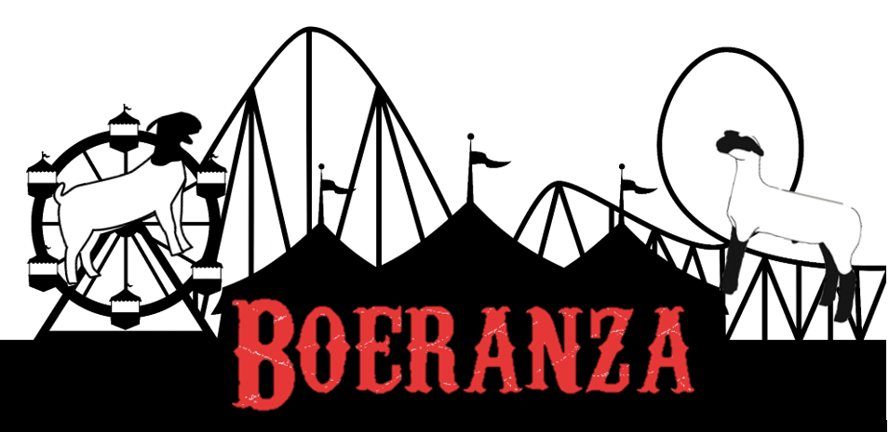

Dorper Show Schedule

Show will start at 10 am with Showmanship
Followed by Black Face Ewes, White Face Ewes & Commercial Ewes
15 minute picture break between Ewes and Rams
Rams will be shown Black Face, White Face, Commercial and Stud Rams
15 minute picture break
Conclude with Wether Show

