REGULAR MEETING
FEBRUARY 21, 2019

A Regular Meeting of the Town Board of the Town of Hampton, County of Washington and the State of New York was held at the Town Hall, 2629 State Route 22A, Hampton, New York on the 21st day of February 2019.

PRESENT: David K. O’Brien------------Supervisor
Tamme Taran----------------Councilwoman-came at 7:35pm
Donald Sady-----------------Councilman
Andrea Sweeney------------Councilwoman
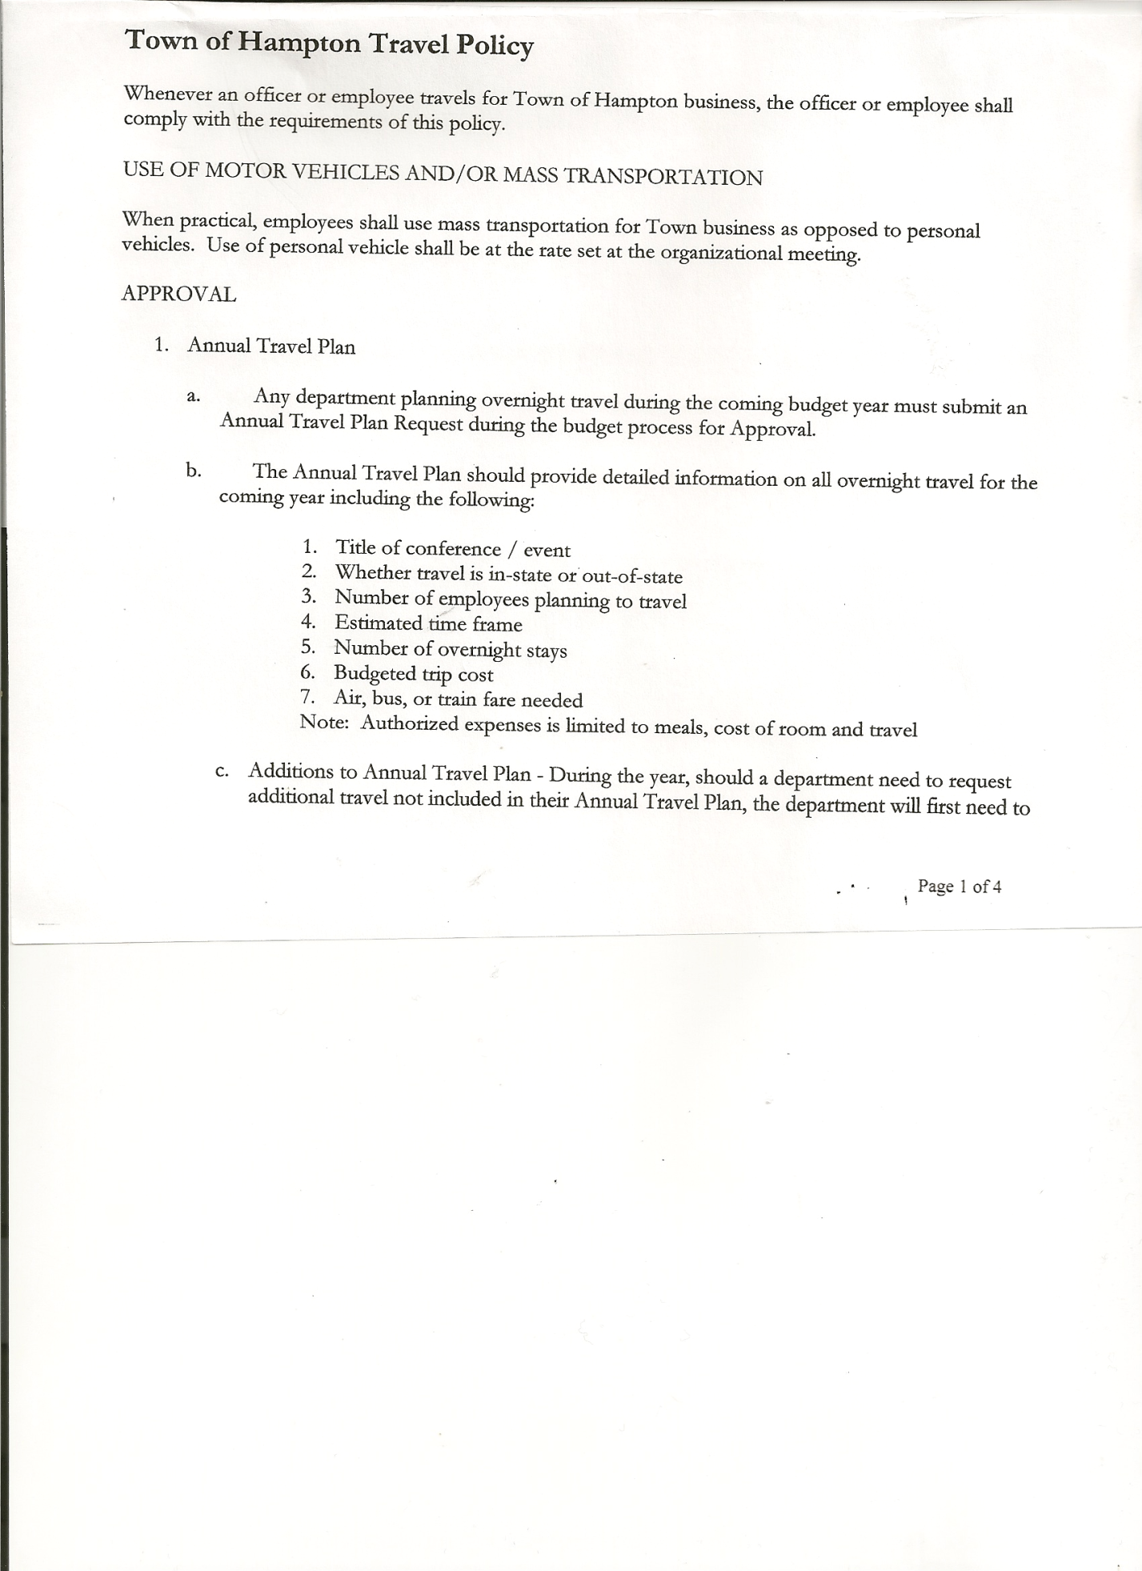
Roger Weeden---------------Councilman
Rebecca Jones---------------Town Clerk
Camilla Shaw----------------Tax Collector/Deputy Town Clerk
Herbert Sady, Jr.-------------Highway Superintendent

Planning Board Member(s): Matthew Pratt

Also present: no one else present

The Regular Meeting was called to order by Supervisor O’Brien at 7:30pm, followed by the Pledge of Allegiance. Location of Fire Exits were given. Quorum of board members present.

RESOLUTION NO. 28-2019
APPROVAL OF THE MINUTES
On a motion of Councilman Weeden, seconded by Councilman Sady, the following resolution was ADOPTED: Ayes 5 O’Brien, Taran, Sady, Sweeney, Weeden
Nays 0
RESOLVED, that the Regular Town Board Minutes for January 17th, 2019 are approved.

Camilla Shaw, Tax Collector- 579 parcels have been so far. Submitted January 2019 report to the Board and also submitted a Bank Statement to the Board for review and signatures.

Larry Carman, Dog Control Officer…submitted his report, which was read by Supervisor O’Brien, copy of report is attached for 1/25/19 – 2/20/19.
Supervisor O’Brien received correspondence from Nancy Quell regarding a Shelter Agreement for 2019. She also indicated there would be a yearly leasing charge of $1000.00. Supervisor O’Brien is going to try and negotiate a lesser fee.

Planning Board Report…
- Starting to discuss an Ag & Farmland Protection Plan
- Next meeting will be March 13th, 2019 @ 7:00pm at the Town Hall
Received a letter from Washington County Planning Agency regarding Town of Hampton Site Plan Law, they found this project to be a “matter of essentially local concern”, therefore the Town Planning Board can move forward and take their final action on this project.

RESOLUTION NO. 29-2019

MOTION BY: Councilman Donald Sady
SECONDED BY: Councilwoman Andrea Sweeney

RESOLUTION INTRODUCING PROPOSED LOCAL LAW
TO AMEND THE TOWN OF HAMPTON SITE PLAN REVIEW LAW

TOWN BOARD MEETING
FEBRUAY 21, 2019 PAGE 2

WHEREAS, pursuant to Section 10 of Municipal Home Rule Law, the Town Board of the Town of Hampton (the “Town”) has the authority to adopt local laws; and

WHEREAS, pursuant to Town Law Article 16, the Town Board has the power to adopt local laws including site plan review within the Town; and

WHEREAS, the Town currently has a site plan review law; and

WHEREAS, the Town’s planning board has reviewed the Town’s site plan review law and recommended certain updates including but not limited to updates regulating solar energy systems within the Town; and

WHEREAS, the Town Board does wish to accept such local law amending the Town’s site plan review law and to hold a public hearing thereon; and

WHEREAS, the proposal is an “action” under the State Environmental Quality Review Act (SEQRA); and

WHEREAS, the action is an unlisted action under SEQRA and the Town Board will undergo uncoordinated review of same pursuant to SEQRA pursuant to an environmental assessment form provided with the draft local law;

WHEREAS, the Town Board is desirous of proceeding with the review and consideration of this proposed Local Law.

NOW, THEREFORE BE IT RESOLVED that the proposed Local Law is hereby accepted for introduction to the Town Board. A public hearing shall be scheduled for the consideration of the proposed Local Law to be held by the Town Board on March 21st, 2018 at 7:00 p.m. at the Town Hall located at 2629 State Route 22A, Hampton, New York. Copies of the Local Law shall be available at the Town Clerk’s office for review; and be it further

RESOLVED, that the Town Clerk is directed to post and publish a notice of said public hearing in Manchester Newspapers (The Granville Sentinel & The Whitehall Times) at least five (5) days before the hearing; and be it further

RESOLVED, that the consideration and proposed adoption of this Local Law is an action under the New York State Environmental Quality Review Act (SEQRA). The Town Board hereby declares that this action is an unlisted action to undergo uncoordinated review; and be it further

RESOLVED, that this resolution shall take effect immediately.

DATED: February 21, 2019 Supervisor O’Brien AYE
Councilwoman Taran AYE
Councilman Sady AYE
Councilwoman Sweeney AYE
Councilman Weeden AYE

TOWN BOARD MEETING
FEBRUAY 21, 2019 PAGE 3

RESOLUTION NO. 30-2019
TIME CHANGE-PUBLIC HEARING
On a motion of Councilman Sady, seconded by Councilwoman Taran, the following resolution was ADOPTED: Ayes 5 O’Brien, Taran, Sady, Sweeney, Weeden
Nays 0
RESOLVED, to change the above Public Hearing from 7:00pm to 7:15pm.

Herbert Sady, Jr., Highway Superintendent submitted his report, copy of which, is attached.

RESOLUTION NO. 31-2019
BUDGET AMENDMENT-GENERAL FUND
On a motion of Councilman Sady, seconded by Councilwoman Taran, the following resolution was ADOPTED:
By Roll Call Vote: Supervisor O’Brien AYE
Councilwoman Taran AYE
Councilman Sady AYE
Councilwoman Sweeney AYE
Councilman Weeden AYE
RESOLVED that, the following Budget Amendments to the General Fund are approved:
Increase Unexpended Balance in the amount of $23,359.04
Increase Personnel Personal Service Account A1430.1 in the amount of $4330.00
Increase Buildings Contractual Expense Account A1620.4 in the amount of $750.00
Increase Contingent Fund Account A1990.4 in the amount of $18,279.04

RESOLUTION NO. 32-2019
BUDGET AMENDMENT-HIGHWAY FUND
On a motion of Councilwoman Taran, seconded by Councilman Sady, the following resolution was ADOPTED: By Roll Call Vote: Supervisor O’Brien AYE
Councilwoman Taran AYE
Councilman Sady AYE
Councilwoman Sweeney AYE
Councilman Weeden AYE
RESOLVED that, the following Budget Amendments to the Highway Fund are approved:
Increase Unexpended Balance in the amount of $9,507.09
Increase Capital Project Fund Account DA9950.9 in the amount of $9,507.09

RESOLUTION NO. 33-2019
APPROVAL OF SUPERVISOR’S 2018 YEARLY REPORT
On a motion of Councilman Sady, seconded by Councilwoman Taran, the following resolution was ADOPTED: Ayes 5 O’Brien, Taran, Sady, Sweeney, Weeden
Nays 0
RESOLVED that, the Supervisor’s YEARLY report be accepted as submitted for 2018.
01/01/18 12/31/18
ACCOUNT BALANCE RECEIPTS DISBURSEMENTS BALANCE
General Fund $ 45,022.32 $102,593.82 $ 99,257.10 $ 48,359.04
Highway Fund $ 33,144.53 $247,876.79 $ 251,514.23 $ 29,507.09
Equipment Reserve $ 76,603.56 $ 17,544.82 $ 0.00 $ 94,148.38
Fire #1 $ 0.00 $ 40,800.00 $ 40,800.00 $ 0.00
Fire #2 $ 0.00 $ 5,4060.00 $ 5,406.00 $ 0.00
Cemetery $ 1,695.28 $ 15.54 $ 0.00 $ 1,710.82
Totals $156,465.69 $414,236.97 $ 396,977.33 $173,725.33
All Board Members present signed Supervisor’s Report.
TOWN BOARD MEETING
FEBRUAY 21, 2019 PAGE 4

RESOLUTION NO. 34-2019
APPROVAL OF SUPERVISOR’S MONTHLY REPORT
On a motion of Councilwoman Taran, seconded by Councilman Sady, the following resolution was ADOPTED: Ayes 5 O’Brien, Taran, Sady, Sweeney, Weeden
Nays 0
RESOLVED that, the Supervisor’s Monthly report be accepted as submitted for JANUARY.
12/31/18 01/31/19
ACCOUNT BALANCE RECEIPTS DISBURSEMENTS BALANCE
General Fund $ 48,359.04 $ 176,976.17 $ 13,171.37 $212,163.84
Highway Fund $ 29,507.09 $ .89 $ 18,407.42 $ 11,100.56
Equipment Reserve $ 94,148.38 $ 4.00 $ 0.00 $ 94,152.38
Fire #1 $ 0.00 $ 0.00 $ 0.00 $ 0.00
Fire #2 $ 0.00 $ 0.00 $ 0.00 $ 0.00
Cemetery $ 1,710.82 $ .07 $ 0.00 $ 1,710.89
Totals $173,725.33 $ 176,981.13 $ 31,578.79 $319,127.67
All Board Members present signed Supervisor’s Report.

BROADBAND….Supervisor O’Brien is sending out a letter and survey to all residents regarding Broadband. There are a couple of grants that the Town may be able to apply for.

RESOLUTION NO. 35-2019
END OF YEAR AUDIT-TOWN CLERK
On a motion of Councilwoman Sweeney, seconded by Councilman Sady, the following resolution was ADOPTED: Ayes 5 O’Brien, Taran, Sady, Sweeney, Weeden
Nays 0
RESOLVED, to accept the Town Clerk’s Audit for 2018.

RESOLUTION NO. 36-2019
STANDARD WORK DAY and REPORTING RESOLUTION
On a motion of Councilwoman Taran, seconded by Councilman Sady, the following resolution was ADOPTED: By Roll Call Vote: Supervisor O’Brien AYE
Councilwoman Taran AYE
Councilman Sady AYE
Councilwoman Sweeney AYE
Councilman Weeden AYE
RESOLVED, that the Standard Work Day and Reporting Resolution for Elected and Appointed Officials (RS2417-A) be approved. Copy is attached.

The Town Clerk’s report for January, 2019 was submitted to the Board. The Town Clerk had Board Members review and sign bank reconciliation statements for the Town Clerk Account and Special Town Clerk Account dated January 31st, 2019.

RESOLUTION NO. 37-2019

AUDIT OF CLAIMS
On a motion of Councilwoman Taran, seconded by Councilman Weeden, the following resolution was ADOPTED: Ayes 5 O’Brien, Taran, Sady, Sweeney, Weeden
Nays 0
RESOLVED that the bills have been reviewed by the Town Board and are authorized for payment in the following amounts.
General Fund No.21 through No.42 $ 9,328.13
Highway Fund No.11 through No.19 $10,834.72
Total both funds $20,162.85

TOWN BOARD MEETING
FEBRUAY 21, 2019 PAGE 5

RESOLUTION NO. 38-2019
END OF YEAR AUDIT-Chief Fiscal Officer (Bookkeeper)
On a motion of Councilwoman Taran, seconded by Councilman Weeden, the following resolution was ADOPTED: Ayes 4 Taran, Sady, Sweeney, Weeden
Nays 0
Abstained 1 O’Brien
RESOLVED, to accept the Chief Fiscal Officer (Bookkeeper) Audit for 2018.

On a motion of Councilwoman Taran, seconded by Councilman Sady, the meeting adjourned at 8:43pm. All in favor Aye.

Respectfully submitted,

Rebecca S. Jones, RMC
Town Clerk

