September 2017 Strathmere Event and Activity Calendar | 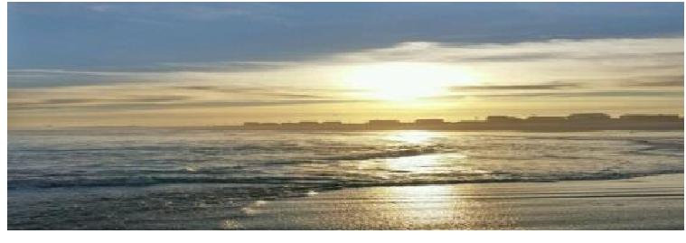

September 2017
Sun Mon Tue Wed Thu Fri Sat
NOTES:Used book sale 9/1-9/30 Schiavo Library Call 609-263-1151 to confirm lifeguard schedule for 9/9-10 & 9/16-17 |  |  |  |  | 1 | 2 SFEC Kids Surf Tournament 9:00am Prescott Road Beach (Rain or extreme weather Date 9/3)
3  STM United Methodist  Church  Hymn Sing 9:15 am  Worship 9:30 am | 4 Labor Day!  Trash & Recyclables will be picked up - normal schedule | 5 | 6 | 7 | 8 | 9 Williams, Whittier, Tecumseh, Sherman and Putnam Street Beaches will be lifeguard protected
10 STM United Methodist  Church  Hymn Sing 9:15 am  Worship 9:30 am  Williams, Whittier, Tecumseh, Whittier Sherman & Putnam Street Beaches will be lifeguard protected | 11 TWP Committee Meeting, 7:30pm TWP Hall | 12 | 13 | 14 | 15 | 16 CFSWB Town Hall, 10:30 am, Firehouse Williams, Whittier, Tecumseh, Sherman and Putnam Street Beaches will be lifeguard protected
17 STM United Methodist  Church  Hymn Sing 9:15 am  Worship 9:30 am Williams, Whittier, Tecumseh, Sherman and Putnam Street Beaches will be lifeguard protected | 18 | 19 | 20 | 21 | 22 | 23
24 STM United Methodist  Church  Hymn Sing 9:15 am  Worship 9:30 am | 25 TWP Committee Meeting,7:30pm TWP Hall | 26 | 27 | 28 | 29 | 30

