14307 County Hwy B, C-21A Sparta, WI 54656 (608)269-5558

SOJOURNERS JOURNEY

July 2015 Report
Page 2 Page 3 Page 4
Volunteer Spotlight Opportunities Simple and
Connections Affordable Ways to Help
Giving Hearts

Having so fond an affection for you, we were well-pleased to impart to you not only the gospel of God but also our own lives, because you had become very dear to us.
1 Thessalonians 2:8

A passage from Pastor Jef:

Maybe you’ve heard to colloquialism, “I feel like a dog chasing a car. I’ve caught the silly thing and I’ve got no idea what to do with it!” That’s how it feels at Sojourner’s Journey some days.

A few months ago the Board of Directors offered me the job as Spiritual Director at Sojourner’s. I’m thrilled to have this opportunity! I get the privilege of telling folks about Jesus and how His beauty can change their lives. Some days feel like whirlwinds, but the joys of serving are incredible.

Let me tell you a couple of stories. I was teaching a Bible study recently and in the midst of the study baptism came up. I simply asked, “What’s with all this baptism stuff?” One of the girls said, “Pastor Jef, I don’t even know what baptism is.” It made me realize just where some of these ladies are at in their understanding of Christ and spirituality. I explained that baptism is a picture of how Christ makes us clean. The looks in the eyes of some of the ladies that day will stay with me for a long time. The idea that they could be clean from all the demons that haunt their lives was a joyful thought for those ladies. That’s what Sojourner’s Journey is all about. We exist to share the gospel and to share our lives with young ladies who we are about very much. Some days are better than others. Sometimes we feel the frustration of broken promises and failed appointments. Other days we are excited for the opportunities that God gives us to touch lives. I guess this is the reality of being the hands, feet, eyes, and ears of Jesus in a fallen world.

I’m grateful to God for all the wonderful people at Sojourner’s who give so much. Julie and Rich have begun a Women’s Support Group to help gather ladies to deal and cope with addictions. Kris goes to the jail weekly to lead a Bible study for ladies. Hilary keeps us all headed in the right direction and Katie inspires us with her encouragement and hard work. There are a lot more folks who do their part behind the scenes. Would you have a spiritual gift you would like to contribute to the Sojourner’s Journey mission? Maybe you would be willing to contribute finances to keep us going. We would certainly be grateful for your prayers as we trust God and His Spirit to reach ladies with the gospel.

Come see us or give us a call. We would love to hear from you! If one of our team members could come to your church or civic group or Bible study and tell your folks about Sojourner’s Journey we would be very grateful to do so. Just let us know and we will be there.

Thank you for your continued prayers and support!

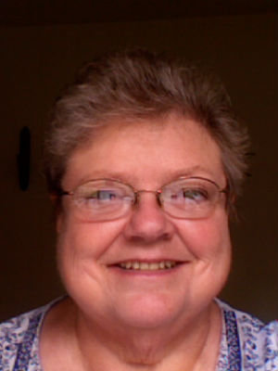
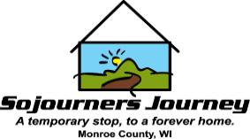
Darlene Heistad
We here at Sojourner’s Journey are so blessed and thankful to have Darlene as our volunteer childcare provider! Darlene is a volunteer who has significantly contributed her time here at Sojourner’s Journey. Darlene provides childcare to the children that come to Sojourner’s Journey with their mothers. Not only can we always count on Darlene, but she walks in Sojourner’s with a smile on her face. She gives the children love, compassion, teachings, care, and friendship. We couldn’t thank you enough Darlene for all that you do. You truly are a shining light on our team, and we are so grateful for your dedication and willingness to serve. We are richly blessed!

Thank you for your servant heart and compassion!

Volunteer Spotlight
We would like to share with YOUR church body the vision God has placed on our hearts for the homeless in Monroe County. We would love to connect with every church to raise awareness of the ministry opportunities at Sojourner’s Journey.
A member of our team, would love to meet with your Pastor, Elder Board, Mission Committee or anyone involved with Outreach/Missions in your church. If you could help us with that connection, please contact us!

Volunteer Opportunities

Child Care: 2 hour commitment once a week
Mentoring: (meet with residents 1 once weekly;
Take residents to church; Bible study; be a friend)
Teachers: Parenting and Relationships
Event Volunteers: Sept. 19th Wild West Carnival
Fundraising: Are you a part of a group who would be interested in doing a small fundraiser for us?
Raffle Tickets: Help Selling
Serve on a committee: Fundraising and Event planning and our Program Committees are in need
Maintenance: Lawn care/Flowerbed upkeep

Connect With Churches

Giving Hearts
Wish List Items:
…………………………..

Prayer Team

Thank You to
Our Sponsors!!

Mathews Inc.
A-Z Mini Storage
Dependable Title
Faith Evangelical Church, Sparta
Grace Community Church Of Ontario
Kwik Trip
Light House Assembly of God, Tomah
Lopez Dental
M.J. Rentals
New Life Assembly of God, Sparta
The North Street Bubble
Spartan Storage
Thrivent
Union National Bank and Trust
Urban Nest
Wal-Mart

- Garbage Bags
- Paper Towel
- Kleenex
- Stamps
- Toilet Paper
- Magic Erasers
If there is an item on our wish list that you would like to donate or give a special monetary gift toward, please contact us!

The success of any ministry lies with the foundation of prayer.
Praise God for Shirley Walker who heads up an army of prayer partners for Sojourner's. If you would like to be a part of this team, email Shirley at fivejwalkers@gmail.com.

1st Prize: 4 Night stay at a Cabin in Winter WI.
2nd Prize: $500.00
3rd Prize: $250.00
4th Prize: $100.00
5th Prize: $50.00

To be drawn at The Wild West Carnival on Sept. 19th
Ticket Cost: $5.00 each or 5 tickets for $20.00

Help Sojourner’s Sell Raffle Tickets

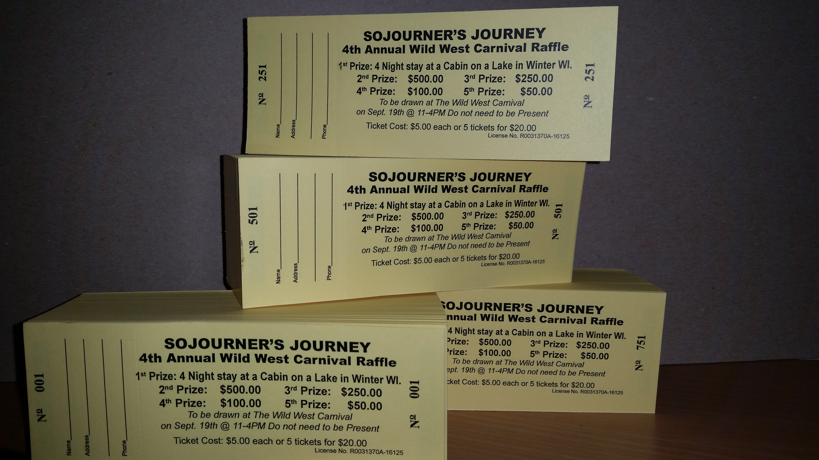

Simple and Affordable Ways to Help

PATHFINDERS:
Discipleship Plan
- This is a supportive and educational environment for women who are overcoming an Alcohol or Drug Addiction
- Overcoming by following Jesus, in relationship with His Spirit, and learning His Word
- Living this new life through repentance from dead works and our faith in God
- Taking a Biblical look at what Jesus did and taught as it has been recorded in the Gospels, as well as what his apostles put forth in the epistles
- Becoming doers of His Word and finding our place in the body of Christ
Come to Sojourner’s Journey Every Monday @7:00pm

Support Sojourners Journey
Like our Facebook community!
Make donations through the Blog page using Paypal http://sojournersjourneyinc.blogspot.com/.
If you would like to make check contributions, please make checks payable to
“Sojourners Journey” and mail your donation to address below.
God Bless!

