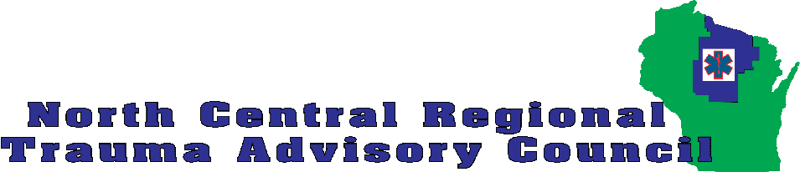
Bike Helmet Request
NCRTAC is requesting that each organization requesting helmets try to attend the NCRTAC meeting on Thursday, July 28th at St Clare’s to pick up their helmets. Education on how to properly size and adjust the bike helmets will be provided to each organization that receives helmets.
Organization requesting bike helmets:_________________________________________
Contact Name:_______________________________________________________________
Contact phone Number:______________________________________________________
Contact email:_______________________________________________________________
Number of bike helmets requested:___________________________________________
What activity or event will the bike helmets be used at? Explain how they will be distributed:_________________________________________________________________________________________________________________________________________________
Date of event:________________________________________________________________

Return completed form to:  Michael.Fraley@Wisconsin.gov | Contact Lisa Ebert with any questions.  Lisa.ebert@aspirus.org

