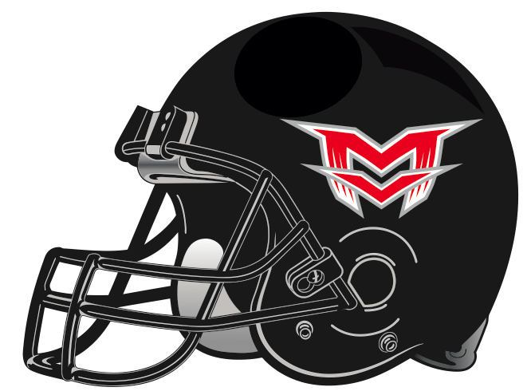
2019 Player Recognitions

MVC 1st Team Offense: Blake Warner- Tackle
Keenan Harpole- Running Back

MVC 1st Team Defense: Riley Oates- Defensive Line
Titus Schulz- Linebacker

MVC 2nd Team Offense: Jack Barrett- Wide Receiver

MVC 2nd Team Defense: Josh Cockrum- Corner

MVC Special Teams: Jack Barrett- 2nd Team Returner

MVC Honorable Mention Offense: Cody Phillips- Guard
Ryan Daubenschmidt- Tackle
Rory Eck- Center
Titus Schulz- TE
Riley Oates- Running back

MVC Honorable Mention Defense: Blake Warner- Defensive Line
Declan Corrigan- Linebacker
Parker Hopfer- Linebacker
Luke Roberts- Safety

