0-

**GSPCI Newsletter Pointer Post October 26, 2013**

**German Shorthair Club of Indiana**

Presidents Message:

Well it has been a while since our last newsletter and I wanted to make sure we had a lot of information to get out before we sent the latest one out. We had our annual picnic at our new home/farm/orchard in New Palestine. It was a good turnout with many new faces to add to our membership. We also had our officers’ meeting and we planned the rest of the 2013 year. Some important dates for everyone to put on their calendar include: The Ladies/Youth Hunt will be held on Sat. Nov. 2nd at Ron Ferris’s Farm. The Club will furnish the pheasants so please contact me or Ron so we will have enough birds for everyone. Our second date of importance will be the annual Steve Hammond Memorial Hunt will be held on Sat. Dec.7th at the farm of Ron Ferris. This year’s host will be last year’s winner, Chris Webber cost for the hunt is yet to be determined so contact Ron or myself so we can order the birds and set the running order. The third date is for anyone interested in running for office this year please contact Kirk Johnson and give him your name. The President’s office will also be open as I have decided to step down. Our 4th date is very important so please place this on your calendar the annual meeting which has been held at the Brick Yard Restaurant has been changed to the Ponderosa Restaurant in Greenfield on Jan. 19th at 2:00 PM. More information will be forwarded later on. I hope to see a big turnout at each of these events plus perhaps some new faces as far as our leadership is concerned. Sign-up and get involved.

Last month we had a very successful Hunt test with several members including yours truly hitting pay dirt. I want to thank everyone who pitched in and once again made this a successful endeavor for the club. It was great to see so many dogs come away with the rewards of countless hours of training. As I have written before when you see a dog do it right it means that their handler has taken a well-bred pup and turned them into a well-trained companion in the field, as the commercial says “PRICELESS”.

In closing, as I stated above I will not run for another term as President I want to thank each of you who have helped, guided, and pushed me to provide this club with the leadership that is needed. When I first got the position I received a plaque with all the names of the previous presidents. As I looked at each name it became evident that there were some big shoes to fill, each one putting their stamp on the club by introducing some new event or taking the club where it hadn’t gone before. I knew that it would be a challenge. I hope that you each believe that we have taken a step forward and I hope that it has been in the right direction. Thanks for all of your support and I hope that each of you has a great opening day.

Sincerely,

Vince

C:\Users\Laura\AppData\Local\Microsoft\Windows\Temporary Internet Files\Content.IE5\4B4LJQIM\MP900314229[1].jpg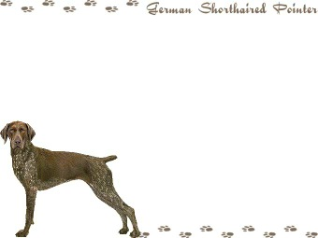



Board Members

**President** - Vincent Guerrini

[guerrini.vince@gmail.com](mailto:guerrini.vince@gmail.com)

**Vice President** – Kirk Johnson

**Secretary/Treasurer** - Debra Moline

[runmom1435@aol.com](mailto:runmom1435@aol.com)

**Board of Directors**

Larry Harris Mark Holzinger Ron Ferris

Laura Getzen Matt Cosgrove John Kennedy

Chris Weber Giles Hoyt Brittany Moline

Indiana Hunting Seasons

Deer Firearms: November 12th – November 27th Deer Muzzleloader: December 3rd – December 18th Deer Late Archery: December 3rd – January 1st, 2012

Wild Turkey (Archery Only): December 3rd – January 7th, 2012

Squirrel: August 15th – January 31, 2012

**Ruffled Grouse (Private Owned Lands): October 1st – December 31st**

**Ruffled Grouse (Public Lands): October 1st – November 11th**

**Pheasant (cock only): November 4th – December 18th**

**Quail (North of SR 26): November 4th – December 18th**

**Quail (South of SR 26): November 4th – January 15th, 2012**

Rabbit: November 4th – February 15th, 2012

Crow: December 13th – March 1st 2012

**“B R A G G I N R I G H T S”**

Titles, Tests and Fun! Our members continue to SHINE!

[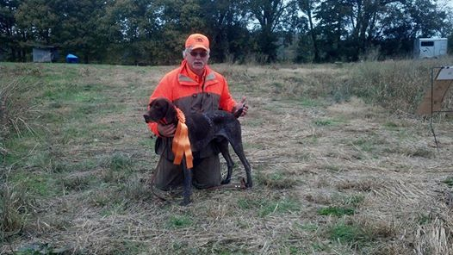](https://www.facebook.com/photo.php?fbid=679744092036654&set=a.451710454840020.87741656.100000032076713&type=1)

Mark and Apache continuing the Holzinger line of success!

[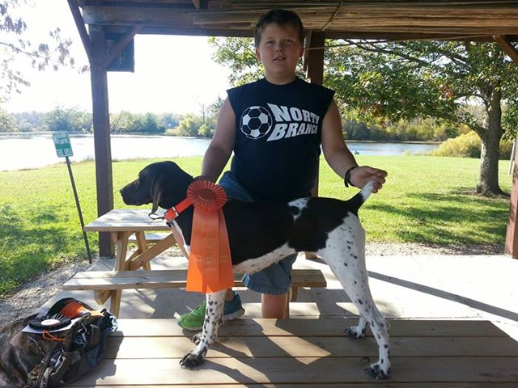](https://www.facebook.com/photo.php?fbid=671038836248482&set=a.261482983870738.70299.100000271144842&type=1&relevant_count=1)

Marcus and Athena

Nice Job buddy. Such a great future as a handler ahead of you!!!



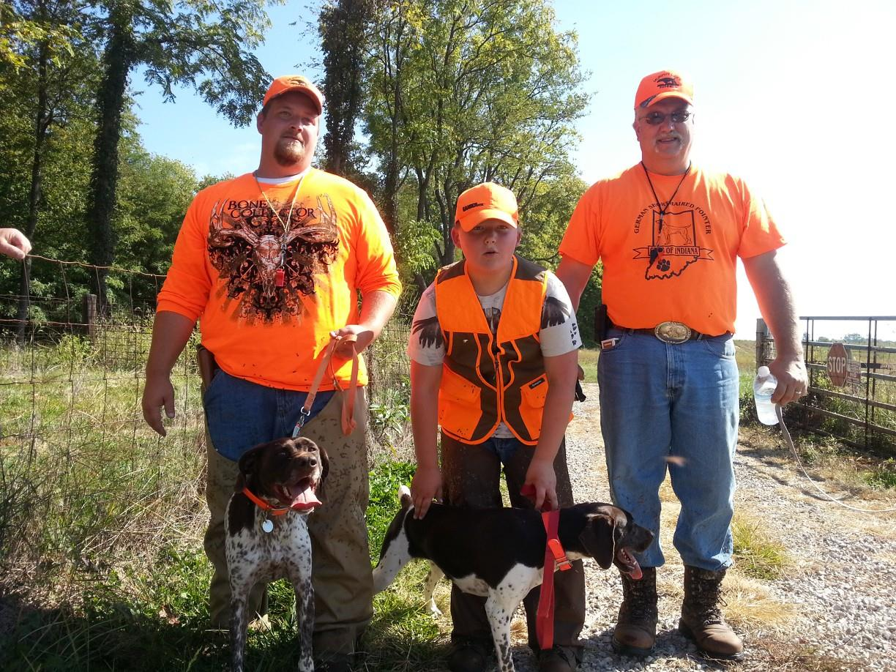

**The Holzingers. 3 generations of handling and hunting. Couldn’t be a prouder moment!**

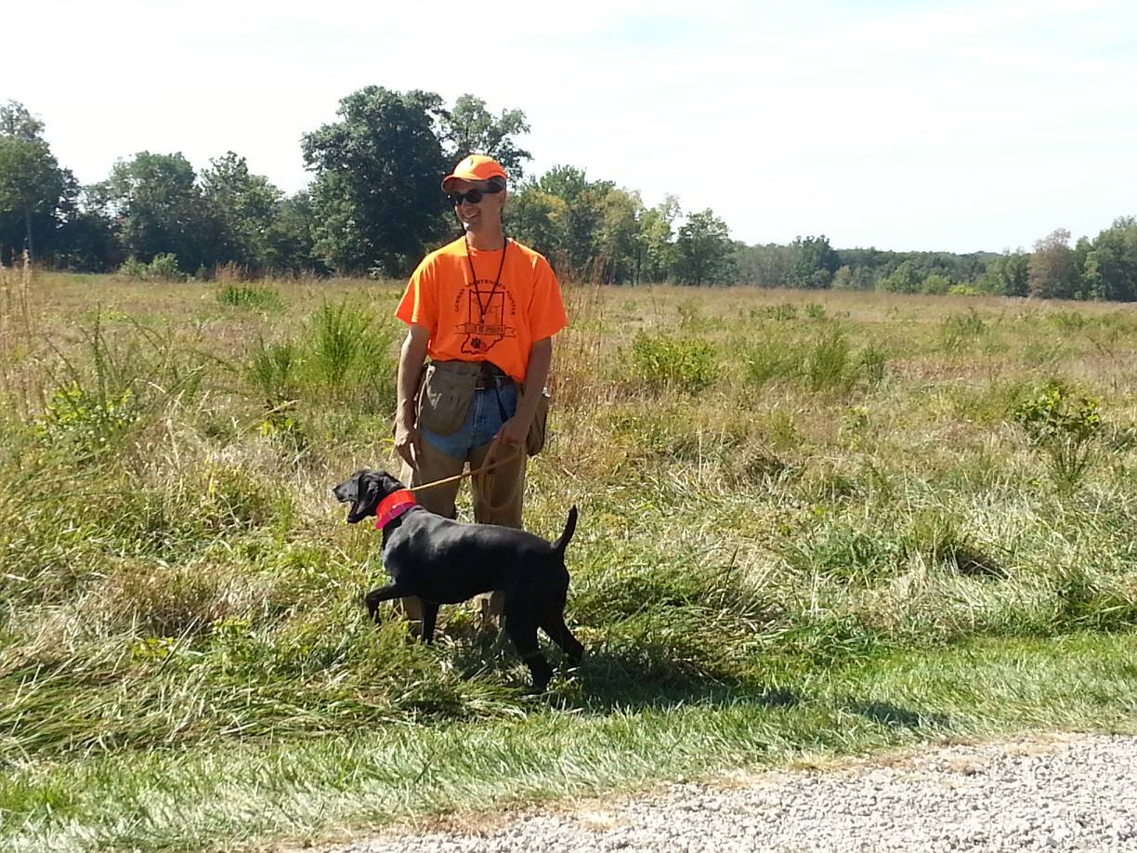

Kirk and Fenway

working for a JH Title

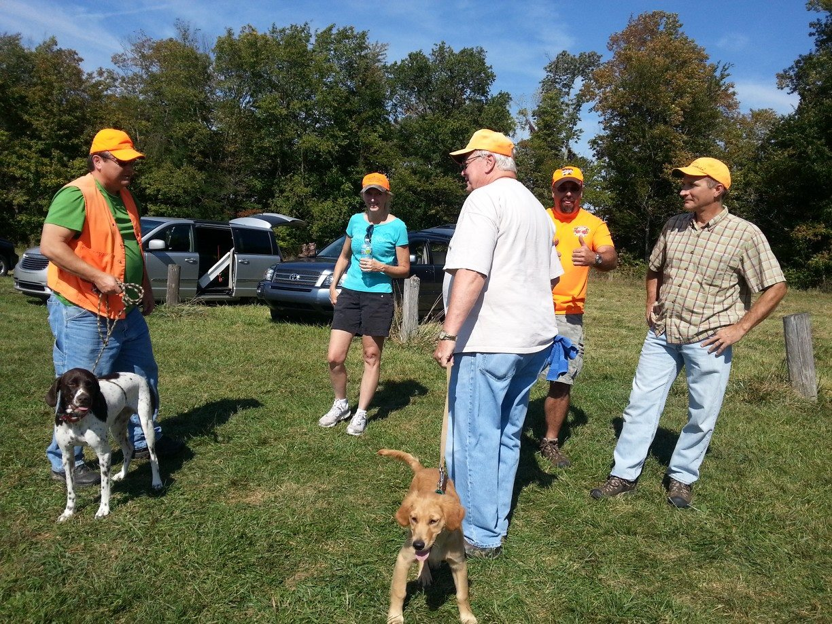

Perry and Shiloh getting a pep talk before taking to the field for their JH Title.

Bird Planters and Planters in Traning!

I Wonder…Who’s Who?

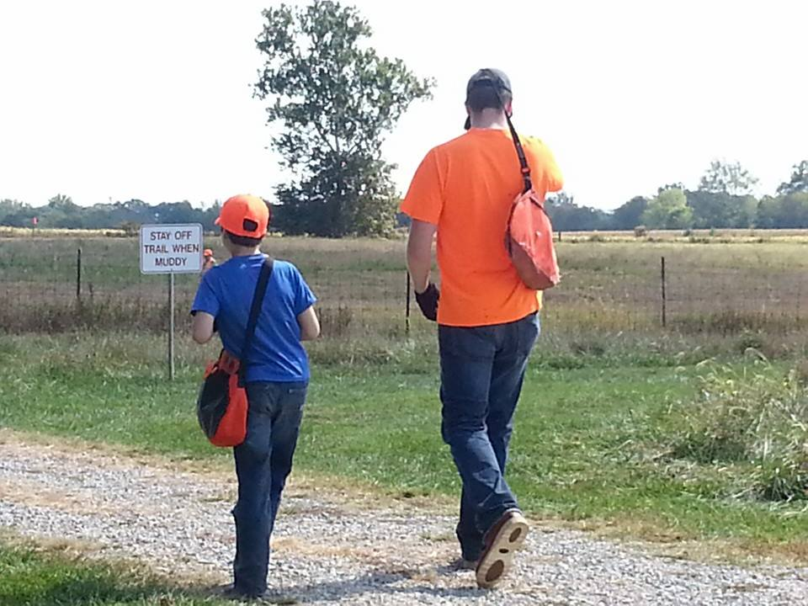 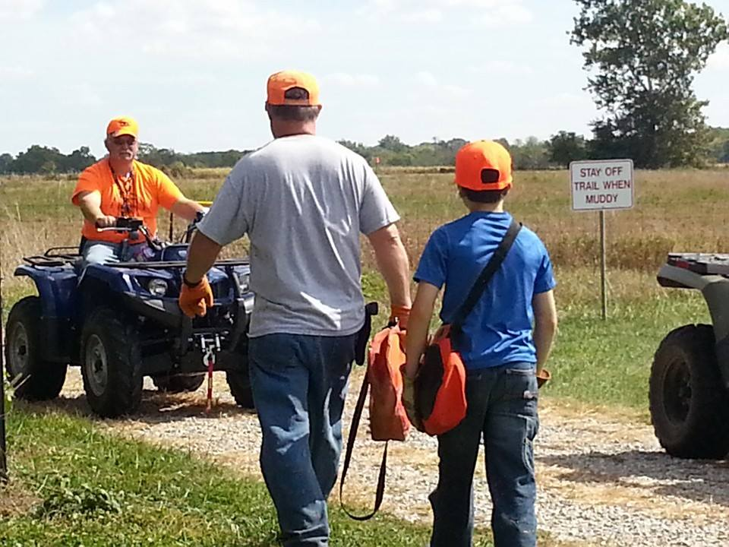

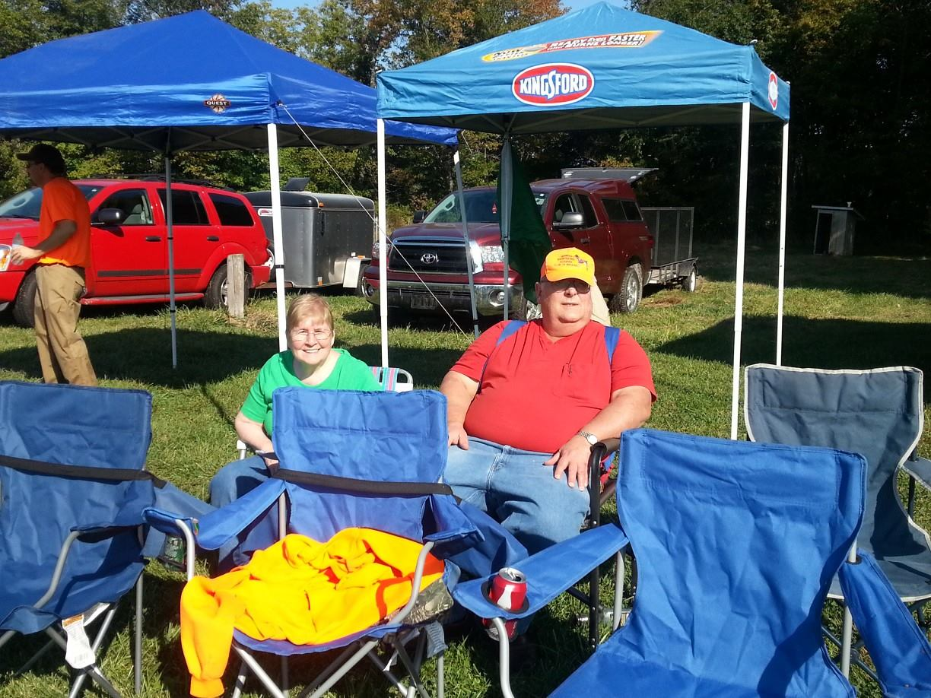

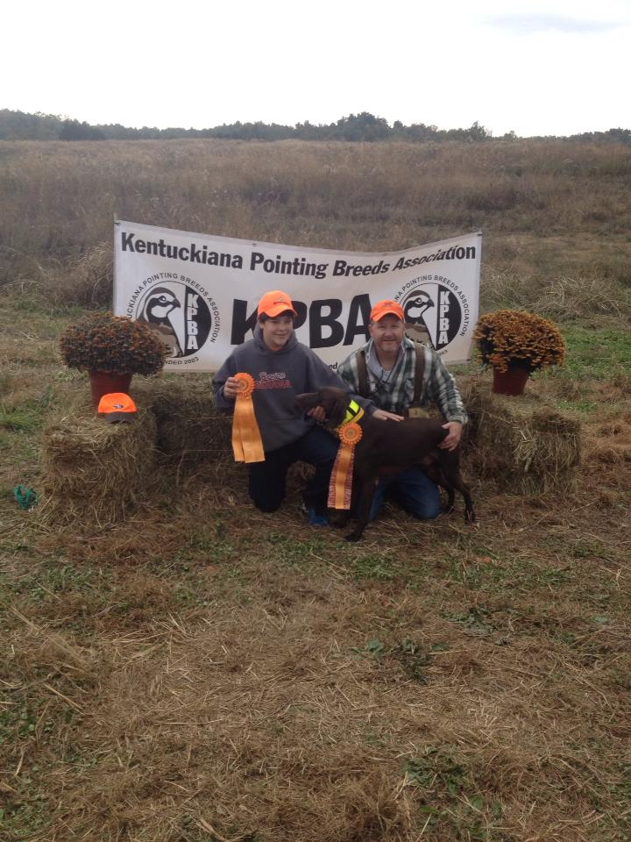

New Master Hunter!

Emmett Vom Montgomerycreek, MH

Very nice job!!!

The Harris Family rooting all the handlers and their companions!!

If you have a bragg that wasn’t included that doesn’t mean you were excluded. Please send any wins or Braggs you would like to have featured please email them to Laura Getzen, Newsletter Editor [markorlaura@comcast.net](mailto:markorlaura@comcast.net).

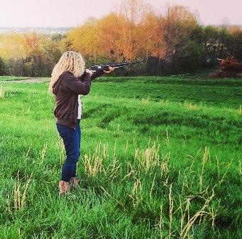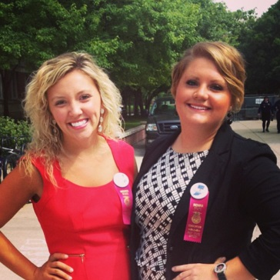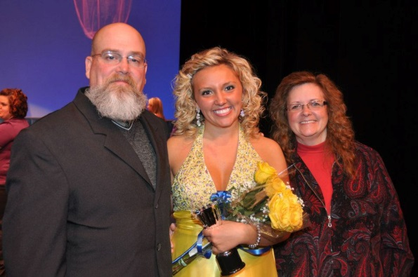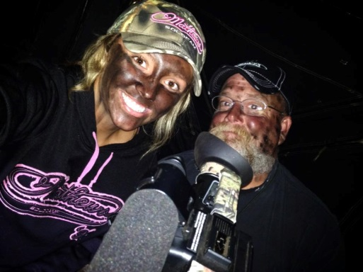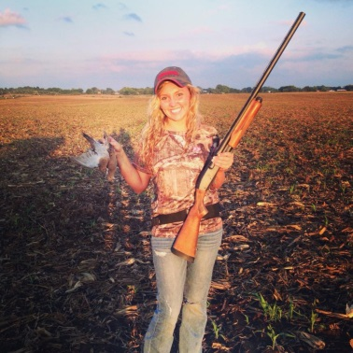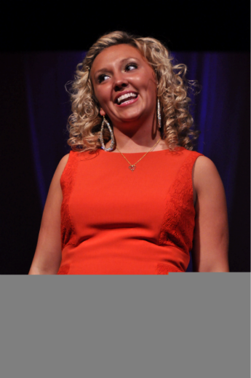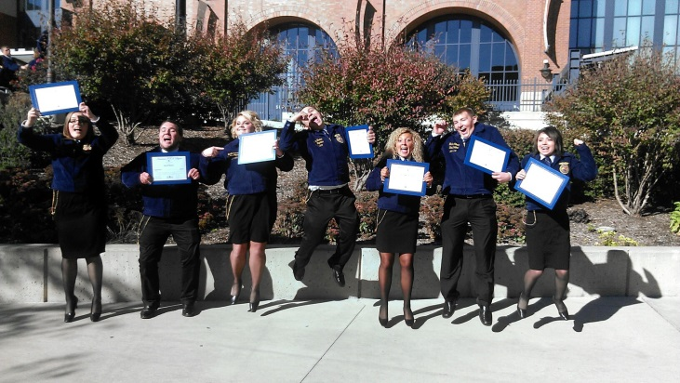

**Where in the World is Casie Conley**

Every year a graduating youth is available for a scholarship from our club. In 2012 Ms. Casie Conley was our recipient. Casie is a wonderful young lady with droves of talent and that strong Conley drive.

I was able to catch up with the busy Ms. Conley…….

Following her year of service to FFA as State President she spent the summer 2012 interned with Governor Mike Pence. Then started at Vincennes University Fall 2012 majoring in Public Relations.

Some of her involvements included:

* Work at Vincennes University Admissions as Tour Guide
* Vincennes University Speech Team Vincennes University Collegiate FFA and Farm Bureau Vincennes University Student Government (served on Public Relations Committee) Miss Vincennes University 1st Runner Up Traveled to Phoenix AZ for the American Farm Bureau Convention with Vincennes Students
* Summer 2013:

Marketing and Outreach Intern at Hancock County Community Foundation Cattle Barn Office Staff during the 2013 Indiana State Fair

* Fall 2013:

Appointed by Governor Mike Pence to serve as the 2013-2014 Vincennes University Student Trustee and

Promoted to Admissions Intern at work. She is currently traveling the state to high school college fairs to promote Vincennes University.

This list of successes isn’t without remembering her even larger success as a person. A beautiful young lady inside and out who is still very active with her family and there outdoor experiences together. Her family has a bond that keeps her roots deep and strong enabling her to reach higher than further than most.

It is young people like this that not only restore hope in society for our children’s future, but also make us proud as a club to have such special individuals in our midst.

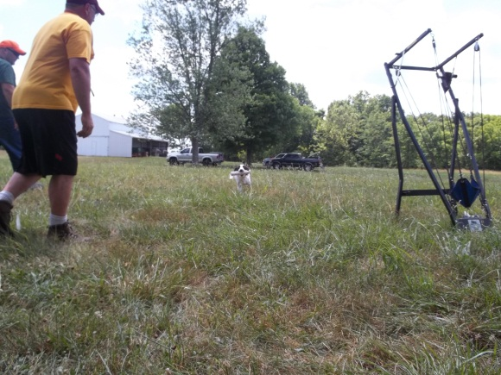

**Happy Hunting**

Its here, its here

Our favorite time of year.

Crunching, snapping

All the leaves are crackling.

Grasses blooming,

Crazy birds are grooving.

Leash em up, let em go

Where they’ll point we don’t know.

Oh he’s staunchy, tail quivers slightly

Whats that moving?.

Flush, there it goes

Straight under his nose.

Track it, blast it

Boom Boom, last I got it.

Feathers falling,

Retrieved upon my calling.

Bird to hand,

Hand soft to the head.

Yup, your still the man!

(silly poem, maybe? Brings a smile, defiantly!)

Upcoming Events

November

**2nd Women & Youth Hunt Ron Ferris Farm 9am**

December

7th Steve Hammond Memorial Hunt

No pitch in, we will eat at the Bluebird Café following

January

19th Ponderosa Restaurant in Greenfield at 2:00 PM.

Details regarding these events are in the Presidents Message. Thank you and we look forwards to seeing you all there!

Hunt Test Qualifiers

Saturday 9/28/13

**Masters:**

Troy Wood and Emmett

**Juniors:**

Perry Cloyd and Shiloh

Kirk Johnson and Fenway

Vince Guerrini and Maggie

Sunday 9/29/13

**Juniors:**

Dr. Giles Hoyt and Ariel

Perry Cloyd and Shiloh

Kirk Johnson and Fenway

**Hunt Test Qualifiers & Upcoming Events**

**Closing Club Notes**

**Club Picnic**

Our annual picnic was hosted by Cindy and Vince at their new home. Much fun was had. A variety of food was enjoyed over great conversation. After a bit of club business was handled, there were a few apples needing pressed. Thank you to everyone who came and enjoyed our fun in the sun!

**Club Hunt Test**

HUGE Success! We had a very nice turnout. Saturday full of sun, then Sunday poured rain. Attendance was great despite the difficult weather. Many club members went home with ribbons, as did many non-members. Thank you to everyone who helped. This is never a one man show! Without all of you who continue to help and support this event….it just couldn’t be done!

**Upcoming Litter Available**

Takoda's Kiwidinok X Takoda's Spirit in the Sky (Naiche)

Both OFA-E and history includes MH & DC

Whelping date is 11/8

Contact Lisa Cleveland [gsprosie@yahoo.com](mailto:gsprosie@yahoo.com)



**Facebook’ers**

*It’s been very helpful that some of the members have continuously shared pictures and training successes on their timeline****. Please go onto the GSPCI FB page and post there as well, that continues to promote how active we are with our dogs!!!***

Again, monthly, until further notice, I need everyone to message Laura Getzen on Facebook a picture of your GSP. Be Fun with it. You have, every month, from the 1st to 24th to send me pictures on Facebook to Laura Getzen or email them to [markorlaura@comcast.net](mailto:markorlaura@comcast.net). Then I will post all of the pictures by the 25th of every month for a “LIKE” Contest. The contest will last until the last day of the month. Whoever gets the most “LIKE” ‘s will be our profile picture for the upcoming month. The winner will be posted on the 1st of every month for that month! This will generate buzz for the club. This will be a great way to get our club in people’s faces monthly. The greatest advertisement is word of mouth, so let’s have fun with this and get beautiful, funny, stunning, showy and hunty pictures. Pass the word to your friends! There is one catch, to enter; you must be an active member of the German Shorthair Pointer Club of Indiana.

**Like, Send and Post those Pictures!!!!!**

**Breeders**

Please make sure you email Christy Featherson if you have any litters available or coming. Christy is listed on AKC website as a Breeder Referral. Also for ***members only***, post your litters to the “German Shorthaired Club of Indiana” Facebook page.

Christy Featherston [artemisgsp@aol.com](mailto:artemisgsp@aol.com)

**Happy Halloween and Happy Thanksgiving!**

May everyone please be safe and have fun during the upcoming holidays!

**Volunteers**

During the events we host or attend there is always room for help. May be it food, cleaning up, setting up or just offering? Contact is easy to make to offer any assistance where needed. There is no specific list for this, or maybe there is and were all on it!

Give where you can and lets all do our part to help things pull together. We have many members who already help and volunteer for many things we do. So a BIG Thank You to them and lets continue to all support and help with our efforts!

**New members!**

The German Shorthaired Pointer Club of Indiana is a club dedicated to the celebration and advancement of the German Shorthaired Pointer. Let’s continue inviting and pursuing new leads for new memberships. We have chosen to be more than just dog owners, we have joined into a family that shares the common interest in making ourselves and our german shorthairs the active sportsmen they were breed to be.

C:\Users\Laura\AppData\Local\Microsoft\Windows\Temporary Internet Files\Content.IE5\4B4LJQIM\MP900314229[1].jpg



Other informative sites; <http://www.bdarn.com/calendar/> <http://www.nstra.org/> <http://www.gspca.org/> <http://www.centralindiananavhda.com/> <http://www.glennsvalley.org/>