MOKENA FIRE PROTECTION DISTRICT
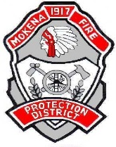

FREE SENIOR LUNCHEON!
Monday, May 16, 2022

“Heat Emergencies and Safety”

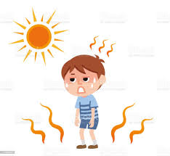

Join us for our Seniors Luncheon on Monday, May 16, 2022! Learn helpful tips regarding Heat Emergencies & Safety.

Luncheon will be held at 10:30 a.m.
At Station #1, 19853 S. Wolf Road

To Register:
- Call 479-5371 - during regular business hours:
Mon-Fri. 8 a.m.-4 p.m.
- Or register on-line: www.mokenafire.org
(*seating is limited)

Station #1/Administrative Office Phone: 708-479-5371
19853 S. Wolf Road Fax: 708-479-2970
Mokena, IL 60448 Email: mfpd@mokenafire.org
Website: www.mokenafire.org

